Avaldatud Italia teadusajakirjas

ROOMA BRINGS VICTORY

Jaan Aigro, Hannes Kinks, Robert Kullamaa, Ott Madis Ozolit
Student
Tallinn University of Technology
Tallinn, Estonia
viis@ati.ttu.ee

Vladimir Viies
Associate Professor
Tallinn University of Technology
Tallinn, Estonia
viis@ati.ttu.ee

Estonia is building up an e-Country. With this in mind, it is very important, that the general public will begin accepting it, or it will fail. At the moment, a block is ready, where the e-Country services can be accessed by authorizing oneself with publishing one’s own personal data. This block works under the Estonian X-tee (“X-road” in Estonian) system. But not all people are ready to publish their personal data in such a way. To get used to the e-Country philosophy, services must be offered which do not require people to publish their personal information, and these services must have the same kind of structure. This, on the other hand, does not exclude usage of X-tee, but rather even simplifies its usage in the future.
The following is a short description of an e-Country service, which provides people with information without the need for them to publish their personal data. Our work is hopefully going to be supported from 2012 by Estonian and Norwegian national environmental organizations.
The Water Framework Directive (European Commission, 2000) is a central element in EU water legislation. The Water Framework Directive (WFD) commits member states to achieve good qualitative and quantitative status of all water bodies by 2015. To reach the goal, one of the most demanding tasks is the selection of cost-effective measures to tackle various issues on water bodies. The Estonian Environmental Information Centre (EEIC) collects, processes, analyses and distributes information about the nature in Estonia, the state of the environment and the factors that impact them. Furthermore, the information about the environment must be available to the general public, as stated by the Aarhus Convention (Aarhus, 1998).
The EEIC has teamed up with a team of students from Tallinn University of Technology (TUT) to create a series of applications, mostly computational models, for an Estonian Water Information System (EWIS) which will use many different databases, which in turn have been created for storage of environmental data in Estonia. EWIS has to obtain data mainly from three EEIC databases, the Environmental Register, the Information System of Environmental Permits and the Information System of Estonian Nature. Since these databases are not inherently interconnected, a bridge-type add-on service is needed to ensure correct communication between our databases and models, especially since our models can also be dependant on each other. The environmental information that EEIC possesses will then be made available to the public via an interactive map service – which anybody can use, be them scientists, citizens, students or hobbyists – and which also provides the aforementioned applications. A result of the workgroup’s efforts is a method, which will be used to link the environmental data and computational models, as shown in Figure 1. The usage of this method is detailed later in the article.

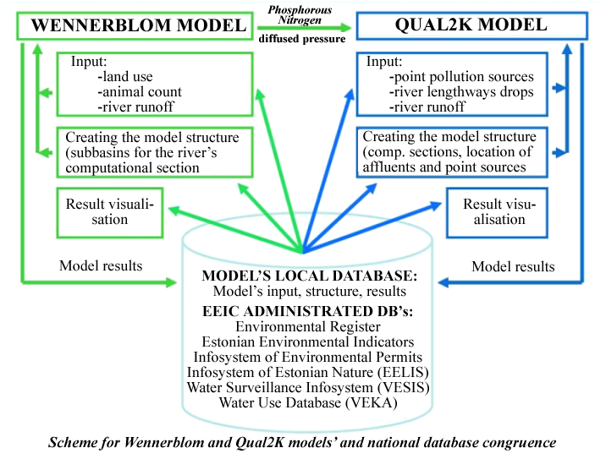
Figure 1. Database linking method.

The system interface is realized using Geographic Information System (GIS) technology. This technique allows us to, for example, test various scenarios and to take coincidently into account the influence of different measures on whole river basins, and mainly provide an interactive map service for our userbase to run applications and make queries with.
Estonia is well suited for this kind of project due to its size and its concomitant amount of data. The amount of water bodies in Estonia is well-manageable and is also handily surveyed. Luckily, some of Estonias rivers have measuring stations for automatic information gathering, so maintaining constant flow of new information is mostly not an issue. Due to Estonia’s size, all this data is still manageable, there is not too much data, and there is no lack of data.
While there is already a tool developed by the Estonian government, X-tee, to allow seamless communication between government administrated databases, we are not limited by its constraints as of yet. The databases we need are fortunately all being administrated in-house and in the future, X-road will indeed be included in our bridge service, nicknamed ROOMA (the city of “Rome” in Estonian, Figure 2). We have defined the term as a backronym – Relational, Object-Oriented, Models, Databases (“Andmebaasid” in Estonian). The bridge service will act as a mediator and translator between the various databases that we will be using, with the linking method (Figure 1) as a base. Since each database is built differently, the data contained within is inherently understandable only for the applications that have been explicitly designed for said database. This problem will be remedied with “Rome”, which will establish a specific format for environmental data. For example, databases might have different ways of storing geospatial data. Some use proper geospatial objects while others are limited to having only a “commentary field” included in a data row, which stores the geographic location in plaintext. If the need arises that this oddly formatted data is to be queried, Rome will convert it to a set format which our applications will be familiar with.

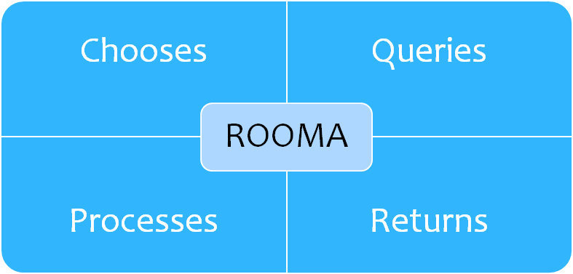
Figure 2. The primary functions of Rome.

This brings to another design decision concerning our applications – since we have a number of databases we are required to use, we don’t simply build our applications with each having their own query logic, the communication part is handled by Rome. So, effectively, our applications are built based on Rome rather than our databases, which means if we have to link some more databases into EWIS further in the development, we can do so without having to edit all our existing applications’ query logic. The communication cycle itself is quite simple: First, an user of EWIS starts and application and desires to calculate some result. The user starts the calculation. Secondly, the application sends to Rome its needs for calculation. Third, Rome chooses the databases where to query required information and queries it. Fourth, Rome processes the data to a set format and forwards it to the application. This cycle is applies for each database. Finally, the application itself starts working and returns the calculation result based on the data from the databases.
Furthermore, the models are linked – the result of one model can provide input to a different model. The models are also linked to EEIC databases for automatic installation and initialization. As such, the applications as well can be linked, and must be, if a complex modelling result is needed. This is where Rome again comes in handy, to make sure that all data is converted to a machine-readable, specific format that our every component can understand (Figure 3). If an application requires input from another application, Rome simply runs it and returns the required data.

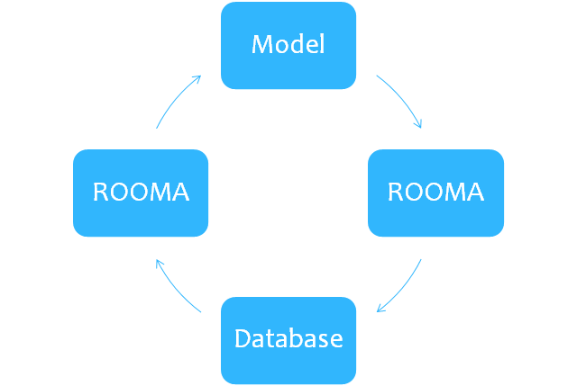
Figure 3. Workflow for running a model.

In addition to Rome being a vital tool in the intercommunication of EWIS’ components, it is also an attempt to standardize environmental data. The very idea of having an unambiguous data format for it is delightful not only for the developers of EWIS, but every hydrologist as well, since as mentioned before, environmental data is stored chaotically at times, since data storage is not centralized into one database, but rather in many, smaller databases. Recently, W3C ja ISO/IEC JTC 1 have started cooperating, as W3C wishes to have its open specifications used as international standard. Any sort of web service standardization inadvertently spills over into the development of EWIS as well, since it is itself a service provided over the web. Homogenizing the web service landscape should serve as an example and by developing EWIS we intend to follow it, attempting to standardize our used data too, albeit in a limited scope.
Hopefully, the efforts put into EWIS so far will bear fruit, as the system will have a wide userbase to satisfy and will simplify the lives of all who are involved in water policies or hydrology in general. The aim is to create something that will be an example to all to follow, as principles used in EWIS can be applied elsewhere, where near-seamless communication of databases and applications is required, especially in regarding public national data, like the subject of our information system – environmental data.

