Create a database (record files), use at least two files
(the variant is determined by the last digit of the date of birth)

0-1 UNIVERSITY
NAME-STRING
GENDER-SINGLE DIGIT INTEGER
ID LONG INTEGER
GRADUATED SCHOOL- STRING
AVERAGE GRADE - LINE NUMBER
WHERE ENTERED-STRING
WHEN ENTERED-ENTRY (DATE)
Report: average grades of the most successful school entrants by year by higher education institution
2-3 WAREHOUSE
ITEM CODE - INTEGER
NAME-STRING
QUANTITY- INTEGER(PCS)
ENTRY (DATE)
FIELD-ENTRY(DATE)
Report: On which day was the most number of items in the warehouse and how much
4-5 STORE
ITEM CODE-INTEGER
NAME- STRING
QUANTITY-REAL NUMBER
PRICE-REAL NUMBER
DATE OF SALE RECORD
% OF ROOT COST - REAL NUMBER(12%)
Report: on which day the goods were sold with the highest profit and by how much
6-7FORESTRY
LANG -INTEGER
OWNER-STRING
THORN trees%; LEAFY trees%;BUSHes%
SIZE-REAL NUMBER(tm)
WHEN-ENTRY (DATE)
Report: in which year and in which month did the forest owners have the largest reserve of hardwood and how much
8-9 LIBRARY
AUTHOR-STRING
TITLE-STRING
BORROWER-STRING
NUMBER OF PAGES - INTEGER
PAGE PRICE-REAL NUMBER
RENTAL CUBE, RETURN CUBE - RECORD (DATE)
Report: how much books are in the hands of borrowers

First Normal Form (1NF)
- Data is stored in tables with rows that can be uniquely identified by a Primary Key.
- Data within each table is stored in individual columns in its most reduced form.
- There are no repeating groups.

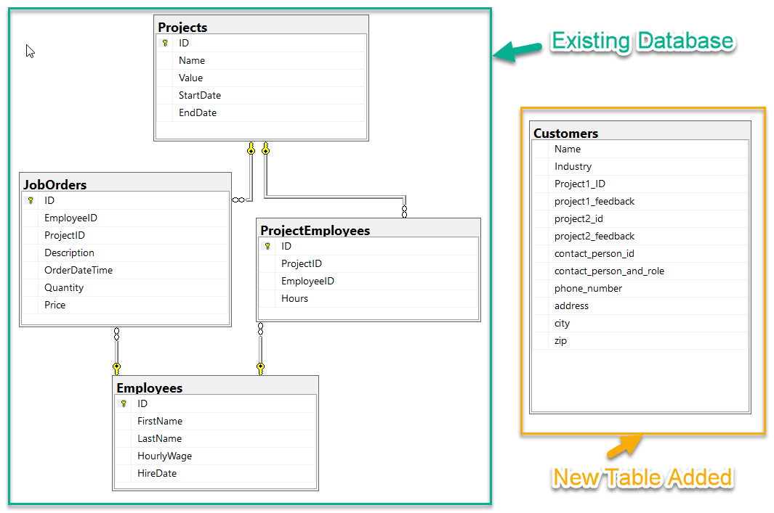 First Normal Form.
The Customers table in the diagram violates all the three rules of the first normal form.
- We do not see any Primary Key in the table.
- The data is not found in its most reduced form. For example, the column ContactPersonAndRole can be divided further into two individual columns - ContactPerson and ContactPersonRole.
- Also, we can see there are two repeating groups of columns in this table - (Project1_ID, Project1_FeedBack) and (Project2_ID, Project2_Feedback). We need to get these removed from this table.

