Mis on binaarfailid?
Binaarfail on fail, mis salvestab andmeid toores binaarvormingus (0 ja 1), täpselt nii, nagu need on mälus, mitte inimloetava tekstina.
Erinevalt tekstifailidest:
• Tekstifail → loetav (nt 123, Hello)
• Binaarfail → ei ole otse loetav (näeb välja nagu juhuslikud baidid)
__________________________________________
Tekstifaili sisu:
123
Salvestatud märkidena: '1' '2' '3'
Binaarfaili sisu:
123 (täisarv)
Salvestatud baitidena (nt 4 baiti mälus)
Miks kasutada binaarfaile?
Eelised
• Kiirem lugemine/kirjutamine
• Väiksem faili suurus
• Täpne mäluesitus (teisendust pole vaja)

Puudused
• Mitte inimloetav
• Vähem kaasaskantav (sõltub süsteemist: lõpupärasus, andmete suurus)
• Raskem siluda

How binary files are used in C
In C, binary files are handled using standard file functions like:
- fopen()
- fread()
- fwrite()
- fclose()

Opening a binary file
FILE *f = fopen("data.bin", "wb"); // write binary
Modes:
- "wb" → write binary
- "rb" → read binary
- "ab" → append binary

Writing to a binary file
int num = 123;
FILE *f = fopen("data.bin", "wb");
fwrite(&num, sizeof(int), 1, f);
fclose(f);
fwrite parameters:
- pointer to data (&num)
- size of each element (sizeof(int))
- number of elements (1)
- file pointer (f)
Reading from a binary file
int num;
FILE *f = fopen("data.bin", "rb");
fread(&num, sizeof(int), 1, f);
fclose(f);
printf("%d\n", num);

Example with struct
Binary files are very useful for saving structures:
typedef struct {
int id;
float grade;
} Student;
Student s = {1, 4.5};
FILE *f = fopen("student.bin", "wb");
fwrite(&s, sizeof(Student), 1, f);
fclose(f);
Reads back exactly the same structure.

Important notes
- Always check if file opened successfully:
if (f == NULL) {
printf("Error opening file\n");
}
- Binary files are machine-dependent:
  - int size may differ
  - byte order (endianness)

🔹 Summary
- Binary files store raw data (not text)
- Used for efficient storage and performance
- In C, handled with fread() and fwrite()
- Common for:
  - saving structs
  - game data
  - images, audio, etc.

fprintf vs fwrite

1. fprintf (text files)
Writes data as human-readable text.
fprintf(file, "%d", num);

Example output in file:
123
Stored as characters: '1' '2' '3'

2. fwrite (binary files)
Writes data as raw bytes (binary).
fwrite(&num, sizeof(int), 1, file);

Example output:
- Not readable (binary data like 0x7B 0x00 0x00 0x00)

Key differences
Feature | fprintf (text) | fwrite (binary)
Format | Human-readable | Raw binary
Speed | Slower | Faster
Size | Larger | Smaller
Portability | Better | Worse (machine-dependent)
Debugging | Easy | Hard

Full example (write + read)

Using fprintf (text)
#include <stdio.h>
int main() {
FILE *f = fopen("text.txt", "w");
int num = 123;
fprintf(f, "%d\n", num);
fclose(f);
// Read back
f = fopen("text.txt", "r");
int x;
fscanf(f, "%d", &x);
fclose(f);
printf("Read from text file: %d\n", x);
return 0;
}

Using fwrite (binary)
#include <stdio.h>
int main() {
FILE *f = fopen("data.bin", "wb");
int num = 123;
fwrite(&num, sizeof(int), 1, f);
fclose(f);
// Read back
f = fopen("data.bin", "rb");
int x;
fread(&x, sizeof(int), 1, f);
fclose(f);
printf("Read from binary file: %d\n", x);
return 0;
}

Tähtis

Tekstifailid:

• Kasutage fprintf, fscanf

• Hea logide, konfiguratsioonide ja loetavate andmete jaoks

Binaarfailid:

• Kasutage fwrite, fread

• Hea:

o struktuuride

o suurte andmekogumite

o jõudluskriitiliste programmide jaoks

_________________________________________

_______________________________________

Mälu vs teksti idee

int 123 mälus → [01111011 00000000 00000000 00000000]

tekst "123" → ['1' '2' '3']

__________________________________________

Lõppkokkuvõte

• fprintf → tekst, loetav, aeglasem

• fwrite → binaarne, kiire, kompaktne

• Kasutage binaarset faili toorandmete või struktuuridega töötamisel

Oluline erinevus

Tekst (fprintf)
- teisendab andmed stringiks
- nt arv → "123"

Raw data (fwrite)
- ei teisenda midagi
- kirjutab otse mälust faili

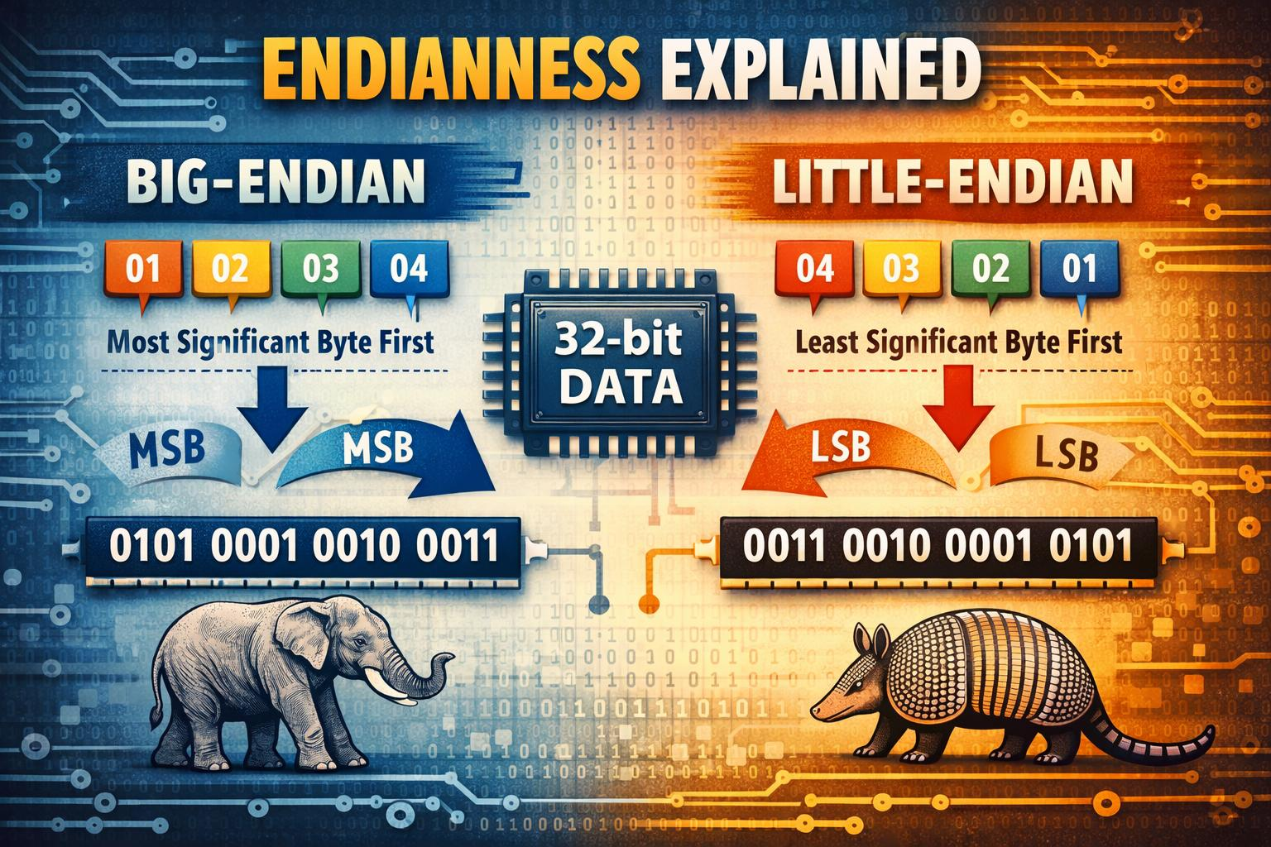

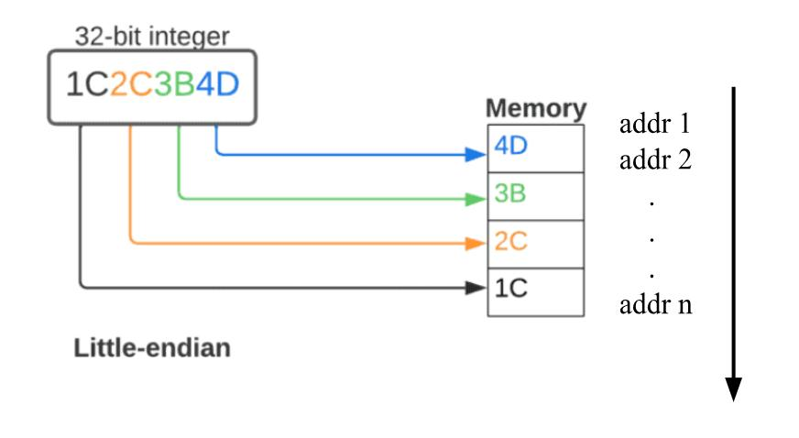

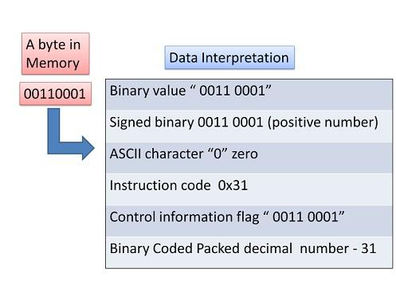

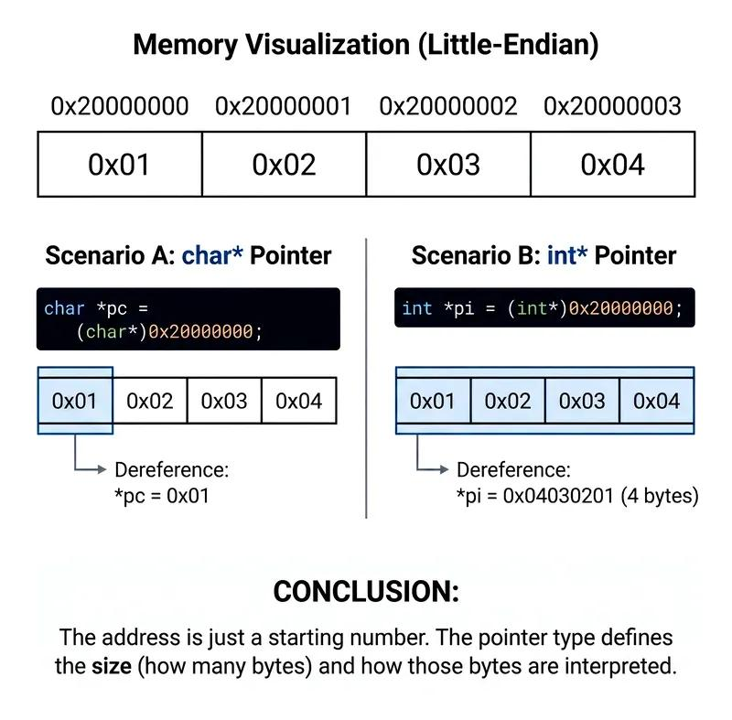

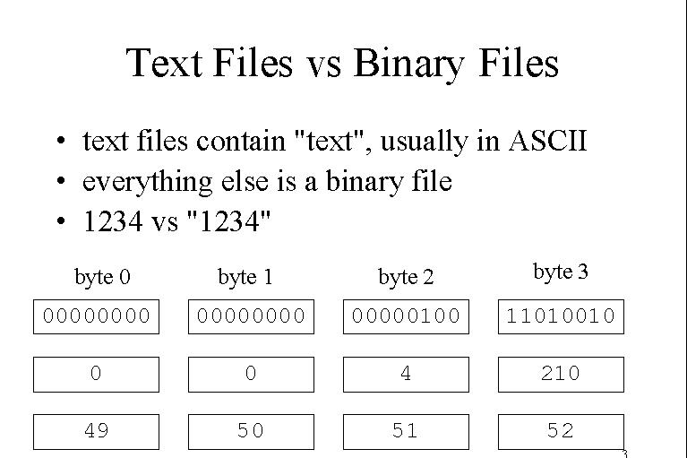

Important

Text files:
- Use fprintf, fscanf
- Good for logs, configs, readable data

Binary files:
- Use fwrite, fread
- Good for:
  - structs
  - large datasets
  - performance-critical programs

Memory vs text idea
int 123 in memory → [01111011 00000000 00000000 00000000]
text "123" → ['1' '2' '3']

Final su

mmary
- fprintf → text, readable, slower
- fwrite → binary, fast, compact
- Use binary when working with raw data or structs

