DEF.A database is an ordered collection of structured information or data, usually stored electronically in a computer system. A database is managed by a database management system.
The most common types of modern databases typically store data in rows and columns that form a table. This data can be easily managed, modified, updated, tracked, and organized. There are several types of databases, each with its own advantages and disadvantages and used for specific tasks. [1]

Relatsiooni andmebaas (Relational database)

This is a type of database in which information is stored in the form of tables consisting of columns and rows. Each row in a table in such a database is a record with a unique identifier called a key. The columns of the table have data attributes, and each record usually contains the value of each attribute, which makes it easy to create relationships between data elements. A relational database is convenient to use when it is necessary to link data elements together and manage them securely and reliably, since the relational model requires a logical data structure: tables, views, and indexes.[2] Relational databases scale vertically. This means that as the amount of data increases, they increase the power of computing processors and the load on the server.[8]
The logical structure differs from the physical structure of a record in that it allows you to work with the physical storage system and therefore not change the data in the tables. Physical and logical structures differ in their operations. Boolean operations allow applications to define requirements for the required content. Physical operations determine how data is accessed and tasks are performed. In order for relational databases to be more accurate and accessible, it is necessary to implement normalization methods. The relational model most effectively maintains data integrity across applications and database instances. Relational databases are excellent for maintaining data integrity across multiple database instances at once.
Four important properties define relational database transactions: atomicity, consistency, isolation, and durability—commonly referred to as ACID.
• Atomicity defines all the elements that make up a complete database transaction.
• Consistency defines the rules for maintaining the correct state of data points after a transaction.
• Isolation keeps the effects of a transaction invisible to others until it is committed, to avoid confusion.
• Durability ensures that changes to data become permanent after the transaction has been committed. [7]

Relational databases are created in a database management system based on SQL, which is the most common standardized language used to access databases. SQL is based on relational algebra algorithms and a clear mathematical structure. The ANSI SQL standard is supported by all popular relational database engines. Some kernels also include extensions to the ANSI SQL standard that support features specific to those kernels. SQL is used to insert, update, and delete rows of data, retrieve datasets for transaction processing and analytical applications, and manage all aspects of the database.[6][9] Microsoft Access is also a relational database management system created by Microsoft Corporation, which has a wide range of features, including linked queries, links to external tables and databases. Thanks to the built-in VBA language, you can write applications that work with databases in Access.[16] Relational databases are in demand in many organizations, where they are used for accounting, tracking the number of items in stock, and managing personnel data for suppliers, partners, and customers. They have also found their application in Internet technologies for organizing the storage of registered user accounts, storing message texts in various areas of the Internet, such as forums, social networks, and news feeds.[28]

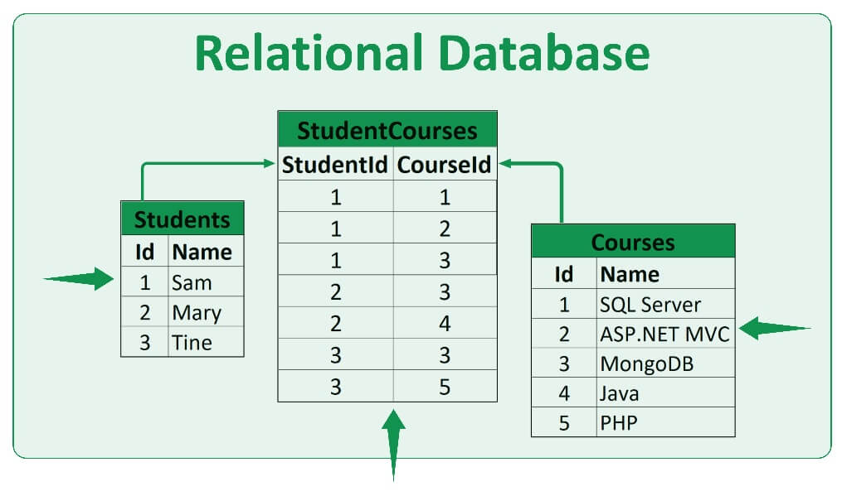
Joonis 1.1 Relatsiooniandmebaasi näiteks

Prosit+:
• The relational database model does not require complex queries as it does not have query processing or structuring, so simple SQL queries are enough to handle the data.
• Users can easily access or retrieve their required information within seconds without compromising the complexity of the database. SQL is used to execute complex queries.
• Relational databases are strictly defined and well organized so that data is not duplicated. Relational databases are accurate due to their structure, without data duplication.
• Relational database management systems are also widely used to ensure data integrity as they ensure consistency across all tables. Data integrity ensures features such as accuracy and ease of use.
• Data is secure as the relational database management system allows only authorized users to directly access the data. No unauthorized user can access the information.
• Multiple users can access the database to get information at the same time and even when the data is being updated.
• Database normalization also ensures that the structure of a relational database is not variable and can be manipulated accurately.
Disadvantages-:
• Managing a relational database becomes difficult over time as the data grows.
• A relational database consists of rows and columns, which requires a lot of physical memory, since each operation performed depends on a separate storage space. Physical memory requirements can increase as the amount of data increases.
• When a relational database is used on multiple servers, its structure changes and becomes difficult to manage, especially when the amount of data is large. Due to this, the data is not scalable across different physical storage servers. This ultimately affects its performance, i.e., data missing, loading time, etc. As the database becomes larger or is distributed across a larger number of servers, it has negative consequences, such as latency and availability issues, which affect overall performance.
• Relational databases can only store data in a table format, which makes it difficult to represent complex relationships between objects. This is a problem because many applications require more than one table to store all the necessary data that their application logic requires. [11]

Relationships between tables
Relationships between two or more tables are created using primary and foreign keys. A primary key is a field that is used to uniquely identify each record in a table. A foreign key is a field or fields in one table that refer to the primary key of another table. There are three types of relationships between tables: one-to-one, one-to-many, and many-to-many.
One-to-one means that a row in one table can be linked to a single row in another table. For example, you can create a table called "students" that contains a student's full name and date of birth, and another table called "University data" that contains their matrix code and university letter.

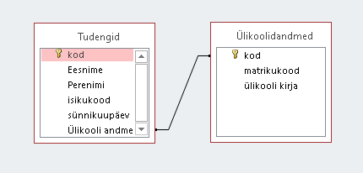

Joonis 1.2 One-to-one relationship, for example

This type of relationship is considered one-to-one, as each student has a unique matrix code and email address, and each university's data belongs to only one student.
One-to-many means that a row in one table can be linked to many rows in another table. For example, the table "Actors" contains the personal information of an actor, and the table "Roles" contains the name of a character and the movie in which the character was.

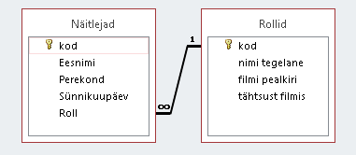

Joonis 1.3 Seos üks-mitmele
This relationship is considered one-to-many because an actor can play more than one character in different films, but only one person can play the character throughout the entire film.
Many-to-many means that a row in one table can be related to many rows in another table, and vice versa. However, such a relationship cannot be created directly. It is done through a third table. Examples of many-to-many relationships are the tables "Students" and "Subjects" according to how many students can be in a class and how many classes a student can attend. [17]

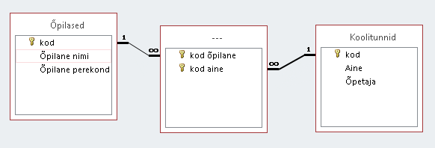
Joonis 1.4 Seos mitu-mitmele

Normaliseerimine

Normalization is a database transformation technique that minimizes data redundancy and eliminates the undesirable consequences of redundancy, such as various outliers, performance degradation, and makes data management more flexible and convenient. When eliminating redundancy, you need to divide a large table into smaller ones and connect them using relationships. In a non-normalized form, the columns and values ​​of a table can store information about two or more entities. Normalization has 9 forms, each containing its own rules and criteria. It takes the table to the next form, and by following the rules, it is possible to avoid various anomalies and bring the table to a minimum redundancy. [18][19]

Unnormalized form (UNF): In this form, the table has many outliers and duplicate values.[29]

Tabel 1.1 Näiteks normaliseerimata vorm
Inimine | E-mail
Kentaro Miura | Isiklik post berserk1989@gmail.com; Töö post Miura.Kentaro@gmail.com
Edward Elric | Ed.ferrum@gmail.com
Edward Elric | Ed.ferrum@gmail.com
Thorkell Long | IamBig@gmail.com; Thorkell.Long@gmail.com

First Normal Form (1NF): In this form, there must be no duplicate rows in a table, each cell must have a non-combined value, and each record must be unique.[30]

Tabel 1.2 Näiteks esimene normaalvorm
Inimene | E-mail | Tüpp
Kentaro Miura | berserk1989@gmail.com | Isiklik post
Kentaro Miura | Miura.Kentaro@gmail.com | Töö post
Edward Elric | Ed.ferrum@gmail.com
Thorkell Long | IamBig@gmail.com
Thorkell Long | Thorkell.Long@gmail.com

Second Normal Form (2NF): In this form, a table must be in first form and must have one column with a primary key.[31]

Tabel 1.3 Näiteks teine normaalvorm
Number | Inimene | Eriala | Kirjeldus
1 | Kentaro Miura | Kunstnik | Joonistab Jaapani koomikseid
2 | Edward Elric | Keemik | Uurib aine koostist ja selle omadusi
3 | Thorkell Long | Ehitaja | Ehitab hooneid

Third Normal Form (3NF): In this form, a table must be in the second form and must not have transitive dependencies, that is, non-key columns must not depend on the values ​​of other non-key columns.[32]
To translate Table 1.3 into third form, it must be split into two tables, since the description of the occupation is not related to the person himself.
Tabel 1.4 Tabel inimeste kolmandal normaalvormil
Number | Inimene | Eriala
1 | Kentaro Miura | 1
2 | Edward Elric | 2
3 | Thorkell Long | 3
Tabel 1.5 Tabel erialade kolmandal normaalvormil
Number eriala | Eriala | Kirjeldus
1 | Kunstnik | Joonistab Jaapani koomikseid
2 | Keemik | Uurib aine koostist ja selle omadusi
3 | Ehitaja | Ehitab hooneid

Boyce-Codd Normal Form (BCNF): In this form, the table must be in third form and the key attributes of the composite key must not depend on the key attributes.[33]
Tabel 1.6 Tabel õpilased
Number õpilane | Õpilane täisnimi
1 | Kentaro Miura
2 | Edward Elric
3 | Thorkell Long
Tabel 1.7 Tabel ainete
Number aine | Aine | Õpetaja
1 | Matemaatika | E.Vasiljeva
2 | Keemia | A.Kuld
3 | Kehalise kasvatus | K.Miyamoto
Tabel 1.8 Suhtlemine õpilaste ja õppeainete vahel
Number õpilane | Number aine
1 | 1
1 | 3
2 | 1
2 | 2
3 | 3
Fourth Normal Form (4NF): In this form, a table must be in third form (if the primary key is simple) or Boyce-Codd form, and the table must not have multivalued dependencies.[34]
Fifth Normal Form (5NF): In this form, a table must be in fourth form, and the table must specify 12 complex and unusual join dependencies on the potential key of the table.[35]
Domain Key Normal Form (DKNF): In this form, a table must be in fifth form, and each constraint imposed on the table is a logical consequence of the constraints imposed on a certain value attribute that appears to be a candidate key.[36]
Sixth Normal Form (6NF): A table in this form cannot be further decomposed without loss.[37]

NoSQL andmebaas
NoSQL databases are also called non-relational databases that store data in a format other than relational tables, but NoSQL databases can handle huge amounts of rapidly changing unstructured data. However, NoSQL databases can be queried using idiomatic language APIs, declarative structured query languages, and pattern-based query languages. The main advantage of a NoSQL database is scalability and flexible schemas. While relational databases scale vertically, NoSQL databases scale horizontally. This means that as the data grows, additional databases are added or the database is distributed across smaller nodes.
A relational database management system is based on the SQL language, which allows users to access and manipulate data in highly structured tables. This is the underlying model for database systems such as MS SQL Server, IBM DB2, Oracle, and MySQL. However, in the case of NoSQL databases, the syntax for accessing data may vary from database to database.
Unlike relational database management systems, NoSQL databases can store data without defining a schema in advance, allowing you to quickly navigate and iterate by defining the data model as you work. This approach can be useful for meeting specific business requirements such as graphs, columns, documents, or for use as a key-value store.
There are different types of NoSQL databases depending on their data model. The main types are document, key-value, column-family, and graph.

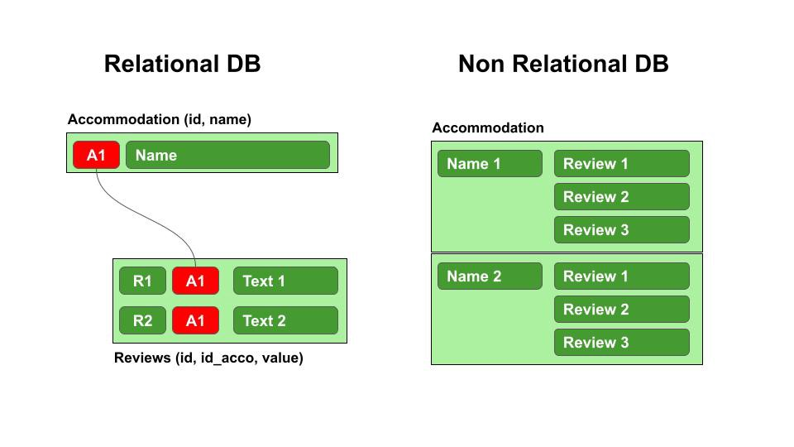
Joonis 1.5 Erinevus relatsioonilise ja NoSQL andmebaasi vahel
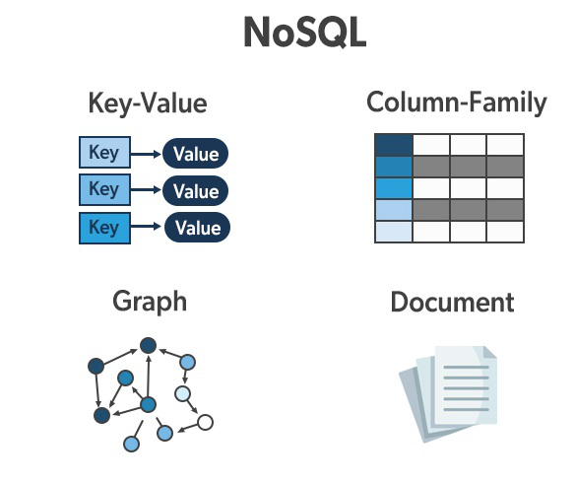
Joonis 1.6 Tüübid NoSQL andmebaas

Pros+:

• NoSQL databases are very flexible as they can store and combine any type of data, both structured and unstructured, unlike relational databases which can only store data in a structured manner.

• NoSQL databases allow you to dynamically update the schema to adapt to changing requirements while ensuring that it does not cause any disruption or downtime to your application.

• Instead of scaling up by adding servers, NoSQL databases can scale horizontally using standard hardware. Scale-out allows NoSQL databases to become larger and more powerful, making them the preferred choice for growing data sets.

• NoSQL databases automatically replicate data across multiple servers, data centers, or cloud resources. This in turn reduces latency for users regardless of their location. This feature also helps reduce the burden of database administration, which frees up time and allows you to focus on other priorities.

• NoSQL databases are designed for distributed data stores that require large amounts of storage. This is what makes NoSQL an ideal choice for big data and real-time web applications.[8]

Cons-:

• There is no standard that defines the rules and roles of NoSQL databases. The design and query languages ​​of NoSQL databases vary widely across NoSQL products—much more so than traditional SQL databases.

• Backups are a drawback for NoSQL databases. While some NoSQL databases, such as MongoDB, offer some tools for backup, these tools are not mature enough to provide a complete data backup solution.

• NoSQL prioritizes scalability and performance, but when it comes to data consistency, NoSQL doesn’t take much into account, which makes it a little unsafe compared to a relational database, e.g., in NoSQL databases, if you insert the same data set again, it will retrieve it without errors, while relational databases ensure that no duplicate rows end up in the database. [12]

KASUTATUD KIRJANDUSE LOETELU
- https://www.oracle.com/cis/database/what-is-database/#WhatIsDBMS (veebiartikkel)

- https://www.techtarget.com/searchdatamanagement/tip/NoSQL-database-types-explained-Column-oriented-databases (veebiartikkel)

- https://www.oracle.com/cis/database/what-is-a-relational-database/ (veebiartikkel)
- https://www.oracle.com/cis/database/nosql/what-is-nosql/ (veebiartikkel)
- https://dev.mysql.com/doc/refman/5.7/en/what-is-mysql.html (veebiartikkel)
- https://en.wikipedia.org/wiki/Document-oriented_database (veebiartikkel)
- https://databasetown.com/relational-database-benefits-and-limitations/ (veebiartikkel)
- https://technologypoint.in/advantages-and-disadvantages-of-nosql-databases/ (veebiartikkel)

- https://hostingdata.co.uk/nosql-database/ (veebiartikkel)
- https://www.freecodecamp.org/news/the-pros-and-cons-of-different-data-formats-key-values-vs-tuples-f526ad3fa964/ (veebiartikkel)

- https://www.youtube.com/watch?v=pYRPYfqWiUo&t=223s (video)

- https://www.guru99.com/database-normalization.html (veebiartikkel)
- https://www.heavy.ai/technical-glossary/in-memory-database (veebiartikkel)

- https://en.wikipedia.org/wiki/In-memory_database (veebiartikkel)
- https://phoenixnap.com/kb/multi-model-database (veebiartikkel)
- https://euroteq.eurotech-universities.eu/ (veebiartikkel)
- https://elearning.sumdu.edu.ua/free_content/lectured:eaeb836f0e4d45b9a509d6c3f79a9ecf6ab05395/20141129091116/49214/index.html (veebilehekülg loengu)
- https://www.mongodb.com/databases/what-is-an-object-oriented-database (veebiartikkel)

- http://mech.math.msu.su/~shvetz/54/inf/databases/chApplications.xhtml (veebillehekülg)
- https://www.pragimtech.com/blog/contribute/article_images/2220211210231003/what-is-a-relational-database.jpg (pild)
- https://media.geeksforgeeks.org/wp-content/uploads/20220405112418/NoSQLDatabases.jpg (pild)
- https://miro.medium.com/max/960/1*A-ggJLL9Q_w1zt87RV8uSg.jpeg (pild)
- https://miro.medium.com/max/768/1*Jhy4UUszi7neyQFhfT6Eow.png (pild)
- https://media.geeksforgeeks.org/wp-content/uploads/20200522103130/Document3.png (pild)
- https://www.influxdata.com/wp-content/uploads/Key-Value-Database.jpg (pild)

