TALLINN UNIVERSITY OF TECHNOLOGY School of

Information Technologies Department of Computer Systems

Study Centre for Computer Systems

xxxxxxx23MVEB

IAX0583 Programming I

**Tabulating function y = f(x)**

Homework I

Supervisor: Vladimir

Viies

Tallinn 2023

**Declaration of originality**

I hereby certify that I am the sole author of this thesis and that no part of this thesis has been published or submitted for publication. All works and major viewpoints of the other authors, data from other sources of literature and elsewhere used for writing this paper have been referenced.

Name: xxxxx

Date: 30.10.23

2

**List of figures**

Figure 1. 2. Y = f(x) Plot.............................................................................................. 5, 6

Figure 3. UML diagram of the application algorithm.................................................. 8

Figure 4. 5. Program running screenshots.................................................................... 9

3

**Table of contents**

Declaration of originality........................................................................................................ 2

List of figures.......................................................................................................................... 3

Table contents ........................................................................................................................ 4

Task description ..................................................................................................................... 5

Function plot ......................................................................................................................... 6

Program description.............................................................................................................. 8

Algorithm................................................................................................................................ 9

Screenshots............................................................................................................................. 10

4

**Task description**

**Method**

Given the initial values of the argument x A, the step H, the step coefficient C and the number of steps N.

Conditions H > 0; C >= 1; N > 0.

The value of the function y is calculated in points:

A  
A + H  
A + H + CH  
...  
A + H + CH + .. + CN-1H.

**Function**

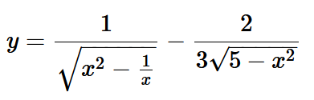

5

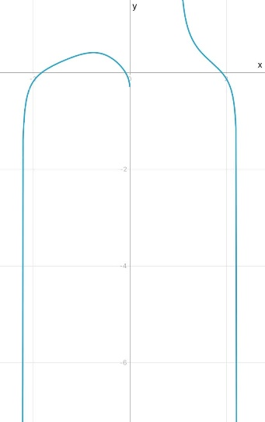**Function plot**

Figure 1;

6

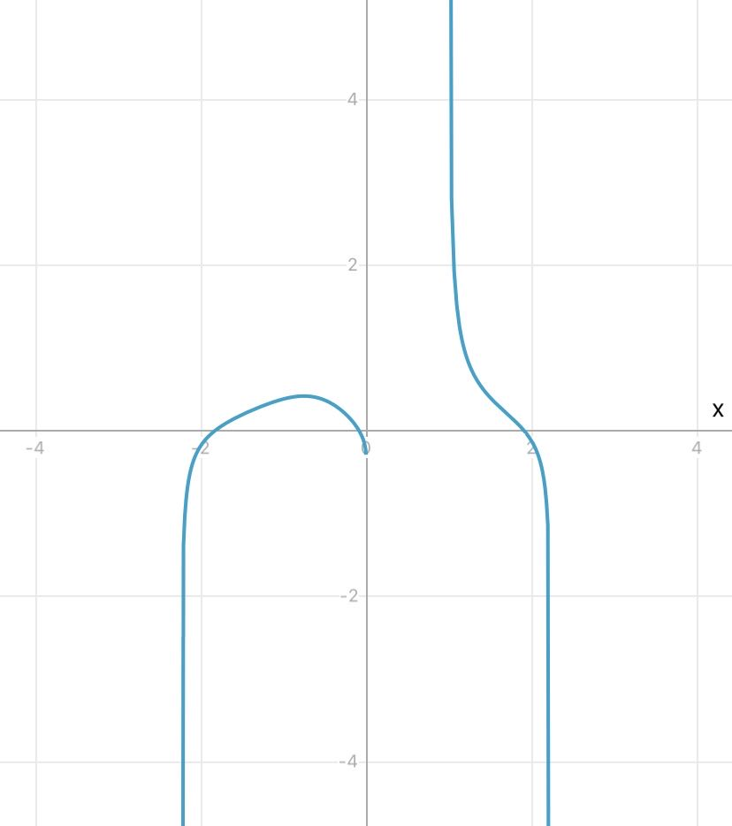

Figure 2;

7

**Program Description**

1. **Libraries**: The code starts by including libraries. **stdio.h** is needed for input and output, and **math.h** is needed for mathematical operations like square root and power.
2. **Function Definition**: A function **calculateFunction** is defined, which takes a number as input and calculates a specific formula based on that number.
3. **Main Function**: This is where the program execution starts. Inside the **main** function:

a. The program asks the user to input four values: the initial value **A**, the step size **H**, the step coefficient **C**, and the number of steps **N**.

b. The program checks if the values entered follow certain rules: **H** should be greater than 0, **C** should be greater than or equal to 1, and **N** should be greater than 0. If any of these conditions are not met, the program prints an error message and stops.

c. If the input values are valid, the program proceeds to calculate the value of the function at each point based on the specified steps. It uses a loop to iterate over the specified number of steps.

d. Inside the loop, it calculates the current value of **x** and then uses the **calculateFunction** function to find the value of the function at that point.

e. The program then prints the value of the function at each point.

4. After all calculations program ends.

8

**Algorithm**

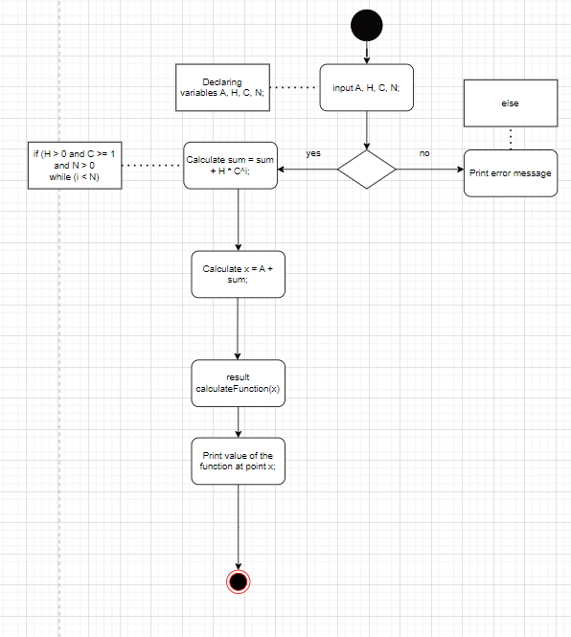

Figure 3;

9

**Screenshots**

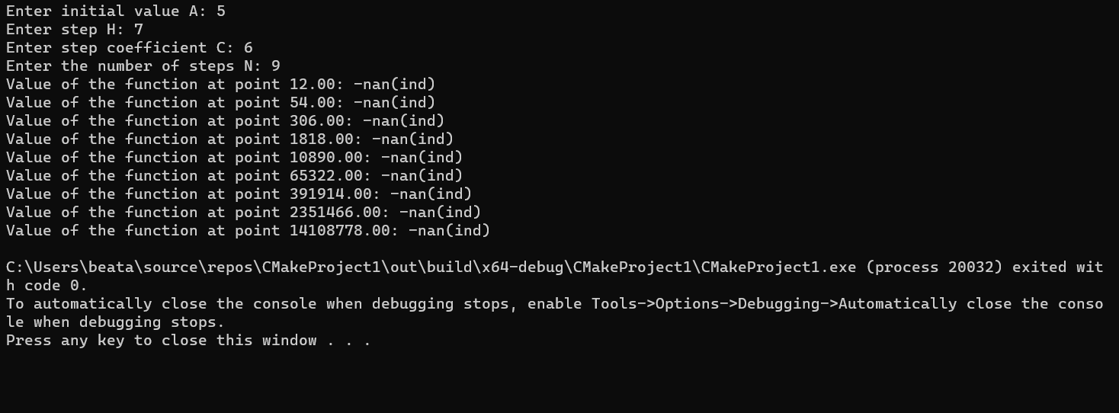

Figure 4. Program running normally.

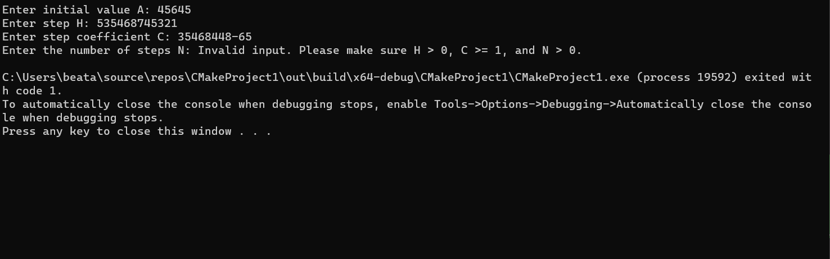

Figure 5. Program error.

10