Python is a high-level, interpreted programming language known for its clear syntax and readability, making it easy to learn and use. It supports multiple paradigms—including procedural, object-oriented, and functional programming—and is widely used in web development, data science, automation, AI, and more.
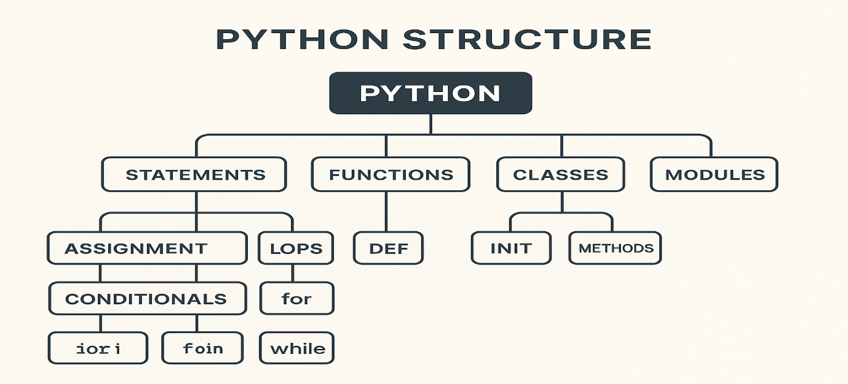

Python Statements

1. Assignment Statements
Used to store values in variables.
x = 10
name = "Alice"
pi = 3.14

2. Conditional Statements
Used to make decisions.
if condition:
...
elif other_condition:
...
else:...
Example: if age >= 18:
print("Adult")
else:
print("Minor")

3. Loop Statements

for loop Iterates a fixed number of times or over a sequence.
for i in range(5):
print(i)

while loop Runs while when condition is true.
while x > 0:
x -= 1

4. Break / Continue / Pass
break # exit loop
continue # skip to next iteration
pass # placeholder, does nothing

🔧 Python Functions

1. Defining a Function def greet():
print("Hello!")

2. Function with Parameters def greet(name):
print(f"Hello, {name}!")

3. Function with Return Value def add(a, b):
return a + b

4. Default Parameters def power(x, exponent=2):
return x ** exponent

5. Keyword Arguments print(power(x=3, exponent=4))

6. Variable Number of Arguments args (positional)
def total(*numbers):
return sum(numbers)

kwargs (keyword) def show_info(**info):
print(info)

7. Anonymous (Lambda) Functions
square = lambda x: x * x

