Bubble sort

Pseudocode

BEGIN the beginning of the algorithm
Input array A
n = length(A)
Sorted = True
j = 0

WHILE Sorted = True and j<n-1 DO:
swap = 0
FOR i=0 TO n-(j+1) STEP 1 DO:
IF A[i] > A[i+1] THEN:
swap(A[i],A[i+1])
swap = swap +1
END-IF
IF swap = 0 THEN:
Sorted = False
END-IF
j = j+1
END-WHILE

Output A
END the end of the algorithm

Flowchart

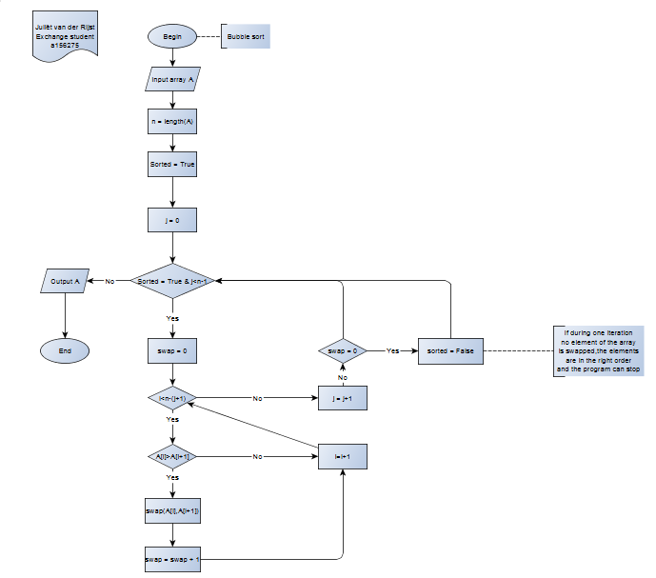

Birthday

Calculates on which day of the week you were born.

Pseudocode

BEGIN the beginning of the algorithm
Input DD-MM-YYYY

D = YYYY-1900
R = Remainder (D/4)
I = IntegerDevision(D/4)
Y = 365*R + (365*3+366)*I

SELECT
CASE MM <= 2:
IF MM = 2 THEN
M = 31
ELSE
M = 0
END-IF
END-CASE
CASE 2<MM<=7:
M = 59
FOR i=2 TO (MM-1) STEP 1 DO
IF i is even THEN
M = M + 31
ELSE
M = M + 30
END-FOR
IF R=0 THEN:
M = M +1
END-IF
END-CASE
ELSE
M = 212
FOR i=7 TO (MM-1) STEP 1 DO
IF i is odd THEN
M = M + 31
ELSE
M = M + 30
END-FOR
IF R=0 THEN:
M = M +1
END-IF
END-SELECT

Total = Y + M + DD

RTotal = Remainder(Total/7)

SELECT
CASE RTotal= 0:
Birthday = Monday
END-CASE
CASE RTotal= 1:
Birthday = Tuesday
END-CASE
CASE RTotal= 2:
Birthday = Wednesday
END-CASE
CASE RTotal= 3:
Birthday = Thursday
END-CASE
CASE RTotal= 4:
Birthday = Friday
END-CASE
CASE RTotal= 5:
Birthday = Saturday
END-CASE
ELSE
Birthday = Sunday
END-SELECT

Output Birthday
END the end of the algorithm

- a1=a2, k1=k2, p2>=p1

L = p2 – p1

p1,k1,a1| p1+1 | ... | p2-1 |p2,k1,a1

- a1=a2, k2>k1

L = ∑ lk_{i} + lk1-p1 + p2 = ∑ lk_{i} + p2 – p1
i = k1+1,k2-1 i = k1,k2-1

p1,k1,a1| p1+1 | ... | lk(k1,a1) | k1+1 | ... | k2-1 | 1 | ... |p2-1 | p2,k2,a1

- a2>a1

L = ∑ la_{i} + ∑ lk_{i} + ∑ lk_{i} + p2 - p1
i = a1+1,a2-1 i = k1,12 i =1,k2-1

p1,k1,a1 | k1+1 | ... | 12 | a1+1 | ... | a2-1| 1 | 2| ... | k2-1 | p2,k2,a2

01.01.1900 - MONDAY

Leap year:

((a mod 4 ) = 0 ) and (((a mod 100) != 0) or ((a mod 400) = 0)))

Flowchart

