TALLINN UNIVERSITY OF TECHNOLOGY

Department of Mechanical and Industrial Engineering.

**Iman Alami 192906MVEB11**

**11MVEB PROGRAMMING 1**

Function **Y = f(x)** Calculation

**Homework 1**

**Author´s Declaration of Originality**

I hereby certify that the work I am the sole author of this thesis and that no part of this thesis has been published or submitted for publication. All works and major viewpoints of the other authors, data from other sources of literature and elsewhere used for writing this paper have been referenced.

**Table of contents**

**Author’s Declaration of Originality**……………………………………………………………...

**Table of Contents**………………………………………………………………………………….

**Assignments**……………………………………………………………………………………......

Generating the task……..…………………………………………………………………….

Understanding the task…...…………………………...………………………………………

**Function y = f(x)**…………………………………………………………………………………...

**Program description**……………………………………………………………………………....

UML-chart……………………………………………………………………………………

Step-by-step guide……………………………………………………………………………

Program output……………………………………………………………………………..…

**Assignments**

Generating the Task:

I generated the task from the link our teacher provided us with based on my student code.

**6.**  User inputs a starting value A, step H and upper limit of the function value YM.  
 The following conditions have to be true: H > 0.  
 The function value y will be calculated in the following points:  
A  
A + H  
A + 2H  
A + 3H

while the condition y < YM holds true, however not more than 15 times.

Understanding the Task:

Based on the methods and task generator, I understood the task.

A user has to input starting value A. Then it has to input H, which is step that is going to help the program find all x. H also has to be bigger than zero. User must finally input YM, which is the limit a user can set, over what y cannot be bigger. Finally program has to calculate all x and f(x). Other limitations are applied in this task. Number of x cannot exceed 15.

**Function y = f(x)**

Equation:

y= $\frac{\sqrt{1- \sqrt{x^{3}-7}}}{x^{3}+ \sqrt{x}}$

Graph:

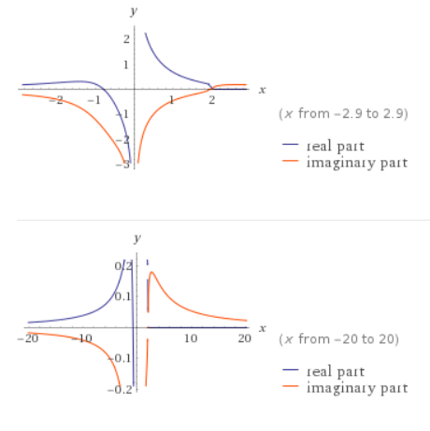

**Program description**

UML chart:

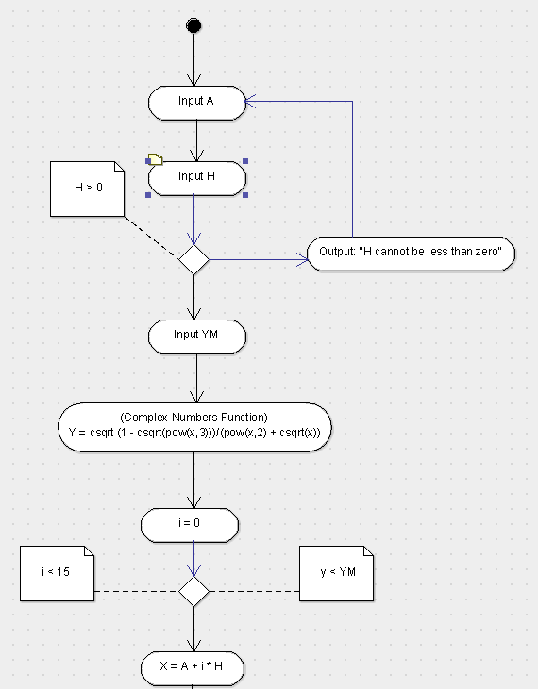

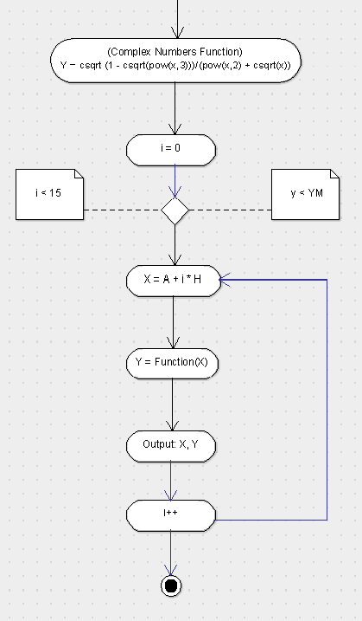

Step-by-step Guide:

1. Program starts with it asking a user to input the value of necessary variables A, H and YM. After the program reads H, it makes sure it’s value is more than 0. Otherwise the program will explain that there’s a problem with variable’s value and ask for it’s value again.
2. Program defines y with a function, where y is a complex number.
3. Program starts initiating x’s values by a function x = A + i * H and makes sure number of x does not exceed then limit 15.
4. Program calculates value of y based on x (y(x)) and makes sure the value is not bigger than YM.
5. Program outputs all x and their values.

Program output:

