TECHNICAL UNIVERSITY OF TALLINN

Faculty of Information Technology

Department of Computer Systems

IAX0583 Programming I

**Calculating function** 𝒚=(𝒙)

Homework I

20xx Tallinn

# Author’s declaration of originality

I hereby certify that I am the sole author of this thesis and that no part of this thesis has been published or submitted for publication. All works and major viewpoints of the other authors, data from other sources of literature and elsewhere used for writing this paper have been referenced.

# Table of Contents

Author’s declaration of originality 2

Table of Contents 3

Assignment 4

Generating task 4

Understanding task 4

Function y = f(x) 5

Program description 6

UML-chart 6

Step-by-step 7

Program output 7

# Assignment

## Generating task

This was surprisingly tricky part of the task, and I'm not even sure if I have done the right one. There were many options to choose, but I chose to go with one introduced in presentation of Lab2.

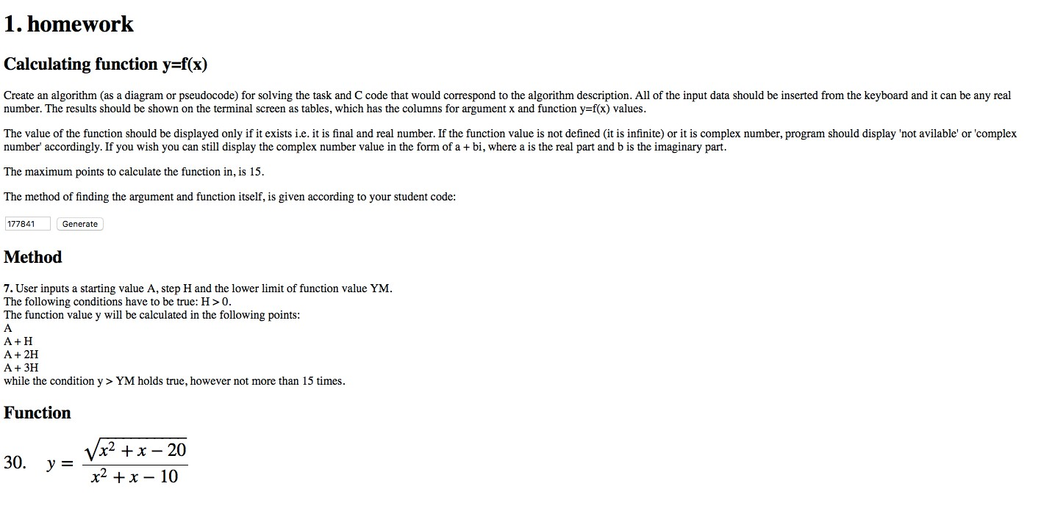

Figure 1: picture of assignment

## Understanding task

I understood that I have to

1. Get user input for starting value **A**, step **H** and minimium value of f(x) **YM**
2. Implement two algorithm, one that calculates value of **x** and another that calculates value of **f(x)**
3. Check if definitions of f(x) hold and if f(x) > YM
4. Print values of f(x) or corresponding 'errors'.

# Function y = f(x)

𝑥!+𝑥−20

𝑓 𝑥 = 𝑥!+𝑥−10

𝑅𝑜𝑜𝑡𝑠: 𝑥=−5 𝑜𝑟 𝑥 = 4

𝐷𝑜𝑚𝑎𝑖𝑛: {𝑥∈ℝ ∶ 𝑥 ≤−5 𝑜𝑟 𝑥≥4}

𝑅𝑎𝑛𝑔𝑒: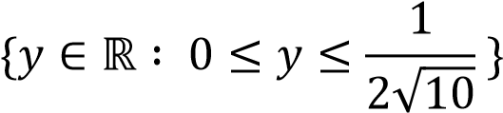

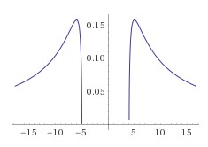

Figure 2: graph of f(x)

# Program description

In this section I'm going to briefly explain how my program gets results.

## UML-chart

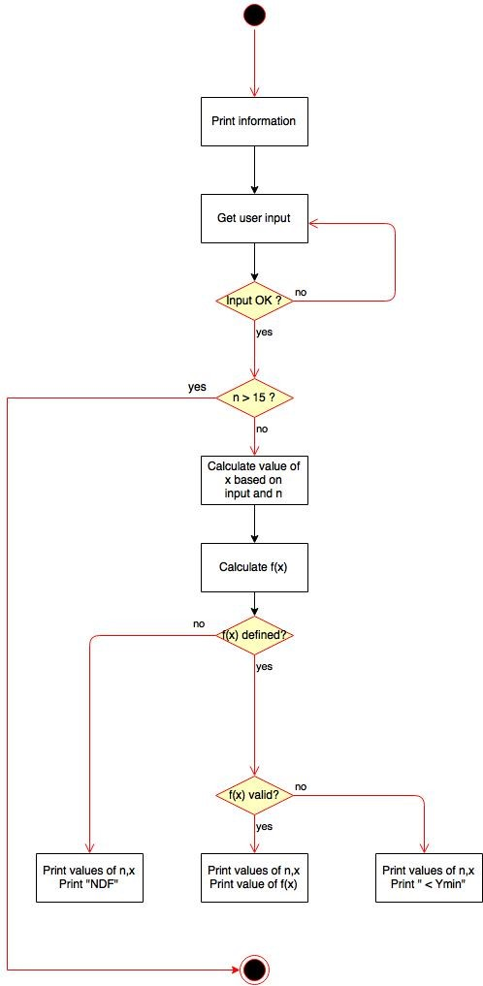

Figure 3: UML chart of program flow

## Step-by-step

Program starts with a greeting user, and then print information about itself. It introduces user to a function f(x), which helps user give proper input. (To be fair, f(x) is'nt most meaningful function to this task, because its range is so restricted.)

After introdutions program asks user input. It asks user to give starting value **A**, step **H** and minimium value for f(x) **YM**. There is restiction defined for value H in assignment, so program checks if value is legal; otherwise it asks it again. There IS NO restriction for YM, it prints range to user so its users responsibility to give suitable value for it. Next program defines value for **n,** which is needed to calculate values for x. Theres is also restriction to n, which is n can have a maximium value 15. This program doesnt ask user input for n; it starts with n=1 and stops n=15. This is a starting point for loop. At this state program has all the parameters it needs to calculate value for x. X is calculated as follows:

𝑋𝓃=𝐴+(𝑛−1)𝐻

After value of x is calculated, program calculates value for f(x). It does that even if f(x) isnt defined with given value of x.

Now program has all the values it needs for output; it has value of n, value of x and value of f(x). First program prints value of n and x, and THEN it checks if value of f(x) is legal. If value is not defined in real numbers, it prints "NDF", not defined. If value is under YM, it prints " < YMin". If value is legal, it prints value of f(x) in decimal.

After program has printed 15 rows, it kills itself.

## Program output

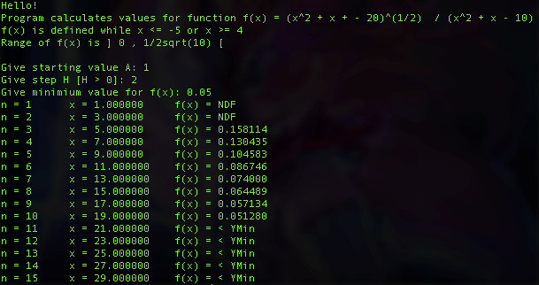

Figure 4: program output

**NB! Programmi kood on lisatud eraldi failiga, kuid võib mahutada selle ka aruandesse.**

**Igal juhul peab see sisaldama funktsioone ja komentaare.**