Evaluation of program language
- Efficient translation
- Efficient execution
- Writeability
- Simplicity- all features of the language should be easy to learn and master
- Expressiveness
- Definiteness
- Readability
- Reliability- static and dynamic checking
- Static during compile
- Dynamic during execution
overloading the operator or name may impair reliability
Evaluation of programming language (per Horowitz and Liskon)

ESSENTIAL CHARACTERISTICS
- Well defined syntactic and semantic definition of language
- Reliability
- Fast translation
- Efficient object code
- Orthogonality
- Machine independence

DESIRABLE CHARACTERISTICS
- Provability
- Generality
- Consistency with commonly used notations
- Subsets
- Uniformity
- Extensibility (ease to add features)
Language evaluation cont.
A:
• Expressivity- readability
• Well defined- syntax, semantics
• Data types & structures
• Modularity
• I/O facilities
• Portability
• Efficiency
• Pedagogy- easy to teach & learn
• Generality- useful in wide range of applications

B:
• Readability :
- Simplicity
- Orthogonality
- Control statements
- Data structures
- Syntax
• Writeability:
- Simplicity
- Orthogonality
- Support for abstraction
• Reliability:
- Type checking
- Exception handling
- Readability/ writeability
- Aliasing – 2 different ways to refer to the same spot in memory/storage
• Cost:
- Training
- Code development
- Compilation
- Execution
- Maintenance

Language design
A:
• Focus on one well known feature at a time, (could be basic as data type)
• Examine many alternative features designed by others & choose the best, rejecting those that are inconsistent
B:
• Choose specific application (logic, financial, etc.)
• Keep design committee small
• Choose precise design goals
• Release versions to small sets of interested people
• Revise language definition
• Attempt to build compiler & write formal language definition- semantics
• Revise language definition
• Produce clear and concise manual
• Provide "production quality" compiler and wide distribution
• Write primers explaining language

Language processors
• Computers- integrated set of algorithms & data structures capable of storing and executing programs
• Composite → actual (hardware) computer-wires and circuits
• Computer → software simulated computer
programming language is implemented by developing a translator capable of transforming programs in one language into machine language of some computer where it can be executed correctly

STATE
• Instructions- represent state transition via program execution
• You have a choice: implement with hardware, (quick yet inflexible)
implement with software, (slow and flexible)

COMPUTER ORGANIZATION
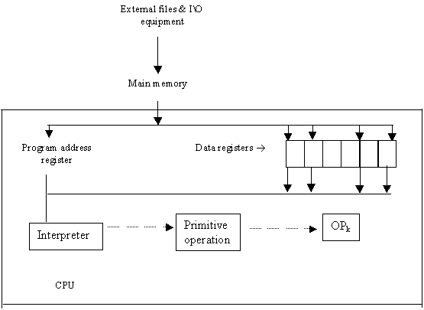
Operations: Sequence control how do we decide which instruction to take next
Note: control sequence changes accomplished by the program address register
Interpreter
• Fetch op code
• De-code op code
• Fetch necessary operands
• Branch to primitive (OP_{k})
• Then repeat until the end of the program
COMPUTER AS A MULTI-LEVEL MACHINE:
Each level supported by the level below it:
level 5 problem oriented language
translated by compiler
level 4 assembly language level
translated by assembly
level 3 operating system
partial interpretation by OS
level 2 conventional machine language
interpreted by micro-program
level 1 micro-programming
directly executed by hardware
level 0 digital logic
gates & transistors,
program address registers
TRANSLATION VS. INTERPRETATION
• Translation: program written for level n machine translated to level 1 machine
• Advantages:
-statements decoded ONCE
-efficient execution
• Disadvantages:
-space consumption
• Interpretation: program written for level n + 1 is executed on level n machine
• Advantages:
-space conservation
• Disadvantages:
-execution
TRANSLATORS
• Compiler: high level→ machine
• Assembler: one to one, assembly → machine
• Loader: relocatable version of machine code → machine code
• Link editor: combines collections of relocatable programs → single relocatable machine program
• Pre-processor: extended language → standard language

