IAG0450 - Home task
For the course homework there are two alternatives: to create a compilator for a general purpose programming language or a SQL translator for a more specialized language.

General purpose language
1.Choose any procedural or object oriented programming language (except C) or make up your own syntax.
2.Define vocabulary for the language using Flex (or any alternative).
3.Define grammar rules for the chosen language using GNU Bison (or any alternative).
Example on C can be seen here: http://www.lysator.liu.se/c/ANSI-C-grammar-y.html
4.Write enough functionality to be able to run one of the final tasks.
5.To demostrate the newly created language, realize one of the given algorithms:
  - Bubblesort b. 99-bottles-of-beer http://www.99-bottles-of-beer.net/

Domain specific language
- Create a language for storing (and manipulating) geometry objects in Cartesian coordinate system. You need to have few of the geometry data types like (but not limited to) point, triangle, rectangle, circle etc. Language should be capable of defining new such objects and doing some operations on them, these are up to you ( for example you could have functions like Area(), Perimeter() etc).
- Define vocabulary for the language using Flex (or any alternative).
- Define grammar rules for the language using Bison (or any alternative).
- Write enough functionality that it could run a simple program.

SQL Translator
- Make up a language for specific area or task of your choice. An example and a possible choice is a language for managing library.
- Create a SQL translator using GNU Bison (or any alternative) to translate your made up language to SQL.
- Write a simple database interface for executing the translated SQL queries in a database.
- Set up a simple database to demostrate inserting and quering data in the made up language.
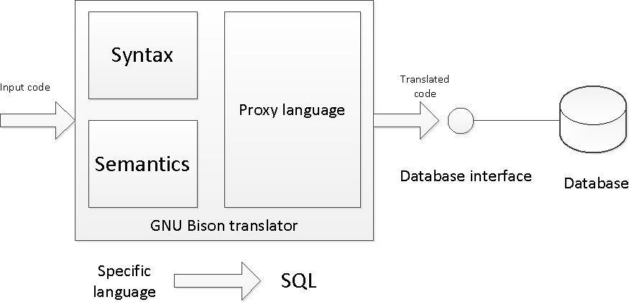

Conversion language + Paper
- Make up a language that converts some input to another format, for example Morse Code to text and vice versa, Roman numerals to Arabic numerals and vice versa etc.
- Define vocabulary for the language using Flex (or any alternative).
- If necessary for implementation, write a parser using GNU Bison (or any alternative) that performs this conversion.
- Write an essay / paper on one of the following topics(as example, from last year):
  - Essential characteristics of Java
  - Best in C#
  - Future of Lisp
  - The new features of Fortran
  - .........

Requirements for the language
At least 3 main sentences and 2 special sentences. 2 types of exception handling.
Lectures timetable(version 2)
1. 03.09 Introduction, some examples of what we're going to do
2. 10.09 Regular Languages, Regular Expressions, Flex
3. 17.09 Context Free Grammar, Bison, Postfix/Infix Calculator
4. 24.09 Abstract Syntax Tree, General Purpose Language, part 2
5. 01.10 General Purpose Language, part 2
6. 08.10 Practice Task 1
7. 15.10 Practice Task 2
8. 22.10 Practice Task 2.2
9. 29.10 Evolution of Programming Languages
10. 05.11 ANTLR (guest lecturer)/ CoCoViLa (guest lecturer) + Test
11. 12.11 Pic Assembler + Language/ CoCoViLa (guest lecturer), part 1
12. 19.11 Pic Specific Language, part 2
13. 26.11 Seminar
14. 03.12 Seminar
15. 10.12 Exam
Points: practice x10 –20p; seminar x2-- 10p(+10 essay); exam –50p(include test max10p)
Permission to examination : 10pract + 10test +10sem/hom

