Language parts

I part

Alphabet = latin characters + arabic numeral + special symbols(inc. punctuation marks).

II part

Lexic/vocabulary

III part

Syntax rules/Spelling

IV part

Semantics rules

The representation of a grammar is made of a set of syntax diagrams.

*Each diagram defines a non-terminal. There is a main diagram which defines the language in the following way:*

*to belong to the language, a word must describe a path in the main diagram.*

*Each diagram has an entry point and an end point.*

*The diagram describes possible paths between these two points by going through other nonterminals and terminals.*

Terminals are represented by round boxes while nonterminals are represented by square boxes

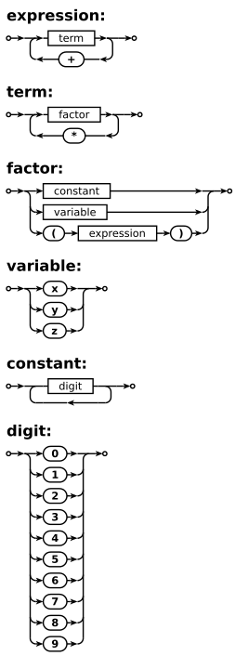

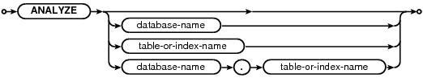

\*\*\*\*\*\*\*\*\*\*\*\*\*\*\*\*\*\*\*\*\*

<expression> ::= <term> | <term> "+" <expression>

<term> ::= <factor> | <term> "\*" <factor>

<factor> ::= <constant> | <variable> | "(" <expression> ")"

<variable> ::= "x" | "y" | "z"

<constant> ::= <digit> | <digit> <constant>

<digit> ::= "0" | "1" | "2" | "3" | "4" | "5" | "6" | "7" | "8" | "9"

