//groups.engin.umd.umich.edu/CIS/course.des/cis400/maxim/

Fortran 0- designed 1954

http://www.engin.umd.umich.edu/CIS/course.des/cis400/fortran/fortran.html
- Compiler completed 1957
- Mostly using assembly languages
- Fortran 1 & 2 designed while the Fortran 0 compiler was in development stage

1960 Fortran IV

- Fixed fields in source code (columns 1-5 labels, 6 'continue', 7-72 source, 73-80 sequence fields)
Column # | 1–5 | 6 | 7 – 72 | 73 - 80
 | Labels | Continue | Source code | Sequence fields
- Implicit typing (I-N was integer variable types, all else was floating point)
- Arithmetic 'if' ⊕, θ , ∅ (>0, <0, =0)
- 'Do' iterator
- Formatted i/o
- Comments
1963 Naur developed Algol 60 ('root' for Pascal, PL/1, Ada)

http://www.engin.umd.umich.edu/CIS/course.des/cis400/algol/algol.html
- 'Free' format (freedom of indentation, spacing, etc)
- Reserved words (certain words could not be variable names)
- Explicit typing (variable type had to be explicitly defined)
- General iterator (similar to 'while')
- Block structure
- Recursive procedures
- Dynamic array bounds
- Value parameters
What is an "Algol-like" language?
- Algorithmic language for describing processes
- Imperative (most computation work done in assignment statements)
- Block & procedure
- Lexical scope
C Algol lexical scope
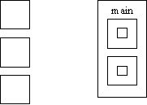
- Lexical scope is where the variable is visible and allows nested subroutines, need order
- Type checking
- Compilation used

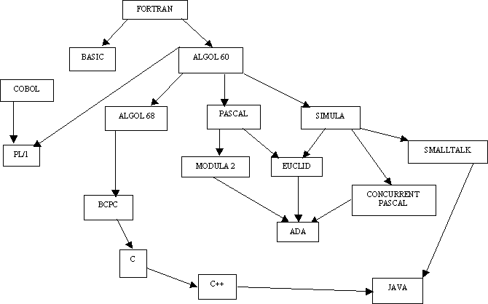

Applicative language- functional
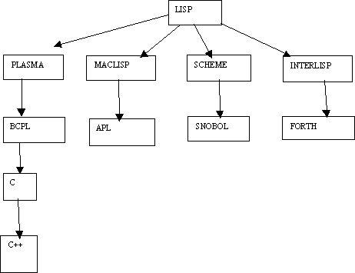

• IBM in its wisdom gave away FORTRAN with all its new computers creating wide spread support for FORTRAN and undermining Algol support
• Both type-checking and scope was not so good in Algol, this resulted in reduced reliability
• Industry preferred Fortran, academics preferred Algol
COBOL:

http://www.engin.umd.umich.edu/CIS/course.des/cis400/cobol/cobol.html
• 1959 Dept. of Defense wanted a single language
• 1960 Remington (Rand) developed the first compilers
• Machine independent
• General if/then else
• 'Noise' words (almost English-like, so lowly accountants could follow programs i.e. they didn’t have to know how to program to know what the code represented)

APL

IBM 1960 (Ken Iverson)
http://www.engin.umd.umich.edu/CIS/course.des/cis400/apl/apl.html
• Very compact notation for computation
• Provided for much matrix manipulation
• NOT Algol-like in nature
• Originally built to describe specifications of IBM360

LISP

http://www.engin.umd.umich.edu/CIS/course.des/cis400/lisp/lisp.html
Developed at MIT, (and others) by John McCarthy, (graduate instructor of Dr. Modesitt!!) AI is its application domain
• Symbolic expression, able to manipulate variable names like variable values (i.e. pointer arithmetic)
• Uniform representation for expression (data≡code) executable data structures.
• New form of conditional expression (similar to "switch" statements)
• Pre-fix expressions- operator followed by arguments
• Recursion more widely used
• "Garbage collection" used for data management
• A "linked-list" type of structure is the basic structure in LISP

Functional programming, (skipping chapter 5 for now, will come back to it)
Sequence control
• Used in expressions, (e.g. Precedence rules, parenthesis)
• Between statements or blocks, (e.g. Iteration and conditionals)
• Between sub-programs, (e.g. Calls)
Control sequences
• Implied, (physical statement order)
• Explicit, (parenthesis or goto's)
Example:
Root = -b ± (b²-4ac)^{1/2}
2a
In Fortran:
Root = ( -b + Sqrt ( b**2 - 4*a*c))/2*a
In some instances, parenthesis are essential, in other they are not. 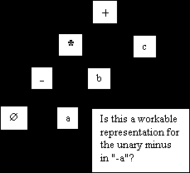
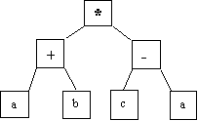
(a + b)*(c - a) in-fix notation
* + a b - c a pre-fix notation
a b + c a - * post-fix notation
What is the difference between unary and binary minus?
(i.e. how does "-b" and "b²-4ac" in the quadratic formula differ in terms of language definition?)
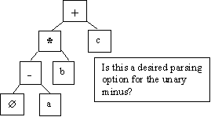
Tree representation: issues
-a * b + c in-fix notation
• Binary vs. unary operator confusion
• Precedence rules
• Associativity
❖ left to right
❖ right to left, (eliminates the need for parenthesis for the "2a" in the denominator of the quadratic)
• Operators with varying number of operands, ( i.e. (+ 2 3 4))
Problem areas:
• Uniform evaluation-once a tree is formed, all operands are treated equally
• Side effects:
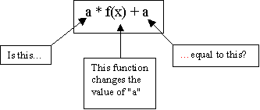

Is this a workable representation for the unary minus in "-a"?
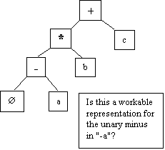

• Error conditions: arithmetic over- or under-flow, (i.e. 4/ (200 * 10,000,000))
• Short circuited boolean evaluation:
(a = 0) OR (b / a > c) in short circuit evaluation, the "OR" is evaluated until a "true" is found.
With full boolean evaluation, the "b/a", where a = 0, is evaluated first. This results in a run-time error.
With an "and", the first "false" stops evaluation.
Statement level control structures:
• Composition, (sequence)
Example:
Block statements
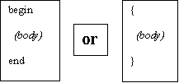
• Alternating (conditional statements)
❖ If-then/else or case, (switch)
"dangling else" issue:
if x = 3 then
y = 5
if x = 5 then
y = 6
else y = 7 // WHICH "IF" GETS THE "ELSE"?
in C++ {} is used to define where the else belongs
❖ If-then/else or case, (switch) continued
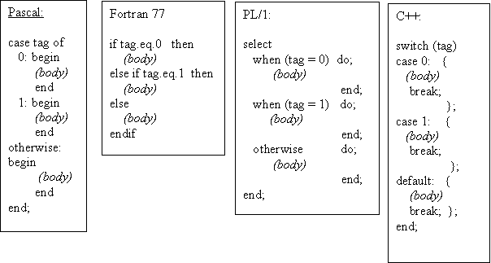

Case design issues:
• What type of selector expression?
• What types of case labels?
• Can you branch to case labels from outside?
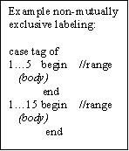
• Mutually exclusive labels?
• Exhaustive label case coverage? ("default", etc.)
Iteration issues:
In COBOL;

Perform {body} k times
How often is k evaluated?
If k is re-evaluated, when?
Can k < 0?
• When is termination test made?
• When are the loop expression variables evaluated?
(Pre and post test loops)
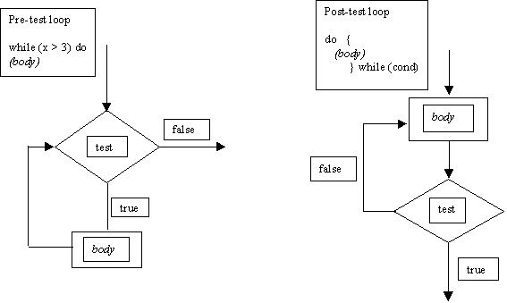
Counter incrementing loop:
do i = start to end by increment until (cond)
begin
(body)
end;
Is this pre- or post-test evaluation?
In Fortran 4 it was post-test!!
In Fortran 77 it was pre-test!!
When is i evaluated?
Can "start" or "end" be altered?
Continuing with iteration
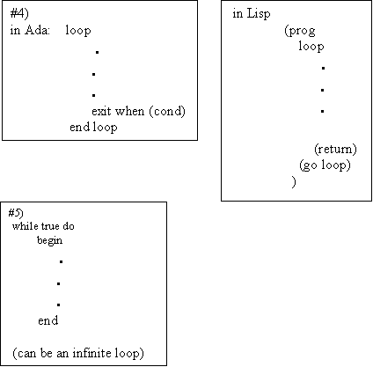
Loop issues
• What type of values may loop variable assume?
• Complexity of loop expression?
• How often is loop variable checked against final value?
• Can loop variable be assignment inside loop body?
• When evaluate stopping expression?
• Transfer permitted outside loop?
• Scope of loop variable?
6) Multiple loop exits
7) "Loop and a half", (variation of #6 with a test in middle of loop)
8) Iterator, (like Lisp)
goto's
Advantages:
• Found in virtually every language
• Conditional or non-conditional
• Easy to use
• Simulate ANY missing control structure
Computed goto:
go to (10,20,30) INDEX //goes to 10, 20 or 30 depending on value of INDEX
Assigned goto:
//assign value, say 10, to LABEL
go to LABEL, (10, 20, 30) //goes to label depending on what was assigned to LABEL
Approaches to LABEL
• Ada- labels as local syntactic tags, evaluated at compilation
• Algol- restricted data items, (all possible values defined at translation)
• Snobol/APL- unrestricted data types
Disadvantages of goto's:
• Readability
• Source order has little bearing on execution
• Groups of statements may serve multiple purposes
Functional programming
Up until now, we have been covering…
• VonNewmann architecture, (single instruction at a time)
• Assignment statement oriented
(imperative languages)
Functional languages:
More expressive, the expression is more important than assignment or control statement
i.e. in C:
max = x > y? x : y;
OR
if x > y then
max = x;
else max = y;
But what is "x" in the following expression?
f(x) + (x) = 2 * f(x)
"side effect" or referential transparency
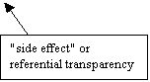
Functional programming ≡ applicative languages
f(x) = x * x
f(2) = 2 * 2
f(z + 1) = (z + 1) * (z + 1)
"lambda" notation:
(λx x*x)2 = 2 * 2 = 4
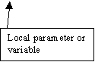
f = λx.x*x
global ≡ non-lambda variable
f ≡ g ο h = g(h(x)) functional languages permit this imperative do not
Functional/ applicative languages
• Set of "primitives"
• Set of functional forms, (for new functions)
• Application operation, (apply function to arguments)
• Set of data objects
How math functions differ form computational functions
• Modifiable variable in computing
• Program functions have side effects
• Programming functions define procedurally in steps-math functions typically done in terms of other functions
• Both can be recursive
Strongly advised to go to Xlisp home page and download a free implementation of Xlisp
Lisp: John McCarthy-MIT 1960
Distinctive features of Lisp:
• Equivalence of form for data and program
• Heavy reliance on recursion over iteration
• Use of linked list as intrinsic data structure

Data objects in Lisp
• "Atoms", (either literal or numeric, i.e. 'sam or 3)
• List- groups of atoms or lists nested list representation is ((1 2 ) (3 4 ))
• Expression- atoms and lists together
There are no reserved words for literal except:
• The literal T is for boolean true
• The literal NIL ≡ '( ) or false
In Lisp
; is for commenting like // for C++. So ; this comment is not recognized by interpreter
' is to read "as is" and not for interpretation
Simulated Lisp input/output:
> 3
3
> sam
undefined variable
> 'sam
sam
> T
T
> NIL
NIL
> (a (b c) d)
undefined function call ;;;;;; interpreter thinks "a" is a function, not a list element
> '(a (b c) d)
(a (b c) d)
In Lisp (a (b c) d)
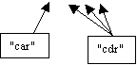
"car" from contents of address register-the first element of a list
"cdr" from contents of decrement register-everything EXCEPT the first element
to exit Lisp:
> (exit)
exit
an atom "A" has:
• A name
• A value
• A property list
In functional languages parameter transmission is by value, (there may be some by name parameter transmission)
Read/ Evaluate loop- and expression is read and evaluated, a value is returned, then the system waits (infinitely) for the next expression
An example of some kind of "by name" parameter transmission:
> (setq x 3)
3
> x
3
> (setq x '(a b c)) ; the apostrophe is needed!!!
(a b c)
> x
(a b c)
> 'x
x

The Lisp Programming Language

Click below to go directly to a specific section:
History | Significant Language Features | Areas of Application | Sample Programs
Related Links | Printed References |

History
Interest in artificial intelligence first surfaced in the mid 1950. Linguistics, psychology, and mathematics were only some areas of application for AI. Linguists were concerned with natural language processing, while psychologists were interested in modeling human information and retrieval. Mathematicians were more interested in automating the theorem proving process. The common need among all of these applications was a method to allow computers to process symbolic data in lists.
IBM was one of the first companies interested in AI in the 1950s. At the same time, the FORTRAN project was still going on. Because of the high cost associated with producing the first FORTRAN compiler, they decided to include the list processing functionality into FORTRAN. The FORTRAN List Processing Language (FLPL) was designed and implemented as an extention to FORTRAN.
In 1958 John McCarthy took a summer position at the IBM Information Research Department. He was hired to create a set of requirements for doing symbolic computation. The first attempt at this was differentiation of algebraic expressions. This initial experiment produced a list of of language requirements, most notably was recursion and conditional expressions. At the time, not even FORTRAN (the only high-level language in existance) had these functions.
It was at the 1956 Dartmouth Summer Research Project on Artificial Intelligence that John McCarthy first developed the basics behind Lisp. His motivation was to develop a list processing language for Artificial Intelligence. By 1965 the primary dialect of Lisp was created (version 1.5). By 1970 special-purpose computers known as Lisp Machines, were designed to run Lisp programs. 1980 was the year that object-oriented concepts were integrated into the language. By 1986, the X3J13 group formed to produce a draft for ANSI Common Lisp standard. Finally in 1992, X3J13 group published the American National Standard for Common Lisp.

Significant Language Features
- Atoms & Lists - Lisp uses two different types of data structures, atoms and lists.
  - Atoms are similar to identifiers, but can also be numeric constants
  - Lists can be lists of atoms, lists, or any combination of the two
- Functional Programming Style - all computation is performed by applying functions to arguments. Variable declarations are rarely used.
- Uniform Representation of Data and Code - example: the list (A B C D)
  - a list of four elements (interpreted as data)
  - is the application of the function named A to the three parameters B, C, and D (interpreted as code)
- Reliance on Recursion - a strong reliance on recursion has allowed Lisp to be successful in many areas, including Artificial Intelligence.
- Garbage Collection - Lisp has built-in garbage collection, so programmers do not need to explicitly free dynamically allocated memory.

Areas of Application
Lisp totally dominated Artificial Intelligence applications for a quarter of a century, and is still the most widely used language for AI. In addition to its success in AI, Lisp pioneered the process of Functional Programming. Many programming language researchers believe that functional programming is a much better approach to software development, than the use of Imperative Languages (Pascal, C++, etc).
Below is a short list of the areas where Lisp has been used:
- Artificial Intelligence
  - AI Robots
  - Computer Games (Craps, Connect-4, BlackJack)
  - Pattern Recognition
- Air Defense Systems
- Implementation of Real-Time, embedded Knowledge-Based Systems
- List Handling and Processing
- Tree Traversal (Breath/Depth First Search)
- Educational Purposes (Functional Style Programming)

Sample Programs

Hello world!

Craps Simulation

Convert

Check 2 numbers

Related Links
- CIS 479: Artificial Intelligence
This a course description of the Artificial Intelligence class taught here at the University of Michigan - Dearborn.
- XLisp Free Compiler
This site has the XLisp-Stat compiler that was used to create and run the sample programs found on this page.
- xlisp21.plus Home Page
This site has the XLisp compiler that Dr. Maxim uses in CIS 479 and links to related versions of XLisp.
- An Introduction to Common Lisp
This site is a great resource for the beginner and advanced lisp programmer. Start your journey here!
- Common Lisp FAQ
This should answer all of your questions!!
- Common Lisp The Language, 2nd Edition
This site has every aspect of the Common Lisp Programming Language, that a web site could possibly contain.
- LISP Books, good reads
This web site has some interesting Common Lisp Programming Language books that could possibly aid you.
- Lisp:Good News, Bad News, How to Win Big
Richard P. Gabriel has a very good grasp on every aspect of the Lisp Programming Language.

Printed References
- Anderson, John R., Albert T Corbett, and Brian J. Reiser. (1987). Essential LISP. Addison-Wesley Publishing Company, Reading, Massachusetts.
- Wilensky, Robert. (1986). Common LISPcraft. W. W. Norton & Company, New York, New York.
- Sebesta, Robert W., (1996). Concepts of Programming Languages, Third Edition. Addison-Wesley Publishing Company, Menlo Park, California.

