//groups.engin.umd.umich.edu/CIS/course.des/cis400/maxim/

Fortran 0- designed 1954

http://www.engin.umd.umich.edu/CIS/course.des/cis400/fortran/fortran.html
- Compiler completed 1957
- Mostly using assembly languages
- Fortran 1 & 2 designed while the Fortran 0 compiler was in development stage

1960 Fortran IV

- Fixed fields in source code (columns 1-5 labels, 6 'continue', 7-72 source, 73-80 sequence fields)
Column # | 1–5 | 6 | 7 – 72 | 73 - 80
 | Labels | Continue | Source code | Sequence fields
- Implicit typing (I-N was integer variable types, all else was floating point)
- Arithmetic 'if' ⊕, θ , ∅ (>0, <0, =0)
- 'Do' iterator
- Formatted i/o
- Comments
1963 Naur developed Algol 60 ('root' for Pascal, PL/1, Ada)

http://www.engin.umd.umich.edu/CIS/course.des/cis400/algol/algol.html
- 'Free' format (freedom of indentation, spacing, etc)
- Reserved words (certain words could not be variable names)
- Explicit typing (variable type had to be explicitly defined)
- General iterator (similar to 'while')
- Block structure
- Recursive procedures
- Dynamic array bounds
- Value parameters
What is an "Algol-like" language?
- Algorithmic language for describing processes
- Imperative (most computation work done in assignment statements)
- Block & procedure
- Lexical scope
C Algol lexical scope
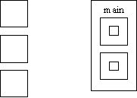
- Lexical scope is where the variable is visible and allows nested subroutines, need order
- Type checking
- Compilation used

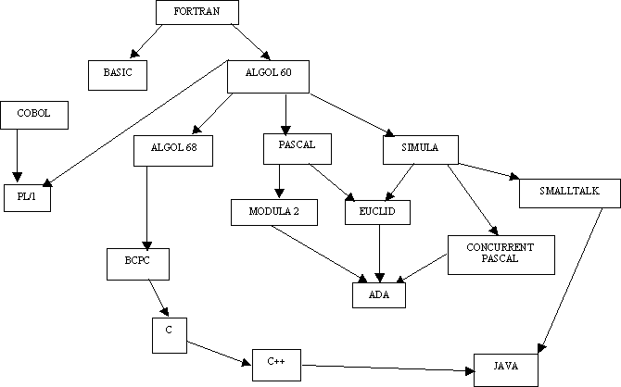

Applicative language- functional
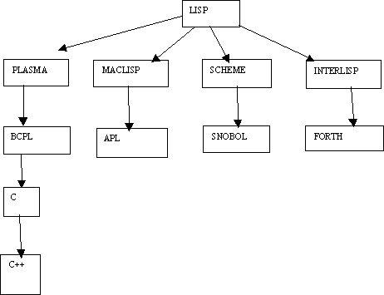

• IBM in its wisdom gave away FORTRAN with all its new computers creating wide spread support for FORTRAN and undermining Algol support
• Both type-checking and scope was not so good in Algol, this resulted in reduced reliability
• Industry preferred Fortran, academics preferred Algol
COBOL:

http://www.engin.umd.umich.edu/CIS/course.des/cis400/cobol/cobol.html
• 1959 Dept. of Defense wanted a single language
• 1960 Remington (Rand) developed the first compilers
• Machine independent
• General if/then else
• 'Noise' words (almost English-like, so lowly accountants could follow programs i.e. they didn’t have to know how to program to know what the code represented)

APL

IBM 1960 (Ken Iverson)
http://www.engin.umd.umich.edu/CIS/course.des/cis400/apl/apl.html
• Very compact notation for computation
• Provided for much matrix manipulation
• NOT Algol-like in nature
• Originally built to describe specifications of IBM360

LISP

http://www.engin.umd.umich.edu/CIS/course.des/cis400/lisp/lisp.html
Developed at MIT, (and others) by John McCarthy, (graduate instructor of Dr. Modesitt!!) AI is its application domain
• Symbolic expression, able to manipulate variable names like variable values (i.e. pointer arithmetic)
• Uniform representation for expression (data≡code) executable data structures.
• New form of conditional expression (similar to "switch" statements)
• Pre-fix expressions- operator followed by arguments
• Recursion more widely used
• "Garbage collection" used for data management
• A "linked-list" type of structure is the basic structure in LISP

Functional programming
Sequence control
• Used in expressions, (e.g. Precedence rules, parenthesis)
• Between statements or blocks, (e.g. Iteration and conditionals)
• Between sub-programs, (e.g. Calls)
Control sequences
• Implied, (physical statement order)
• Explicit, (parenthesis or goto's)
Example:
Root = -b ± (b²-4ac)^{1/2}
2a
In Fortran:
Root = ( -b + Sqrt ( b**2 - 4*a*c))/2*a
In some instances, parenthesis are essential, in other they are not. 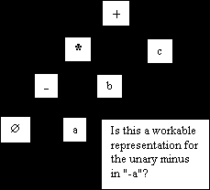
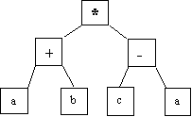
(a + b)*(c - a) in-fix notation
* + a b - c a pre-fix notation
a b + c a - * post-fix notation
What is the difference between unary and binary minus?
(i.e. how does "-b" and "b²-4ac" in the quadratic formula differ in terms of language definition?)
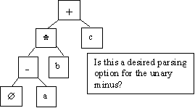
Tree representation: issues
-a * b + c in-fix notation
• Binary vs. unary operator confusion
• Precedence rules
• Associativity
❖ left to right
❖ right to left, (eliminates the need for parenthesis for the "2a" in the denominator of the quadratic)
• Operators with varying number of operands, ( i.e. (+ 2 3 4))
Problem areas:
• Uniform evaluation-once a tree is formed, all operands are treated equally
• Side effects:
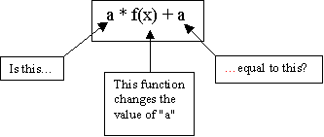

Is this a workable representation for the unary minus in "-a"?
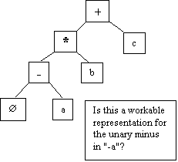

• Error conditions: arithmetic over- or under-flow, (i.e. 4/ (200 * 10,000,000))
• Short circuited boolean evaluation:
(a = 0) OR (b / a > c) in short circuit evaluation, the "OR" is evaluated until a "true" is found.
With full boolean evaluation, the "b/a", where a = 0, is evaluated first. This results in a run-time error.
With an "and", the first "false" stops evaluation.
Statement level control structures:
• Composition, (sequence)
Example:
Block statements
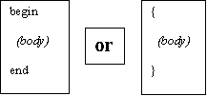
• Alternating (conditional statements)
❖ If-then/else or case, (switch)
"dangling else" issue:
if x = 3 then
y = 5
if x = 5 then
y = 6
else y = 7 // WHICH "IF" GETS THE "ELSE"?
in C++ {} is used to define where the else belongs
❖ If-then/else or case, (switch) continued
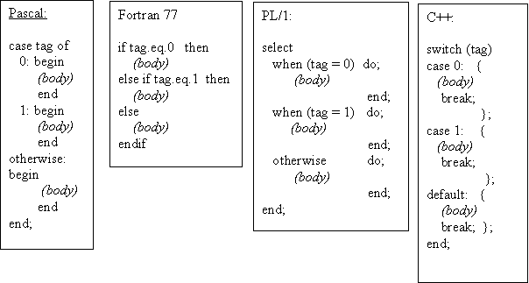

Case design issues:
• What type of selector expression?
• What types of case labels?
• Can you branch to case labels from outside?
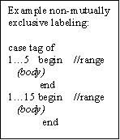
• Mutually exclusive labels?
• Exhaustive label case coverage? ("default", etc.)
Iteration issues:
In COBOL;

Perform {body} k times
How often is k evaluated?
If k is re-evaluated, when?
Can k < 0?
• When is termination test made?
• When are the loop expression variables evaluated?
(Pre and post test loops)
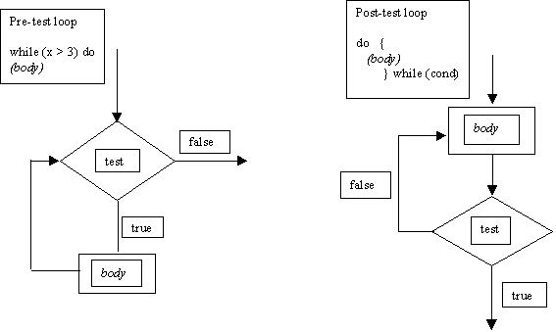
Counter incrementing loop:
do i = start to end by increment until (cond)
begin
(body)
end;
Is this pre- or post-test evaluation?
In Fortran 4 it was post-test!!
In Fortran 77 it was pre-test!!
When is i evaluated?
Can "start" or "end" be altered?
Continuing with iteration
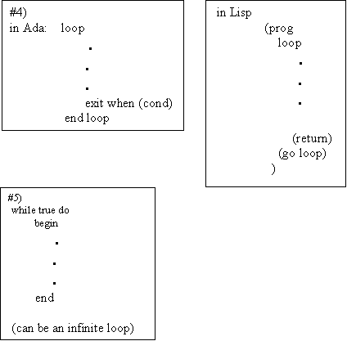
Loop issues
• What type of values may loop variable assume?
• Complexity of loop expression?
• How often is loop variable checked against final value?
• Can loop variable be assignment inside loop body?
• When evaluate stopping expression?
• Transfer permitted outside loop?
• Scope of loop variable?
6) Multiple loop exits
7) "Loop and a half", (variation of #6 with a test in middle of loop)
8) Iterator, (like Lisp)
goto's
Advantages:
• Found in virtually every language
• Conditional or non-conditional
• Easy to use
• Simulate ANY missing control structure
Computed goto:
go to (10,20,30) INDEX //goes to 10, 20 or 30 depending on value of INDEX
Assigned goto:
//assign value, say 10, to LABEL
go to LABEL, (10, 20, 30) //goes to label depending on what was assigned to LABEL
Approaches to LABEL
• Ada- labels as local syntactic tags, evaluated at compilation
• Algol- restricted data items, (all possible values defined at translation)
• Snobol/APL- unrestricted data types
Disadvantages of goto's:
• Readability
• Source order has little bearing on execution
• Groups of statements may serve multiple purposes
Functional programming
Up until now, we have been covering…
• VonNewmann architecture, (single instruction at a time)
• Assignment statement oriented
(imperative languages)
Functional languages:
More expressive, the expression is more important than assignment or control statement
i.e. in C:
max = x > y? x : y;
OR
if x > y then
max = x;
else max = y;
But what is "x" in the following expression?
f(x) + (x) = 2 * f(x)
"side effect" or referential transparency
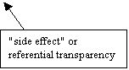
Functional programming ≡ applicative languages
f(x) = x * x
f(2) = 2 * 2
f(z + 1) = (z + 1) * (z + 1)
"lambda" notation:
(λx x*x)2 = 2 * 2 = 4
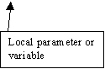
f = λx.x*x
global ≡ non-lambda variable
f ≡ g ο h = g(h(x)) functional languages permit this imperative do not
Functional/ applicative languages
• Set of "primitives"
• Set of functional forms, (for new functions)
• Application operation, (apply function to arguments)
• Set of data objects
How math functions differ form computational functions
• Modifiable variable in computing
• Program functions have side effects
• Programming functions define procedurally in steps-math functions typically done in terms of other functions
• Both can be recursive
Strongly advised to go to Xlisp home page and download a free implementation of Xlisp
Lisp: John McCarthy-MIT 1960
Distinctive features of Lisp:
• Equivalence of form for data and program
• Heavy reliance on recursion over iteration
• Use of linked list as intrinsic data structure

Data objects in Lisp
• "Atoms", (either literal or numeric, i.e. 'sam or 3)
• List- groups of atoms or lists nested list representation is ((1 2 ) (3 4 ))
• Expression- atoms and lists together
There are no reserved words for literal except:
• The literal T is for boolean true
• The literal NIL ≡ '( ) or false
In Lisp
; is for commenting like // for C++. So ; this comment is not recognized by interpreter
' is to read "as is" and not for interpretation
Simulated Lisp input/output:
> 3
3
> sam
undefined variable
> 'sam
sam
> T
T
> NIL
NIL
> (a (b c) d)
undefined function call ;;;;;; interpreter thinks "a" is a function, not a list element
> '(a (b c) d)
(a (b c) d)
In Lisp (a (b c) d)
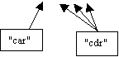
"car" from contents of address register-the first element of a list
"cdr" from contents of decrement register-everything EXCEPT the first element
to exit Lisp:
> (exit)
exit
an atom "A" has:
• A name
• A value
• A property list
In functional languages parameter transmission is by value, (there may be some by name parameter transmission)
Read/ Evaluate loop- and expression is read and evaluated, a value is returned, then the system waits (infinitely) for the next expression
An example of some kind of "by name" parameter transmission:
> (setq x 3)
3
> x
3
> (setq x '(a b c)) ; the apostrophe is needed!!!
(a b c)
> x
(a b c)
> 'x
x

