Language parts
I part
Alphabet = latin characters + arabic numeral + special symbols(inc. punctuation marks)

II part
Lexic/vocabulary

III part
Syntax rules/Spelling

IV part
Semantics rules

The representation of a grammar is made of a set of syntax diagrams.
Each diagram defines a non-terminal. There is a main diagram which defines the language in the following way:
to belong to the language, a word must describe a path in the main diagram.
Each diagram has an entry point and an end point.
The diagram describes possible paths between these two points by going through other nonterminals and terminals.
Terminals are represented by round boxes while nonterminals are represented by square boxes

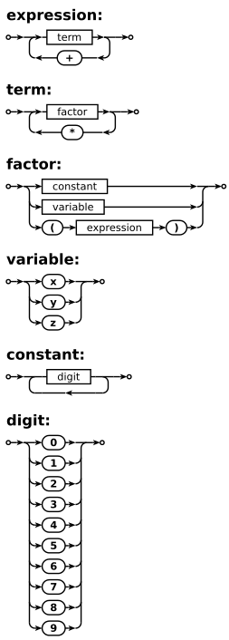

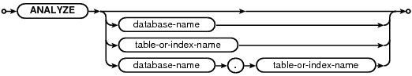

*********************
<expression> ::= <term> | <term> "+" <expression>
<term> ::= <factor> | <term> "*" <factor>
<factor> ::= <constant> | <variable> | "(" <expression> ")"
<variable> ::= "x" | "y" | "z"
<constant> ::= <digit> | <digit> <constant>
<digit> ::= "0" | "1" | "2" | "3" | "4" | "5" | "6" | "7" | "8" | "9"

