Test date | 12.12.2023
Operator | T. Märtson
Test method | EVS-EN ISO 4136:2012
Method name | Destructive tests on welds in metallic materials - Transverse tensile test
Test machine | Instron 8516
Load cell | Load cell +-300 kN
Dimensions measuring device | Caliper TESA nr.7H 1261 01
Sample description | Flat dogbone sample
Notes | -
Test results
 | Specimen identification | Fm  (kN) | Rm  (MPa) | Thickness  (mm) | Width  (mm) | Location of fracture | Remark
1 | TT-1 | 30.5 | 530 | 5.70 | 10.10 | Parent metal | -
2 | TT-2 | 32.4 | 563 | 5.70 | 10.10 | Parent metal | -
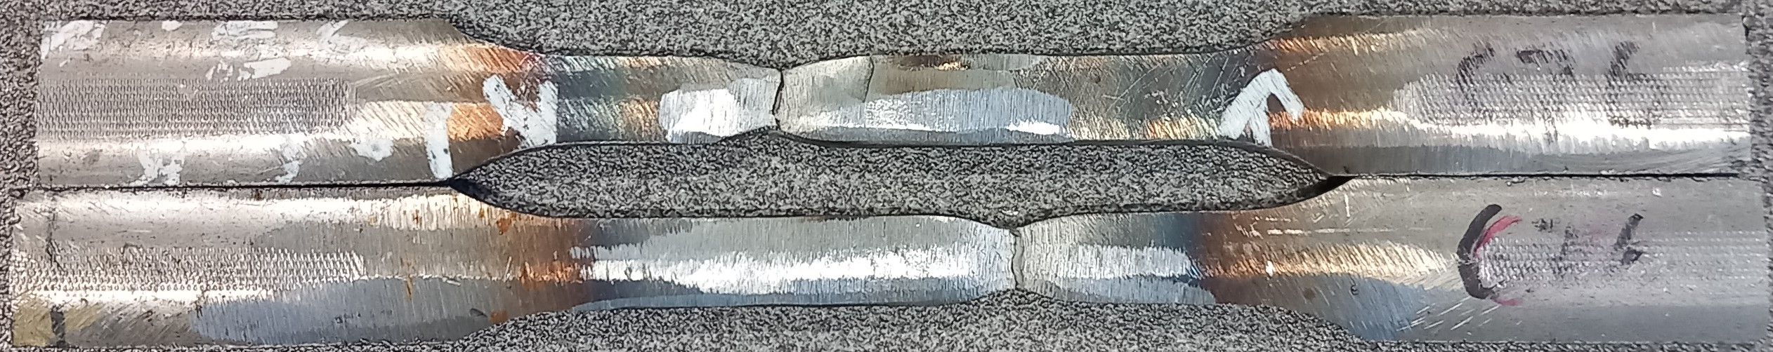

Photo of tested specimens

