Date of testing: |  | 06.02.24
Test operator: |  | T. Märtson
Test method: |  | Bend test (EN ISO 5173:2023) with former
Temperature: |  | +21 °C
Notes: |  | -
Bend test results
Test piece |  |  |  | Former diameter, mm | Distance between rollers, mm | Bend angle, ° | Remark
Identification of test specimens |  | Dimensions, mm
 |  | Thickness, mm | Width, mm
FB-1 |  | 6 | 16 | 24 | 40 | 180 | No crack
FB-2 |  | 6 | 16 | 24 | 40 | 180 | No crack
RB-1 |  | 6 | 16 | 24 | 40 | 180 | No crack
RB-2 |  | 6 | 16 | 24 | 40 | 180 | No crack
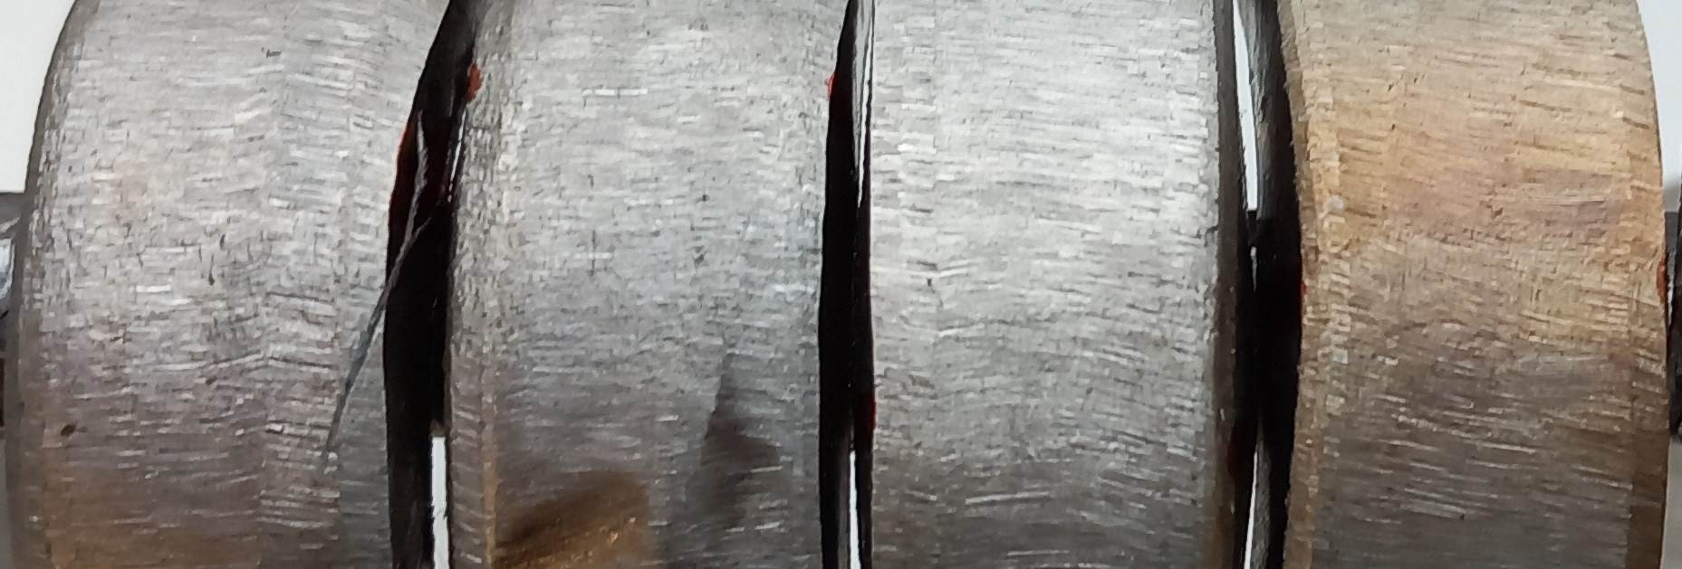
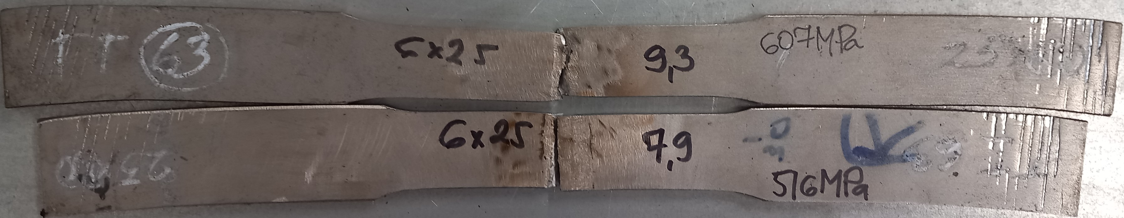

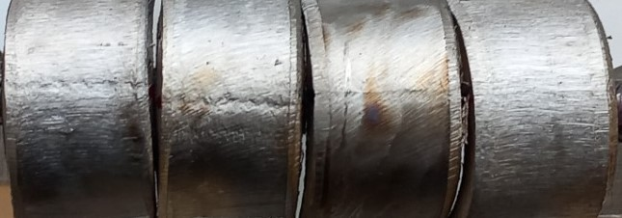

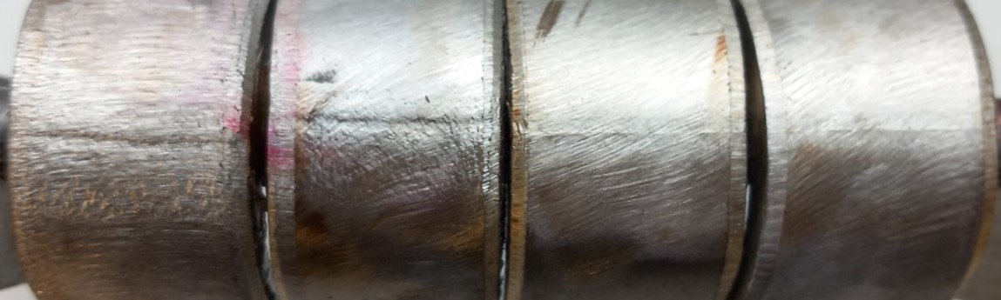
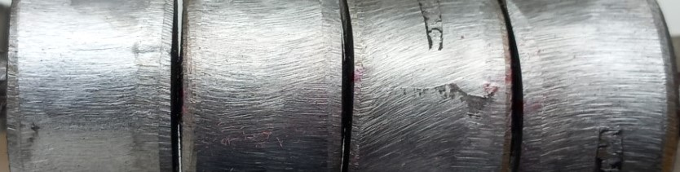

Photo of tested specimens

