Test date | 26.07.2024
Operator | T. Märtson
Test method | EVS-EN ISO 4136:2012
Method name | Destructive tests on welds in metallic materials - Transverse tensile test
Test machine | DWU 30t
Load cell | Load cell +-100 kN
Dimensions measuring device | Caliper TESA nr.7H 1261 01
Sample description | Flat dogbone sample
Notes | -
Test results
 | Specimen identification | Fm  (kN) | Rm  (MPa) | Width  (mm) | Thickness  (mm) | Location of fracture
1 | TT-1 | 52 | 544 | 11,6 | 8,3 | Parent metal
2 | TT-2 | 52 | 540 | 11,7 | 8,3 | Parent metal
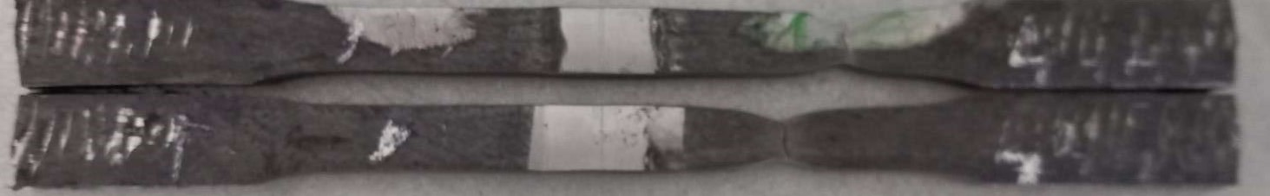
Photo of tested specimens

