Test date | 16.07.2024
Operator | T. Märtson
Test method | EVS-EN ISO 4136:2012
Method name | Destructive tests on welds in metallic materials - Transverse tensile test
Test machine | DWU 30t
Dimensions measuring device | Caliper TESA nr.7H 1261 01
Sample description | Flat dogbone sample
Notes | -
Test results
 | Specimen identification | Fm  (kN) | Rm  (MPa) | Thickness  (mm) | Width  (mm) | Location of fracture | Remark
1 | TT-1 | 14,8 | 575 | 10 | 25 | Parent metal | -
2 | TT-2 | 139 | 581 | 19,5 | 12,25 | Parent metal
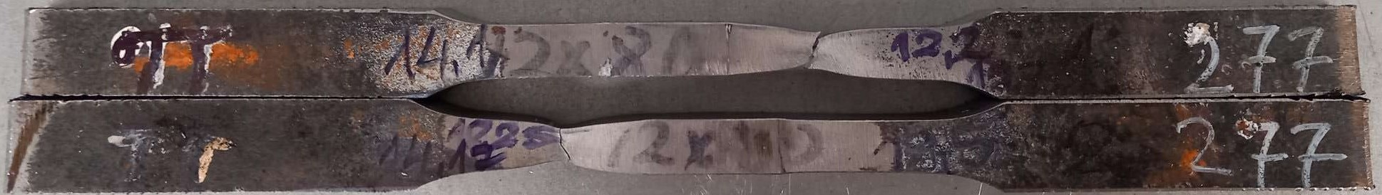
Photo of tested specimens

