Test date | 27.06.2024
Operator | T. Märtson
Test method | EVS-EN ISO 4136:2012
Method name | Destructive tests on welds in metallic materials - Transverse tensile test
Test machine | Instron 8516
Load cell | Load cell +-100 kN
Dimensions measuring device | Caliper TESA nr.7H 1261 01
Sample description | Flat dogbone sample
Notes | -
Test results
 | Specimen identification | Fm  (kN) | Rm  (MPa) | Thickness | Width | Section area (mm2) | Location of fracture
1 | TT-1 | 10,6 | 541 | 2,0 | 9,8 | 19,6 | HAZ
2 | TT-2 | 10,0 | 505 | 2,0 | 9,9 | 19,8 | HAZ
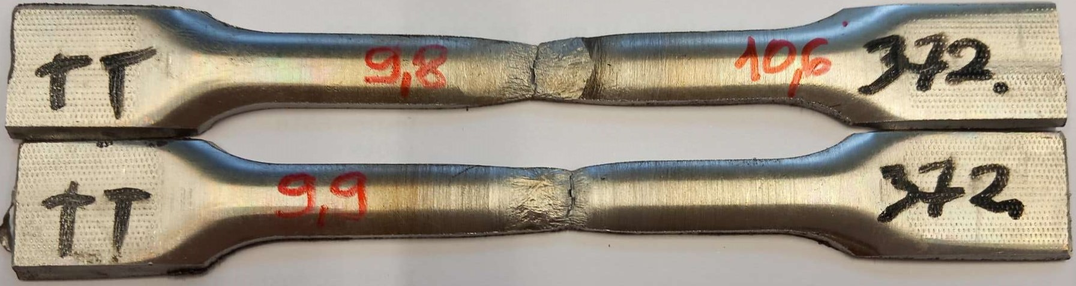
Photo of tested specimens

