Test date | 25.06.2024
Operator | T. Märtson
Test method | EVS-EN ISO 4136:2012
Method name | Destructive tests on welds in metallic materials - Transverse tensile test
Test machine | WPM 30t
Load cell | Load cell +-300 kN
Dimensions measuring device | Caliper TESA nr.7H 1261 01
Sample description | Flat dogbone sample
Notes | -
Test results
 | Specimen identification | Fm  (kN) | Rm  (MPa) | Thicknes | WIdth | Section area (mm2) | Location of fracture
1 | TT | 119 | 467 | 10,15 | 25,1 | 254,765 | Parent metal
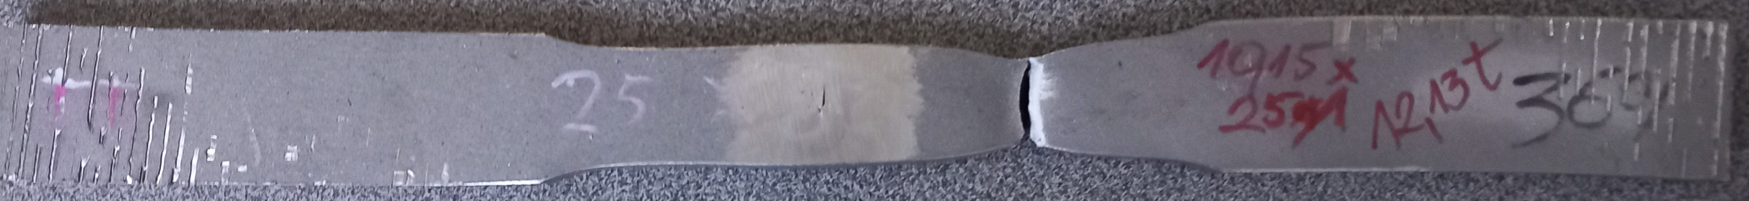
Photo of tested specimens

