Test date | 20.06.2024
Operator | T. Märtson
Test method | EVS-EN ISO 4136:2012
Method name | Destructive tests on welds in metallic materials - Transverse tensile test
Test machine | DWU 30 t
Load cell | Load cell +-100 kN
Dimensions measuring device | Caliper TESA nr.7H 1261 01
Sample description | Flat dogbone sample
Notes | -
Test results
 | Specimen identification | Fm  (kN) |  | Rm  (MPa) | Outer diametre  (mm) | Inner diametre  (mm) | Section area | Location of fracture
1 | TT-1 | 4,2 | 41 | 420 | 13,7 | 7,8 | 98 | Parent metal
2 | TT-2 | 4,2 | 41 | 420 | 13,7 | 7,8 | 98 | Parent metal
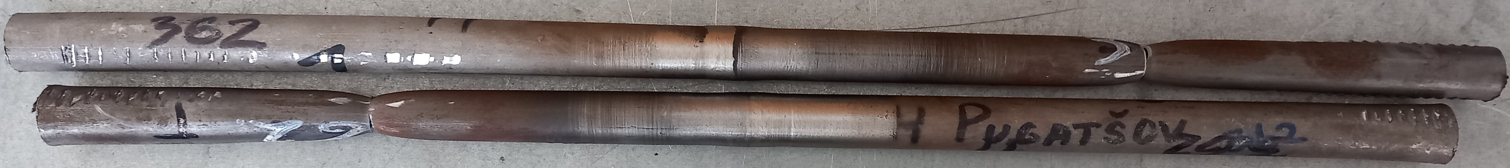
Photo of tested specimens

