Test date | 24.04.2024
Operator | T. Märtson
Test method | EVS-EN ISO 4136:2012
Method name | Destructive tests on welds in metallic materials - Transverse tensile test
Test machine | Instron 8516
Load cell | Load cell +-300 kN
Dimensions measuring device | Caliper TESA nr.7H 1261 01
Sample description | Flat dogbone sample
Notes | -
Test results
 | Specimen identification | Fm  (kN) | Rm  (MPa) | Thickness  (mm) | Width  (mm) | Location of fracture | Remark
1 | TT-Ü1 | 155 | 542 | 11,6 | 24,65 | Parent metal | -
2 | TT-A1 | 158 | 551 | 11,7 | 24,5 | Parent metal
3 | TT-A2 | 161 | 552 | 11,8 | 24,7 | Parent metal
4 | TT-Ü2 | 159 | 544 | 11,9 | 24,6 | Parent metal
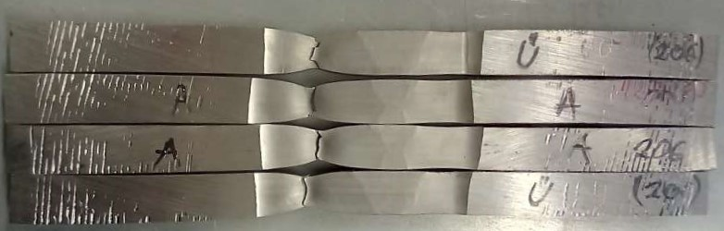
Photo of tested specimens

