Test date | 12.01.2024
Operator | T. Märtson
Test method | EVS-EN ISO 4136:2012
Method name | Destructive tests on welds in metallic materials - Transverse tensile test
Test machine | Instron 8516
Load cell | Load cell +-300 kN
Dimensions measuring device | Caliper TESA nr.7H 1261 01
Sample description | Flat dogbone sample
Notes | -
Test results
 | Specimen identification | Fm  (kN) | Rm  (MPa) | Thickness  (mm) | Width  (mm) | Location of fracture | Remark
1 | TT-1 | 7,3 | 315 | 1,9 | 12,2 | Parent material | -
2 | TT-2 | 7,4 | 295 | 2,0 | 12,5 | HAZ | -
3 | TT-3 | 6,8 | 295 | 1,9 | 12,1 | HAZ | -
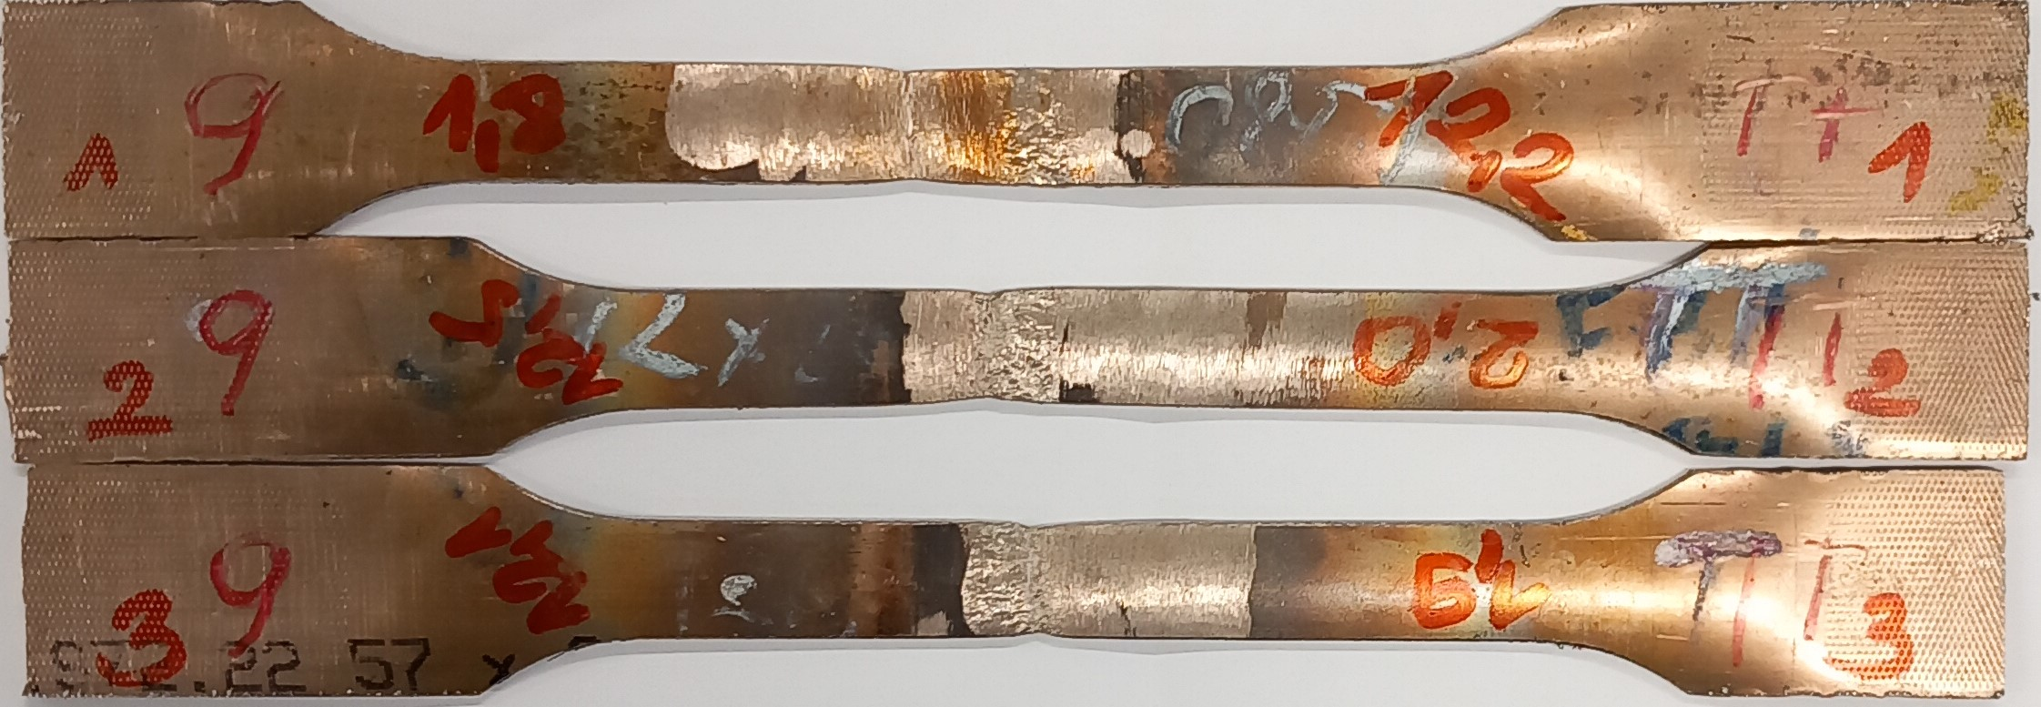
Photo of tested specimens

