**An Overview of Goal Modelling and Domain Modelling**

1. Socio-Technical Systems

A socio-technical system is a software intensive system that has defined operational processes followed by human operators and which operates within an organization.

It is a system that contains both a social aspect, which may be a subsystem, and a technical aspect.

1. Goal modelling

Motivational goal models. Motivation goal models are useful in early stage requirements engineering to capture initial understandings, and share these with other stakeholders.

Table 1: Description of notations for goal modelling

|  |  |
| --- | --- |
| Notation | Description |
|  | Goals are based on motives, and  describe an intended state of the  environment. Goals can consist of  sub-goals. |
|  | Quality goals are non-functional  (or quality) goals. These are sometimes  referred to as soft goals. |
|  | Roles are the capacities or positions  that are required for achieving of  goals. Roles are played by agents,  which can be humans or artificial. |
|  | Connection between functional goal and sub-functional goals or the role that aims to fulfil that particular functional goal. |
|  | Connection between functional goal and quality goal. |

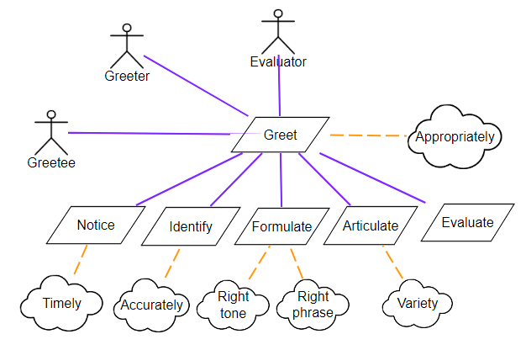

Figure 1: Goal model of greeting scenario

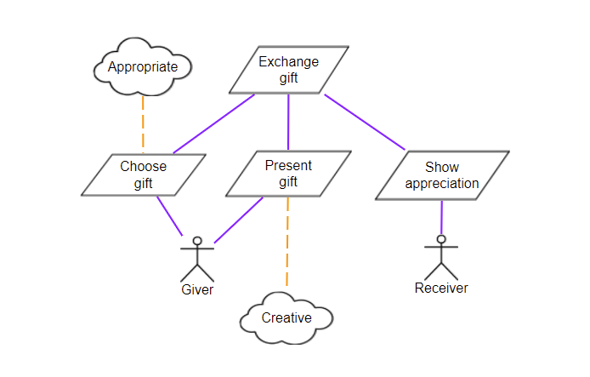

Figure 2: Exchange gift scenario

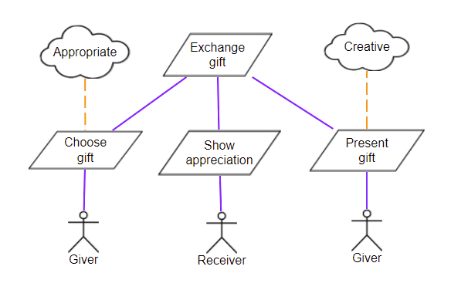

Figure 3: Another representation of goal model of exchange gift scenario

Figure 3 shows that you can have duplicate roles in the same model and the order of the functional goals in the same level of the hierarchy is not important.

1. Domain Modelling

Domain model represents the knowledge within the system that the system is supposed to handle.

A domain entity is a modular unit of knowledge handled by a sociotechnical system.

A domain model consists of domain entities, roles and relationships between them.

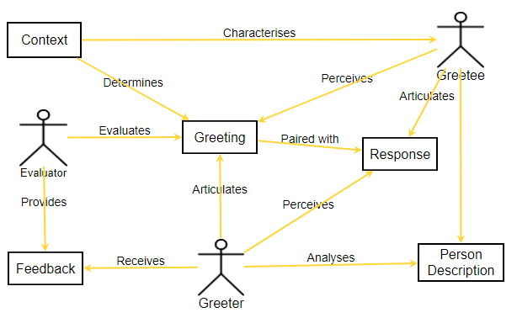

Figure 4: Domain model of the greeting scenario.