**An Overview of Goal Modelling and Domain Modelling**

1. Characteristics of Socio-Technical Systems

* Common main objective – the success of the whole system relies on the ways individual parties forming the system fulfil their objectives.
* Interdependent parties – the individual parties of the system collaborate by exchanging knowledge items through interactions.
* Socio and technical sub-systems – the quality of the whole system depends on the joint optimisation of the technical and social sub-systems, i.e., focusing on one of these systems to the exclusion of the other is likely to degraded system’s quality.
* Open system – the system needs to be aware and adaptive to the changes in the environmental conditions, including the existence of new knowledge and requirements.
* Equifinality – the goals of the system can be achieved via many different ways or set of activities. Thus, motivates the need to make design choices during system development process.

1. Goal modelling

Motivational goal models. Motivation goal models are useful in early stage requirements engineering to capture initial understandings, and share these with other stakeholders.

Definition 1 (Functional goal): Functional goals are based on motives, and describe an intended state of the environment. Functional goals can consist of sub-goals.

Definition 2 (Quality goal): Quality goals are non-functional goals (sometimes referred to as soft goals). Quality goals are attached to functional goals, capturing that the functional goal should be achieved while maintaining the quality.

Definition 3 (Role): Roles are some capacities or positions that facilitate the achievement of functional goals. Roles are played by agents, which can be humans or artificial. Roles have responsibilities, which determine what the agent must do to achieve the functional goals, and constraints, which determine the conditions that must be considered when trying to achieve functional goals.

Table 1: Description of notations for goal modelling

|  |  |
| --- | --- |
| Notation | Description |
|  | Goals are based on motives, and  describe an intended state of the  environment. Goals can consist of  sub-goals. |
|  | Quality goals are non-functional  (or quality) goals. These are sometimes  referred to as soft goals. |
|  | Roles are the capacities or positions  that are required for achieving of  goals. Roles are played by agents,  which can be humans or artificial. |
|  | Connection between functional goal and sub-functional goals or the role that aims to fulfil that particular functional goal. |
|  | Connection between functional goal and quality goal. |

Typically, arcs are used to connect the following:

1) Roles to functional goals: this represents that the agent playing the role is responsible for achieving the functional goal. For example, a person playing the role of Manager is responsible for the functional goal of approving a piece of external correspondence.

2) Functional goals to quality goals: this represents that the functional goal should be achieved under consideration of this quality. For example, the functional goal should be achieved efficiently, where “efficiently” may be defined more precisely.

3) Goals to sub-goals: this represents that the functional goals are related. We use undirected arcs to denote that one goal is a sub-goal of the other, and therefore the sub-goal contributes to achieving the higher level goal. To distinguish the goal from its sub-goal, we place the sub-goal below the goal, thus enforcing a hierarchical goal model, rather than adopting notation from existing software engineering notations, such as directed arcs. We have found this to be a simple and natural way of expressing sub-goals for non-technical stakeholders.

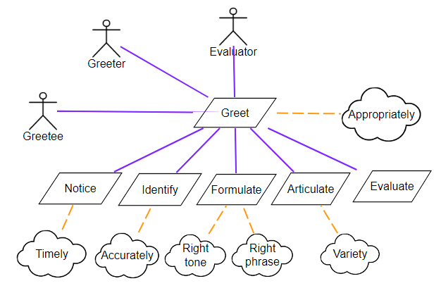

Figure 1: Goal model of greeting scenario

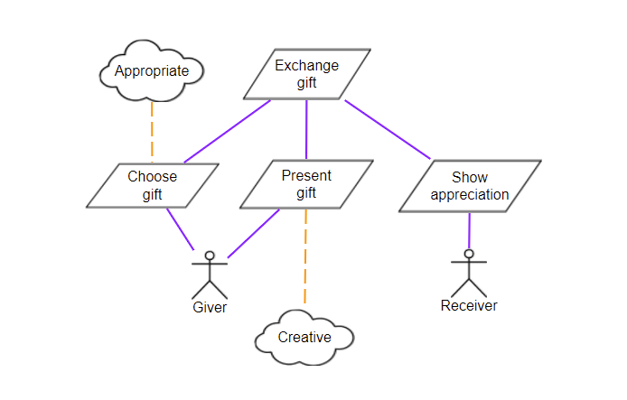

Figure 2: Exchange gift scenario

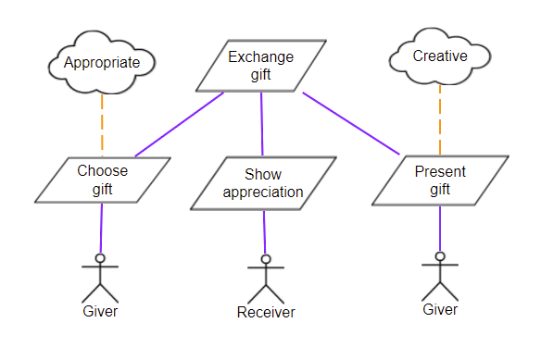

Figure 3: Another representation of goal model of exchange gift scenario

Figure 3 shows that you can have duplicate roles in teh same model and the order of the functional goals in the same level of the hierarchy is not important.

1. Domain Modelling

* Domain model represents the knowledge within the system that the system is supposed to handle.
* A modular unit of knowledge handled by a sociotechnical system
* A domain model consists of domain entities, roles and relationships between them.

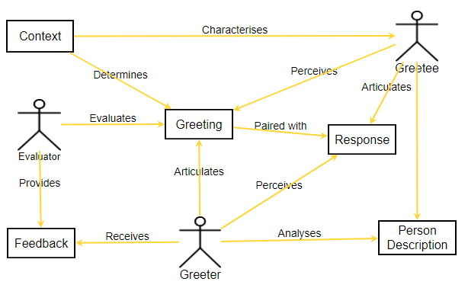

Figure 4: Domain model of the greeting scenario.