An Overview of Goal Modelling and Domain Modelling
- Socio-Technical Systems

A socio-technical system is a software intensive system that has defined operational processes followed by human operators and which operates within an organization.
It is a system that contains both a social aspect, which may be a subsystem, and a technical aspect.

- Goal modelling

Motivational goal models. Motivation goal models are useful in early stage requirements engineering to capture initial understandings, and share these with other stakeholders.

Table 1: Description of notations for goal modelling
Notation | Description
Goals are based on motives, and
describe an intended state of the
environment. Goals can consist of
sub-goals.
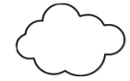 | Quality goals are non-functional  (or quality) goals. These are sometimes  referred to as soft goals.
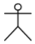 | Roles are the capacities or positions  that are required for achieving of  goals. Roles are played by agents,  which can be humans or artificial.
 | Connection between functional goal and sub-functional goals or the role that aims to fulfil that particular functional goal.
 | Connection between functional goal and quality goal.

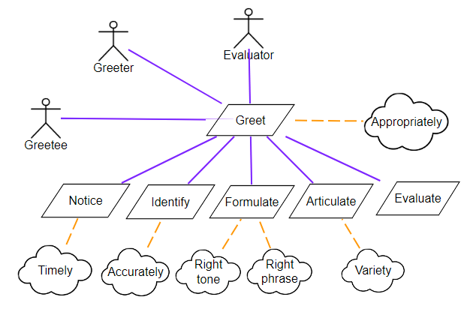
Figure 1: Goal model of greeting scenario

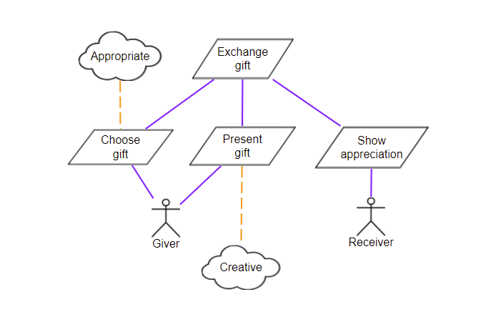
Figure 2: Exchange gift scenario

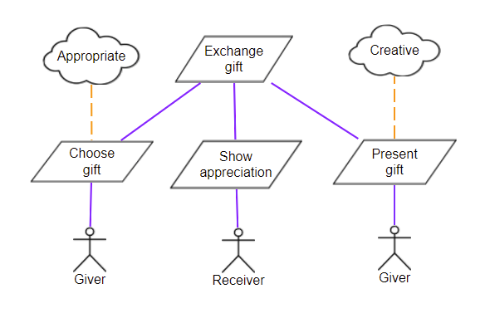
Figure 3: Another representation of goal model of exchange gift scenario
Figure 3 shows that you can have duplicate roles in the same model and the order of the functional goals in the same level of the hierarchy is not important.

- Domain Modelling

Domain model represents the knowledge within the system that the system is supposed to handle.
A domain entity is a modular unit of knowledge handled by a sociotechnical system.
A domain model consists of domain entities, roles and relationships between them.

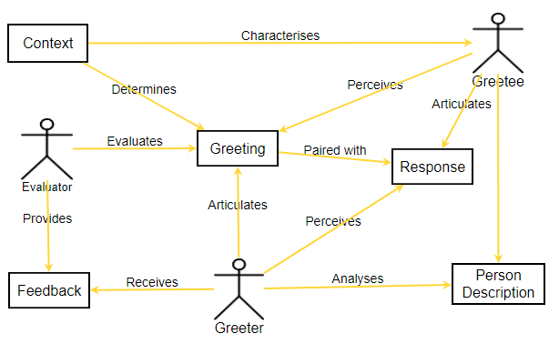
Figure 4: Domain model of the greeting scenario.

