Exam in the course “Agent-Oriented Modelling and Multiagent Systems”

Time: Wednesday, 5 June 2013, 10:00 – 12:00

Instructions

- 11 questions
- Two hours of time for answering
- Questions are in English
- You can answer in English or Estonian
- Provide answers on empty answer sheets
- Number the answers
- Please write on each answer sheet your name and student number
- For each question is shown the maximum number of points
- Illegible answers will not give you any points
- Maximal number of points is 83
- Minimal number of points for passing is 42
- NO mobile phones!
- NO laptops!
- NO additional materials, this is a closed-book exam.

Question 1 (5 p.)

What are the differences between agents and objects?

Question 2 (6 p.)

What is goal and how are goals categorized? Provide examples.

Question 3 (6 p.)

What is knowledge item? What kinds of knowledge items can be distinguished? Provide examples.

Question 4 (15 p.)

Create goal, role, organization, and domain models based on the following motivational scenario:

Scenario name | Commercial fishery
Scenario description | Commercial fishery involves the following steps:  - Fishing;  - Fish transportation;  - Fish processing;  - Selling of fish
Quality description | Fish is brought to land at different locations. Fish has to be sold or processed within 48 hours. Fish needs to be sold at an optimal price. Up-to-date information about the availability of fish is required. Some of the fish is sold as raw and some – as processed.

Question 5 (7 p.)

What kinds of interaction models can be distinguished? Draw examples.

Question 6 (6 p.)

What are the horizontal abstraction layers and vertical aspects of the viewpoint framework? List the types of models under the information aspect.

Question 7 (15 p.)

Decide the types of agents based on the analysis models you created under Question 4 and create agent models, agent acquaintance models, knowledge model(s), and one behavioural scenario for the case study.

Question 8 (5 p.)

What are the three meanings of quality? How are they related to software?

Question 9 (7 p.)

What is the difference between Jason and JADE agent platforms? Provide a short example.

Question 10 (5 p.)

Explain the Prometheus System Overview Diagram below:

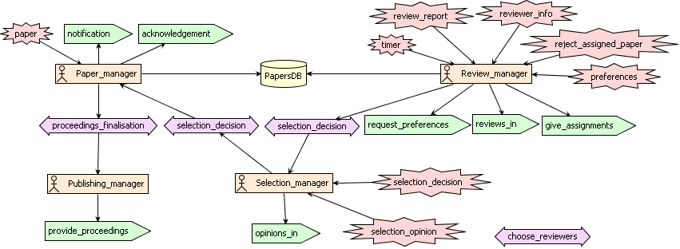

Question 11 (6 p.)

Explain at least two case studies in agent technology from the lectures or from other sources. Argue for or against in each case.

