Exam in the course “Agent-Oriented Modelling and Multiagent Systems”

Time: Wednesday, 29 May 2013, 10:00 – 12:00

Instructions

- 11 questions
- Two hours of time for answering
- Questions are in English
- You can answer in English or Estonian
- Provide answers on empty answer sheets
- Number the answers
- Please write on each answer sheet your name and student number
- For each question is shown the maximum number of points
- Illegible answers will not give you any points
- Maximal number of points is 83
- Minimal number of points for passing is 42
- NO mobile phones!
- NO laptops!
- NO additional materials, this is a closed-book exam.

Question 1 (5 p.)

What are the differences between client-server and peer-to-peer systems? Provide examples.

Question 2 (6 p.)

What is social policy? How are social policies related to roles? Provide example.

Question 3 (6 p.)

What is rule? How are rules related to agents? Provide example.

Question 4 (15 p.)

Create goal model, role models, organization model, and domain model based on the following motivational scenario:

Scenario name | Bush fire management
Scenario description | Bush (forest) fire management involves the following activities:  - Identification of bush fire;  - Rescuing of civilians;  - Fire fighting;  - Maintaining communications;  - Maintaining supply of resources
Quality description | Bush fire is identified by UAVs (Unmanned Aerial Vehicles). Warning of inhabitants should be quick. Inhabitants should be evacuated in the order of fire’s moving. Aircraft and ground units consisting of robots and humans are used in fire fighting. Fire fighting should consider up-to-date information about the situation continuously received from UAVs.

Question 5 (7 p.)

What is expressed by knowledge model? Present examples.

Question 6 (6 p.)

What are the abstraction layers and aspects of the viewpoint framework? List one example for each cell of the framework.

Question 7 (15 p.)

Decide the types of agents based on the analysis models you created under Question 4 and create agent models, agent acquaintance model, knowledge model, and one behavioural scenario for the case study.

Question 8 (7 p.)

What are the differences between the abstract agent architecture and execution loop and BDI agent architecture and execution loop?

Question 9 (5 p.)

Explain the Tropos goal diagram below:

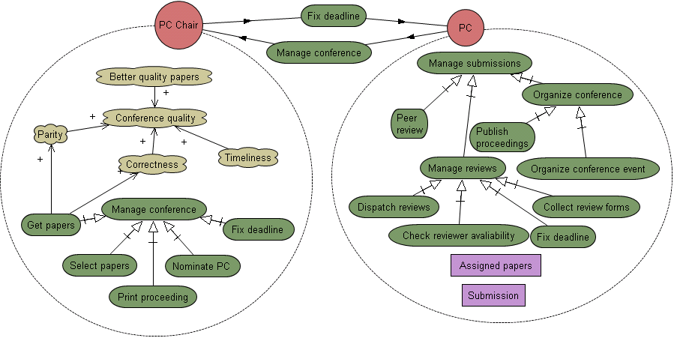

Question 10 (6 p.)

Describe a multiagent system of your choice and explain the benefit of agents in that system.

Question 11 (5 p.)

What are the two ways services are related to a multiagent system? Provide examples.

