Exam in the course “Agent-Oriented Modelling and Multiagent Systems”

Time: Wednesday, 22 May 2013, 10:00 – 12:00

Instructions

- 11 questions
- Two hours of time for answering
- Questions are in English
- You can answer in English or Estonian
- Provide answers on empty answer sheets
- Number the answers
- Please write on each answer sheet your name and student number
- For each question is shown the maximum number of points
- Illegible answers will not give you any points
- Maximal number of points is 83
- Minimal number of points for passing is 42
- NO mobile phones!
- NO laptops!
- NO additional materials, this is a closed-book exam.

Question 1 (5 p.)

What is model? Provide examples.

Question 2 (6 p.)

What is domain entity? How are domain entities related to roles? Provide examples.

Question 3 (6 p.)

What is action? What kinds of actions are there? Provide examples.

Question 4 (15 p.)

Create goal model, role models, organization model, and domain model based on the following motivational scenario:

Scenario name | Flood management
Scenario description | Flood management involves the following steps:  - Identification of flooding;  - Warning inhabitants;  - Calling rescue workers;  - Evacuation of inhabitants;  - Reinforcing flooding points
Quality description | Flooding is identified by sensors at appropriate locations. Inhabitants from most critical areas should be evacuated first. Up-to-date information about the situation should be available. Rescue workers should be allocated and re-allocated dynamically, by considering changes in the situation.

Question 5 (7 p.)

What is expressed by agent models and agent acquaintance model? Present examples.

Question 6 (6 p.)

What are the abstraction layers and aspects of the viewpoint framework? List the types of models under the interaction aspect.

Question 7 (15 p.)

Decide the types of agents based on the analysis models you created under Question 4 and create agent models, agent acquaintance model, knowledge model, and one behavioural scenario for the case study.

Question 8 (5 p.)

What are services in agent-oriented modelling? Provide examples.

Question 9 (7 p.)

Describe the BDI agent architecture and execution loop.

Question 10 (5 p.)

Explain the MaSE plan diagram below:

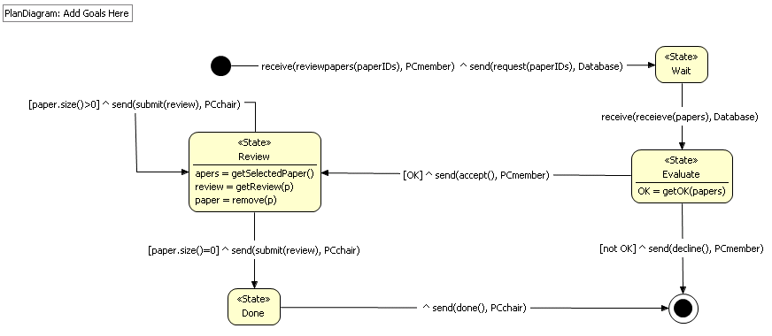

Question 11 (6 p.)

Explain at least two case studies in agent technology from the lectures or from other sources. Argue for or against in each case.

