Exam in the course “Agent-Oriented Modelling and Multiagent Systems”

Time: Thursday, 20 September 2012, 9:30 – 11:30

Instructions

- 14 questions
- Two hours of time for answering
- Questions are in English
- You can answer in English or Estonian
- Provide answers on empty answer sheets
- Number the answers
- Please write on each answer sheet your name and student number
- For each question is shown the maximum number of points
- Illegible answers will not give you any points
- Maximal number of points is 100
- Minimal number of points for passing is 31
- NO mobile phones!
- NO laptops!
- NO additional materials, this is a closed-book exam.

Question 1 (5 p.)

What are the differences between agents and objects?

Question 2 (6 p.)

What are the concepts at the motivation layer of the conceptual space? Please explain how they are related to each other.

Question 3 (6 p.)

What is goal and how are goals categorized? Provide examples.

Question 4 (6 p.)

What is knowledge item? What kinds of knowledge items can be distinguished? Provide examples.

Question 5 (15 p.)

Create goal, role, organization, and domain models based on the following motivational scenario:

Scenario name | Commercial fishery
Scenario description | Commercial fishery involves the following steps:  - Fishing;  - Fish transportation;  - Fish processing;  - Selling of fish
Quality description | Fish is brought to land at different locations. Fish has to be sold or processed within 48 hours. Fish needs to be sold at an optimal price. Up-to-date information about the availability of fish is required. Some of the fish is sold as raw and some – as processed.

Question 6 (5 p.)

Explain the difference between hard security and soft security. Provide examples for both.

Question 7 (7 p.)

What kinds of interaction models can be distinguished? Draw examples.

Question 8 (6 p.)

What are the horizontal abstraction layers and vertical aspects of the viewpoint framework (preferably represent them as a table)? List the types of models under the information aspect.

Question 9 (15 p.)

Decide the types of agents based on the analysis models you created under Question 5 and create agent models, agent acquaintance models, knowledge model(s), and one behavioural scenario for the case study.

Question 10 (5 p.)

What are the three meanings of quality? How are they related to software?

Question 11 (7 p.)

What is the difference between Jason and JADE agent platforms? Provide a short example.

Question 12 (5 p.)

Explain the Prometheus System Overview Diagram below:

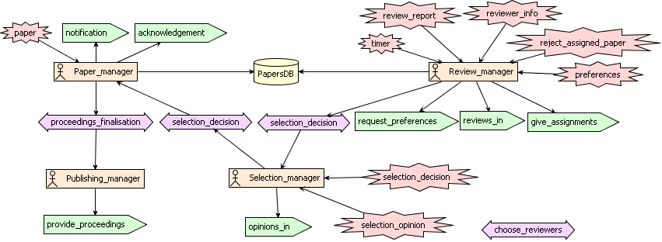

Question 13 (6 p.)

Explain at least two case studies in agent technology from the lectures or from other sources. Argue for or against (will not be punished!) in each case.

Question 14 (6 p.)

Compare Web Services and agents.

