Exam in the course “Agent-Oriented Modelling and Multiagent Systems”

Time: Tuesday, 1 June 2010, 10:00 – 12:00

Instructions

- 14 questions
- Two hours of time for answering
- Questions are in English
- You can answer in English or Estonian
- Provide answers on empty answer sheets
- Number the answers
- Please write on each answer sheet your name and student number
- For each question is shown the maximum number of points
- Illegible answers will not give you any points
- Maximal number of points is 100
- Minimal number of points for passing is 31
- NO mobile phones!
- NO laptops!
- NO additional materials, this is a closed-book exam.

Question 1 (5 p.)

What is model? Provide examples.

Question 2 (6 p.)

What are the concepts at the deployment layer of the conceptual space. Explain how they are related to each other.

Question 3 (6 p.)

What is domain entity? How are domain entities related to roles? Provide examples.

Question 4 (6 p.)

What is action? What kinds of actions are there? Provide examples.

Question 5 (15 p.)

Create goal model, role models, organization model, and domain model based on the following motivational scenario:

Scenario name | Flood management
Scenario description | Flood management involves the following steps:  - Identification of flooding;  - Warning inhabitants;  - Calling rescue workers;  - Evacuation of inhabitants;  - Reinforcing flooding points
Quality description | Flooding is identified by sensors at appropriate locations. Inhabitants from most critical areas should be evacuated first. Up-to-date information about the situation should be available. Rescue workers should be allocated and re-allocated dynamically, by considering changes in the situation.

Question 6 (5 p.)

How does the UAI Cultural Dimension by Hofstede influence software agent design?

Question 7 (7 p.)

What is expressed by agent models and agent acquaintance model? Present examples.

Question 8 (6 p.)

What are the abstraction layers and aspects of the viewpoint framework? List the types of models under the interaction aspect.

Question 9 (15 p.)

Decide the types of agents based on the analysis models you created under Question 5 and create agent models, agent acquaintance model, knowledge model, and one behavioural scenario for the case study.

Question 10 (5 p.)

What are services in agent-oriented modelling? Provide examples.

Question 11 (7 p.)

Describe the BDI agent architecture and execution loop.

Question 12 (5 p.)

Explain the MaSE plan diagram below:

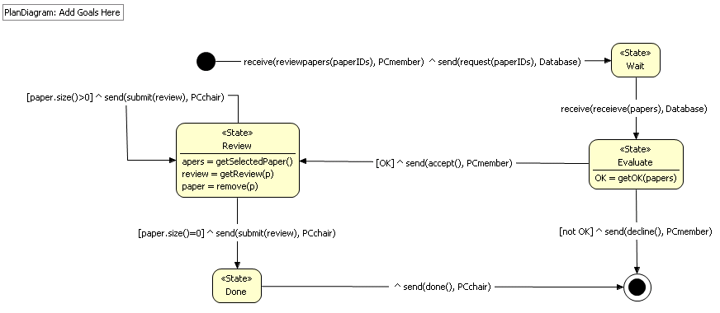

Question 13 (5 p.)

What is the benefit of agents in the case study of Smart Music Player that was overviewed in the course?

Question 14 (7 p.)

What are the differences and similarities between a hybrid cloud application and a multi-agent system?

