Exam in the course “Agent-Oriented Modelling and Multiagent Systems”

Time: Wednesday, 26 May 2010, 17:00 – 19:00

Instructions

- 14 questions
- Two hours of time for answering
- Questions are in English
- You can answer in English or Estonian
- Provide answers on empty answer sheets
- Number the answers
- Please write on each answer sheet your name and student number
- For each question is shown the maximum number of points
- Illegible answers will not give you any points
- Maximal number of points is 100
- Minimal number of points for passing is 51
- NO mobile phones!
- NO laptops!
- NO additional materials, this is a closed-book exam.

Question 1 (5 p.)

What is multi-agent system? Provide examples.

Question 2 (6 p.)

What are the concepts at the system design layer of the conceptual space? Explain how they are related to each other.

Question 3 (6 p.)

What is role? How are roles related to goals? Provide examples.

Question 4 (6 p.)

What is activity? What kinds of activities are there? Provide examples.

Question 5 (15 p.)

Create goal, role, organization, and domain models based on the following motivational scenario:

Scenario name | Distributed car manufacturing
Scenario description | Distributed car manufacturing involves the following steps:  - Production of parts;  - Part transportation;  - Assembling of cars;  - Selling of cars
Quality description | Parts are produced at different locations. There may be several alternative producers of the same type of parts. Production of cars has to be seamless (without breaks). Up-to-date information about the availability of parts is required. Parts have to be purchased at an optimal price.

Question 6 (5 p.)

How does the MAS Cultural Dimension by Hofstede influence software agent design?

Question 7 (7 p.)

What kinds of behaviour models are there? Present examples.

Question 8 (6 p.)

What are the abstraction layers and aspects of the viewpoint framework? List the types of models under the behaviour aspect.
Question 9 (15 p.)

Decide the types of agents based on the analysis models you created under Question 5 and create agent models, agent acquaintance model, knowledge model, and one behavioural scenario for the case study.

Question 10 (5 p.)

Provide at least four examples of quality attributes for software and explain how they can be achieved.

Question 11 (7 p.)

Describe the abstract agent architecture and execution loop.

Question 12 (5 p.)

Explain the Tropos Actor Diagram below:

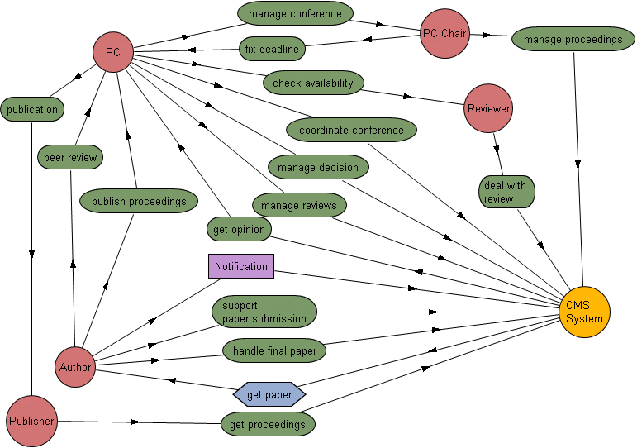
Question 13 (5 p.)

What do agents buy us in the case study of Magic Box / Collage that was overviewed in the course?

Question 14 (7 p.)

What are the differences and similarities between a hybrid cloud application and a multi-agent system?

