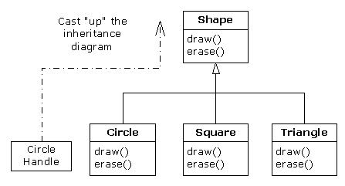

class Shape {
void draw() { /* midagi... */ }
void erase() { /* midagi... */ }
}

/*********
javac lisab faili Shape.class tabeli Shape.method[2], milles on
selle klassi meetodite aadressid:

0 | Shape.draw()
1 | Shape.erase()

*********/

class Circle extends Shape {
/* **********
javac tekitab faili Circle.class aadressite tabeli Circle.method[2]
kui koopia tabelist Shape.method[2]:

0 | Shape.draw()
1 | Shape.erase()

************/

void draw() { /* overriding */ }

/***********

Muutub element Circle.method[0]

0 | Circle.draw()
1 | Shape.erase()

***********/

void setColor( Color c ) { /* uus meetod! */ }

/**********
Tabelisse Circle.method[] lisatakse uus element:

0 | Circle.draw()
1 | Shape.erase()
2 | Circle.setColor()

**********/

public static void main(String arg[]) {

// igas java objektis on peidus muutuja
// methodsTable[ ],milles hoitakse viita
// vastava klassi meetodite tabelile!

Circle ring = new Circle();
// ring.methodsTable =Circle.method; NB!

ring.draw(); // CALL ring.methodsTable[0]

Shape s = ring; // upcasting!
// kuid methodsTable ei muutu!

s.draw(); // CALL s.methodsTable[0]

s.setColor( Color.RED );
/*********
javac annab veateate: klassis Shape ei ole meetodit setColor()
*********/
ring.setColor( Color.RED );
// CALL ring.methodsTable[2]
}
}

