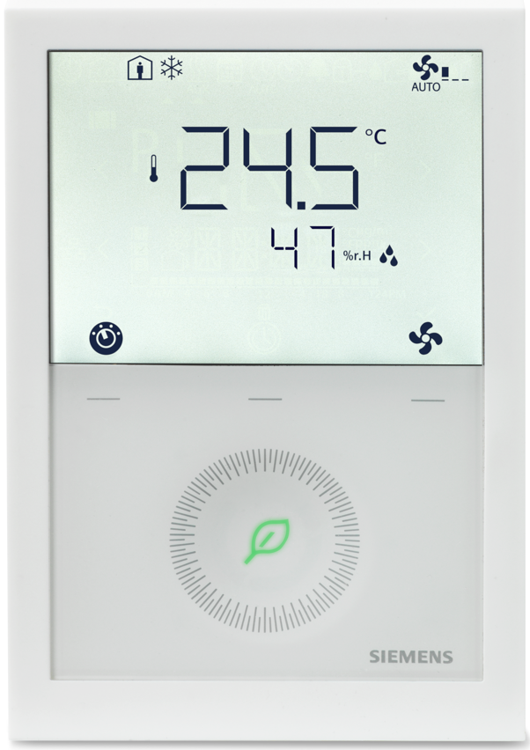   | - Powered with AC 230V or AC 24V  - Temperature and humidity measurement  - Temperature or temperature and humidity control  - Heating or cooling  - On/Off, PWM, On/Off 3-wire or 3-position control of heating / cooling actuators  - Automatic or manual fan speed control: 1-speed, 3-speed or DC Fan  - Automatic or manual heating / cooling changeover  - Multifunctional inputs for keycard contact, external sensor, etc.  - Adjustable commissioning and control parameters  - Backlit LCD  - KNX bus communications

Plant diagram

Description  of general functions | When"2-pipe fan coil unit" is selected (via DIP switches or tool), the following functions are available.  For details see basic documentation (A6V11545892 for RDG200KN)

 | Control sequence
 | - Control of thermal or motorized valve actuators (On/Off, On/Off 3-wire, PWM or 3-position)
 | - Heating only or cooling only
 | - Manual or automatic heating / cooling changeover |  | Other functions
 |  |  | - Button lock
 | Fan control |  | - 2nd line display setting
 | - 1-speed, 3-speed or DC fan, automatic |  | - Setting access with password protection
 | - Manual speed control on room thermostat |  | - Valve exercising to prevent from gripping
 | - Fan control in dead zone
 | - Fan start related to the coil temperature |  | Humidity control
 |  |  | - By shifting temperature setpoint
 | Room and humidity temperature measurement |  | - By controlling an external equipment
 | - Internal sensor
 | - External room temperature sensor |  | 3 multifunctional inputs
 | - External return air sensor |  | - Temperature (room, return air, changeover …)
 |  |  | - Digital (changeover, presence, window contact …)
Device list | <START StandardDeviceList>  <END StandardDeviceList>
  Legend | Type of unit | Data sheet | Product no. | Qty.
  N1 | Room thermostat with KNX communications, AC 24 V or AC 230 V, for fan coil units and universal applications | A6V11545853 | RDG200KN | 1
  YHC | 2- or 3-port valve |  | V..P4.. | 1
   | Actuator for small valves, 2-position, PWM, 3-position, On/Off or DC 0…10 V, AC 24 V or AC 230 V |  | SS..3.. / ST..2.. | 1
 | + For selection of actuators and valves please refer to the product catalog

Optional | <START OptionalDeviceList>  <END OptionalDeviceList>
  Legend | Type of unit | Data sheet | Product no. | Qty.
  B1 | Cable temperature sensor PVC 2.5 m, NTC 3 kOhm, with connectors 2.8 x 0.8 mm | N1840 | QAH11 | 1
  B2 | Cable temperature sensor PVC 2.5 m, NTC 3 kOhm, with connectors 2.8 x 0.8 mm | N1840 | QAH11 | 1

Variants | <START VariantsDeviceList>  <END VariantsDeviceList>
  Legend | Type of unit | Data sheet | Product no. | Qty.
  B1a | Room temperature sensor NTC 3 kOhm | N1747 | QAA32 | 1

Connection diagram
  DC 0…10 V fan | 1-speed/3-speed fan

 | N1 | Room thermostat RDG200KN |  | B1, B2, B3 | Optional external sensors
 | M1 | 1-speed, 3-speed or DC 0…10 V fan |  | S1, S2, S3 | Optional switches
 | YHC | Heating / cooling valve actuator  (On/Off, On/Off 3-wire, PWM or 3-position) |  | CE+, CE- | KNX bus
Notes
- Type of control output selectable via DIP switches and parameter P201 Y1&Y3 (On/Off, On/Off 3-wire, PWM or 3-position).
- Multifunctional input function selectable via parameters P150…P156 (Room temp. / return air temp, H/C changeover, window contact, dewpoint sensor, fault input)
- 3-speed, 1-speed or DC fan selectable via parameter P351 +[P356 … P365]
- [P400] Q1 – Switch On in H demand
- [P401] Q2 – No function
- [P402] Q3 – Switch ON in C demand

Setting option | Device can be set via
 | - DIP switches and parameters  - Smartphone APP PCT Go for Android™ ☑ [P500] NFC  - Remotely via KNX tools such as Siemens ACS or ETS5 |  |  | 
DIP switch settings | Application | DIP switches |  |  | Remark
 | Remote configuration (factory setting) |  |  |  | Application, outputs and parameters will be downloaded via commissioning tool
 | Remote configuration (factory setting) | ON = | OFF =
 | Remote configuration (factory setting) | DIP No.: 1…8 | DIP No.: 1…8
Application | 2-pipe fan coil unit |  |  |  | Set DIP switch 1
Control outputs | - Heating / cooling actuator  On/Off, PWM or On/Off 3-wires |  |  |  | Set DIP switch 7  If DIP = "2 position (PWM)":  Select On/Off, PWM or On/Off 3-wires via P201  - On/Off = 4 (factory setting)  - PWM = 3  - On/Off 3-wires = 2
Control outputs | - Heating / cooling actuator 3-position
Fan | - DC fan |  |  |  | Set DIP switch 6  If DIP = "3-speed fan":  Select 1-speed fan, 3-speed fan via P351  - 1-speed fan = 1  - 3-speed fan = 2
Fan | - 1-speed fan, 3-speed fan

Main settings | Function | Parameters | Remarks
Control sequence | Select the control sequence(s) of the controller | P001 = 0…3 | 0 = Heating only
 |  |  | 1 = Cooling only (Factory setting)
 |  |  | 2 = H/C changeover auto
 |  |  | 3 = H/C changeover manual
General parameters | User operating mode profile | P002 = 1…3 | 1 = Auto – Protection (Factory setting)  2 = Auto – Comfort – Economy – Protection  3 = Auto – Protection Hospitality
 | User fan mode selection | P003 = 0...3 | 0 = Auto – Manual (Factory setting)  1 = Manual  2 = Auto – Manual – Protection  3 = Auto – Protection
 | Standard temperature display | P008 = 0, 1 | 0 = Room temperature (Factory setting)  1 = Setpoint
 | Additional display information | P009 = 0…5 | 0 = --- (No display) (Factory setting)  1 = °C and °F  2 = Outside temperature (via bus)  3 = Time of day (12 h) (via bus)  4 = Time of day (24 h) (via bus)  5 = Humidity
 | Comfort setpoint | P011 = 5...40 °C | Factory setting 21 °C
 | Economy heating setpoint | P019 = OFF, 5 °C…P020 | Factory setting 15 °C
 | Economy cooling setpoint | P020 =OFF,  P019…40 °C | Factory setting 30 °C

Multifunctional inputs, digital input | External / return air temperature | P150 = 1 | Factory set on X1 (NTC 3k | LG-Ni1000)
Multifunctional inputs, digital input | No function | P153 = 0 | Factory set on X2 (H/C changeover | …)
 | Window contact | P155 = 3 | Factory set on U1
Inputs selection | 0 = --- (no function) |  | 7 = Monitor input (Digital)(DI)
 | 1 = Room temp ext. sensor / return (AI) |  | 8 = Monitor input (Temp) (AI)
 | 2 = H/C changeover (AI/DI) |  | 9 = Supply air sensor (AI)
 | 3 = Window contact [PROT] (DI) |  | 10 = Presence detector / card reader (DI)
 | 4 = Dewpoint sensor (DI) |  | 11 = External temperature limit (AI)
 | 5 = Enable electric heater (DI) |  | 12 = Coil temperature (AI)
 | 6 = Fault input (DI) |  | 13 = Hotel presence detector / card reader (DI)
Fan setting | Fan type 1-speed | P351 = 1
Fan setting | Fan type 3-speed | P351 = 2
Fan setting | DC fan 0…10V (ECM) | P351 = 3
Humidity control | Control strategy | P450 = 0 | Only temperature control (default)
Humidity control |  | P450 = 1 | Temperature and humidity control
Humidity control | Humidity setpoint high | P024 = OFF, P026 or 20…90 % | Factory setting: 50
Humidity control | Humidity setpoint low | P026 = OFF, 20…90 % or P024 | Factory setting: OFF
Humidity control | Max. shift temp setpoint (Dehumid.) | P461 = -3...3 K | Temperature setpoint deviation due to the humidity in the room
Engineering | For a complete list of parameters and detailed description of functions see basic documentation:  A6V11545892 for RDG200KN; PI controller settings [P050 … P064]  For engineering of RDG in conjunction with Synco see CE1P3127 (Communication via the KNX bus for Synco 700, Basic documentation)

Preselection reception: Com. Obj 1 bit
Time switch reception: Com. Obj ---
State transmission: Com. Obj ---
Window status input Local
Presence detector input Local | Bus
Presence detector function Standard

Issued by  Siemens Switzerland Ltd  Smart Infrastructure  Global Headquarters  Theilerstrasse 1a  CH-6300 Zug  Tel. +41 58 724 2424  www.siemens.com/buildingtechnologies | © Siemens Switzerland Ltd, 2020  Technical specifications and availability subject to change without notice.

