Contract Management

Bizagi Modeler

Table of Contents
Contract Management 1
Bizagi Modeler 1
1 Stakeholders (Stakeholder documentation) 8
1.1 Main Process 9
1.1.1 Process Elements 9
1.1.1.1 Activity 9
1.1.1.2 Activity 9
1.1.1.3 Activity 9
1.1.1.4 Legal area worker 9
1.1.1.5 Contract owner 9
1.1.1.6 Consenter 10
2 Consenter (Stakeholder documentation) 11
2.1 Main Process 12
2.1.1 Process Elements 12
2.1.1.1 Audit contract 12
2.1.1.2 Search contracts 14
3 Contract owner (Stakeholder documentation) 15
3.1 Main Process 16
3.1.1 Process Elements 16
3.1.1.1 Activity 16
3.1.1.2 Activity 16
3.1.1.3 Attach an alert 16
3.1.1.4 Request draft assessment 17
3.1.1.5 Audit contract 17
3.1.1.6 Search contracts 19
4 Legal area worker (Stakeholder documentation) 20
4.1 Main Process 21
4.1.1 Process Elements 21
4.1.1.1 Activity 21
4.1.1.2 Activity 21
4.1.1.3 Activity 21
4.1.1.4 Activity 21
4.1.1.5 Activity 21
4.1.1.6 Activity 22
4.1.1.7 Attach an alert 22
4.1.1.8 Audit contract 22
4.1.1.9 Update status from draft 24
4.1.1.10 Update status from In renewal 24
4.1.1.11 Update status from In negotiation 24
4.1.1.12 Update status from Released 25
4.1.1.13 Update status from Locked 25
4.1.1.14 Search contracts 26
5 Contract Management 27
5.1 Contract Management 28
5.1.1 Process Elements 28
5.1.1.1 Event 28
5.1.1.2 Gateway 28
5.1.1.3 Save digital copy of signed contract 28
5.1.1.4 Gateway 29
5.1.1.5 Request approval and receive feedback 29
5.1.1.6 Is Approved? 30
5.1.1.7 Gateway 30
5.1.1.8 Notify draft denial 30
5.1.1.9 Notify contract acceptance 30
5.1.1.10 Event 31
5.1.1.11 Notify cancellation 31
5.1.1.12 Start 31
5.1.1.13 Register cancellation 31
5.1.1.14 Cancel request 31
5.1.1.15 Enable contract execution 32
5.1.1.16 Draft authoring 32
5.1.1.17 Employee 33
5.1.1.18 Legal Team Employee 33
5.1.1.19 Contract Request 33
5.1.1.20 Contract Authoring 33
5.1.1.21 Contract Negotiation and Approval 33
5.1.1.22 Contract Signing 33
5.2 Draft authoring 34
5.2.1 Process Elements 34
5.2.1.1 Edit draft 34
5.2.1.2 Is Approved? 35
5.2.1.3 Contract requester consent 35
5.2.1.4 Gateway 35
5.2.1.5 Event 36
5.2.1.6 All approbations finished 36
5.2.1.7 Legal representative consent 36
5.2.1.8 Gateway 36
5.2.1.9 Event 37
6 Assess Draft 38
6.1 Assess draft 39
6.1.1 Process Elements 39
6.1.1.1 Start 39
6.1.1.2 Event 39
6.1.1.3 Assess Draft 39
6.1.1.4 Evaluator 40
7 Request approval and receive feedback 41
7.1 Request approval and receive feedback 42
7.1.1 Process Elements 42
7.1.1.1 Start 42
7.1.1.2 Receive feedback 42
7.1.1.3 Event 43
7.1.1.4 Send draft for approval 43
7.1.1.5 Contract owner 43
8 Contract tracking 44
8.1 Contract tracking 45
8.1.1 Process Elements 45
8.1.1.1 Register audit feedback 45
8.1.1.2 Convergence 45
8.1.1.3 Start 46
8.1.1.4 Program upcoming alert 46
8.1.1.5 More alerts upcoming? 46
8.1.1.6 Inform participants 46
8.1.1.7 Is a meeting? 46
8.1.1.8 Gateway 47
8.1.1.9 Convergence 47
8.1.1.10 Send status message to participant 47
8.1.1.11 Date alarm 47
8.1.1.12 No more upcoming alerts 48
8.1.1.13 Is audit meeting? 48
8.1.1.14 Save feedback externally 48
8.1.1.15 Legal team member 48
9 Update contract status 49
9.1 Update contract status 50
9.1.1 Process Elements 50
9.1.1.1 Manage status change 50
9.1.1.2 Notify participants 50
9.1.1.3 Start 50
9.1.1.4 Event 51
10 Resources 52
10.1 Contract Owner (Entity) 52
10.2 Consenter (Entity) 52
10.3 Legal team employee (Entity) 52
10.4 Evaluator (Role) 52

Stakeholders (Stakeholder documentation)

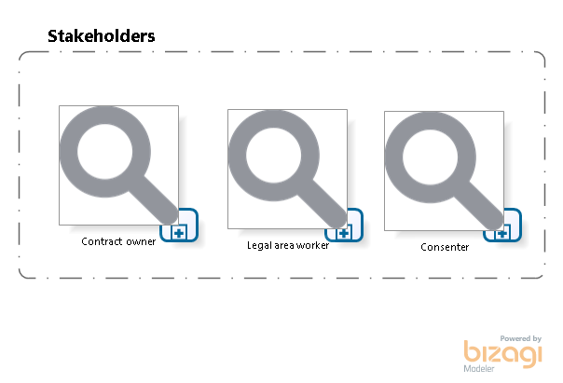

Version: 1.0
Author: DiegoO

Main Process

Process Elements

Activity
Process
Contract owner (Stakeholder documentation) - Main Process

Activity
Process
Consenter (Stakeholder documentation) - Main Process

Activity
Process
Legal area worker (Stakeholder documentation) - Main Process

Legal area worker
Description
Is every employee from the legal department able to participate in contract management.

Contract owner
Description
Can be any employee empowered to request contracts within the company.

Consenter
Description
Is every contract owner and the legal representative. This is due to the necessity of consent from the contract owner and the company legal representative.

Consenter (Stakeholder documentation)

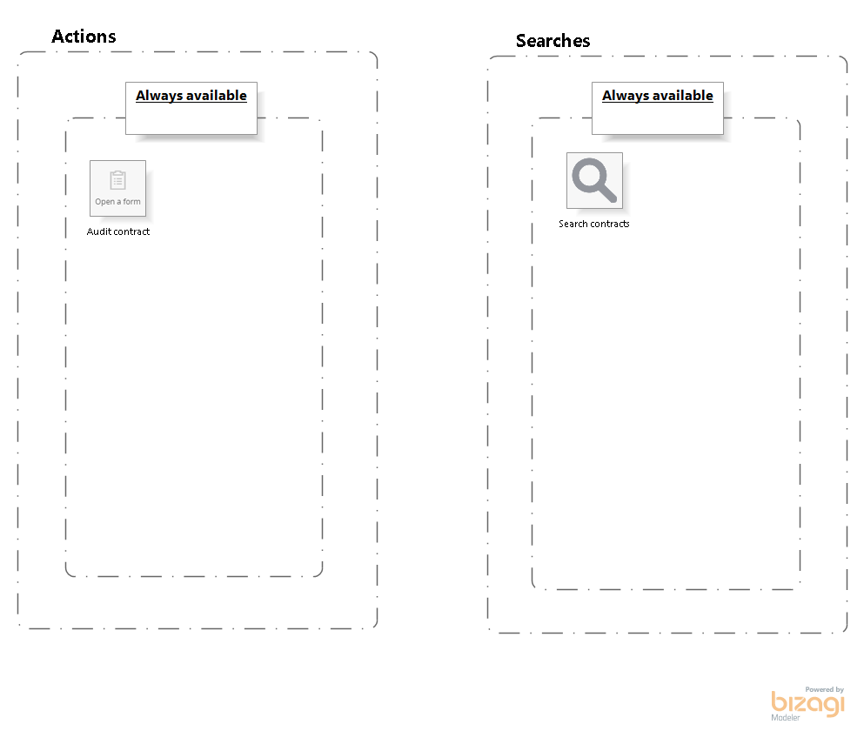

Version: 1.0
Author: DiegoO

Main Process

Process Elements

Audit contract
Description
Queries the contract request, displaying all the information related to every version of the contract.

Associated form

Applied to all Stakeholders
No
Can be launched from:
Me
Is visible when:
Always

Search contracts
Description
Allows the stakeholder to search all the contracts saved, and filter the search results.

Search form
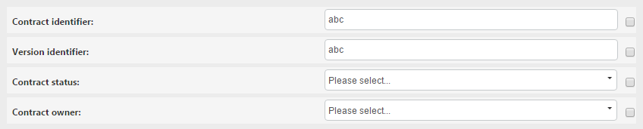

Contract owner (Stakeholder documentation)

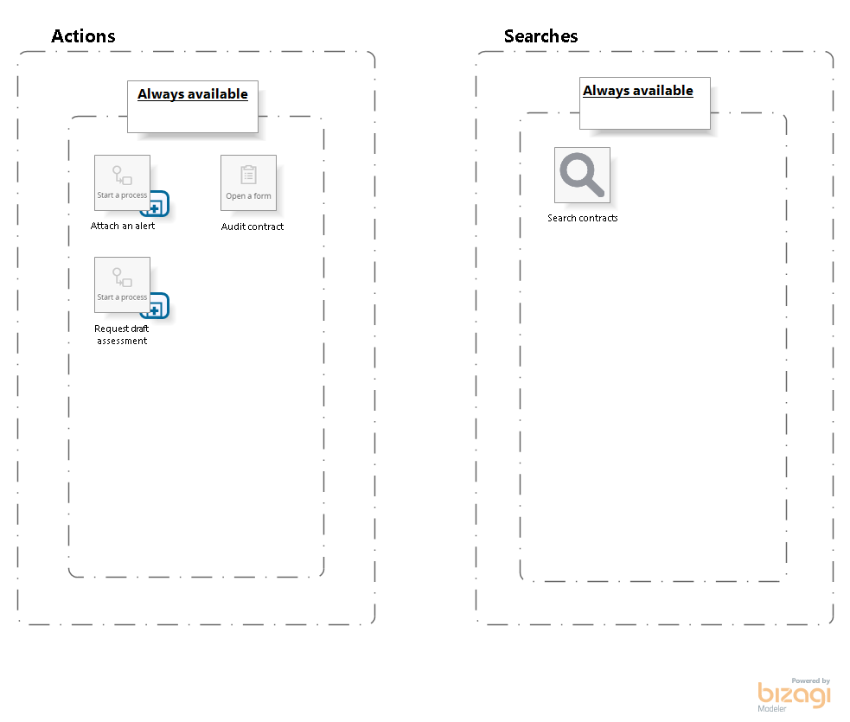

Version: 1.0
Author: DiegoO

Main Process

Process Elements

Activity
Process
Contract tracking - Contract tracking

Activity
Process
Assess Draft - Assess draft

Attach an alert
Description
Launches a new instance of the Contract Tracking process, allowing the user to relate alerts and register feedback from meetings regarding the contract.

Is a batch action?
No
Applied to all Stakeholders?
No
Can be launched from
Me
Is visible when:
Always

Request draft assessment
Description
Starts the Assess draft process. This acction allows the contract owner to require assessments to any user enabled to assess a contract.

Is a batch action?
No
Applied to all Stakeholders?
No
Can be launched from
Me
Is visible when:
Always

Audit contract
Description
Queries the contract request, displaying all the information related to every version of the contract.

Associated form
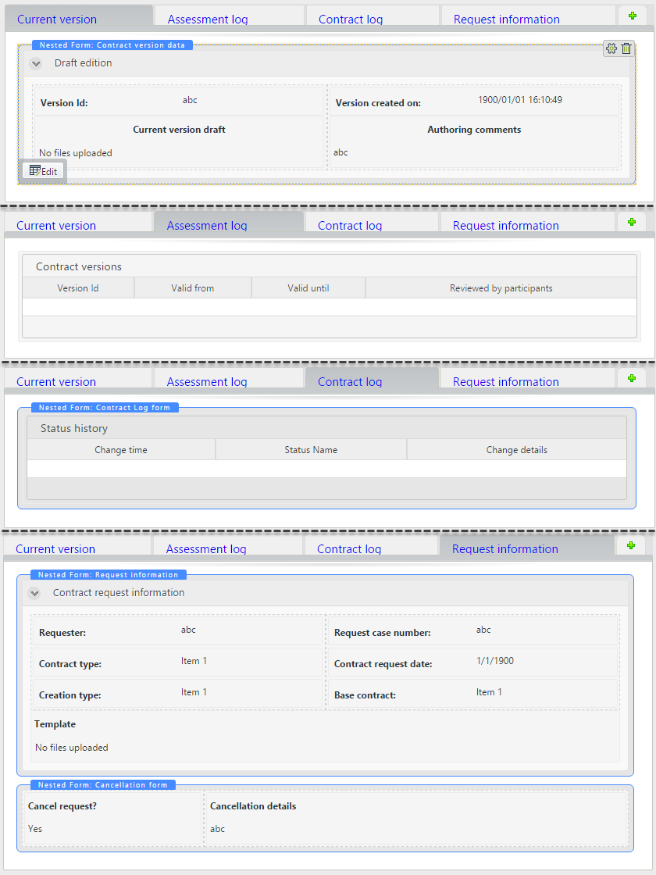

Applied to all Stakeholders
No
Can be launched from:
Me
Is visible when:
Always

Search contracts
Description
Allows the stakeholder to search all the contracts saved, and filter the search results.

Search form

Legal area worker (Stakeholder documentation)

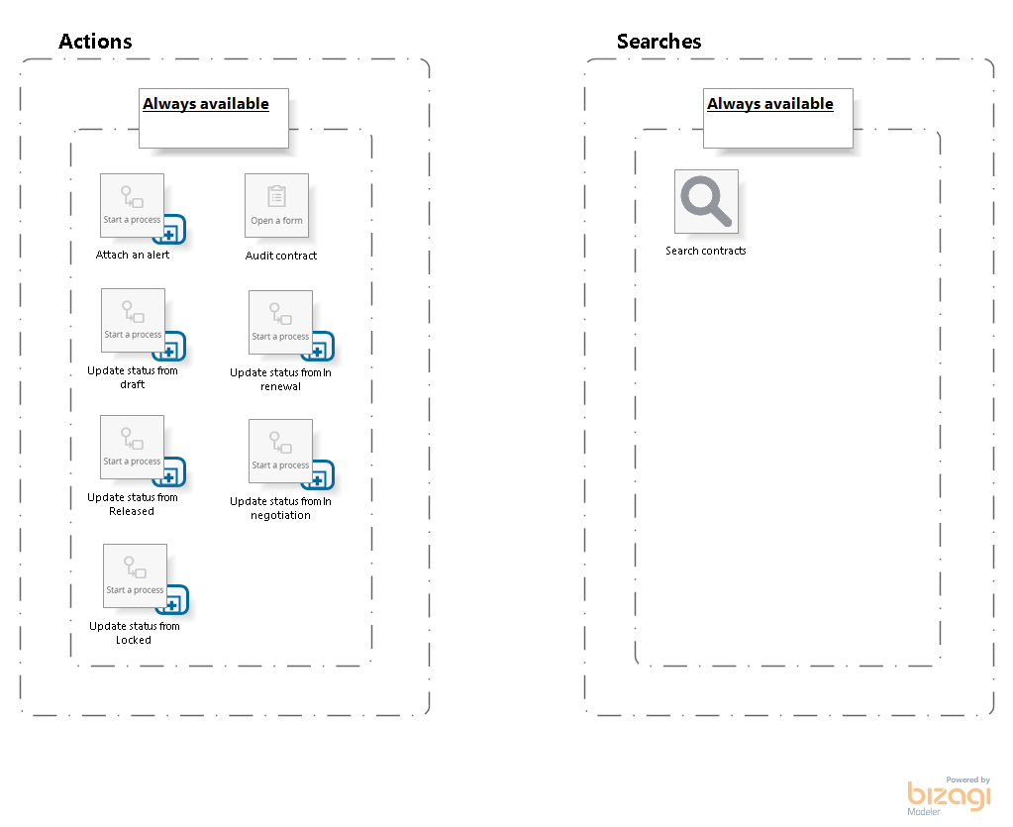

Version: 1.0
Author: DiegoO

Main Process

Process Elements

Activity
Process
Contract tracking - Contract tracking

Activity
Process
Update contract status - Update contract status

Activity
Process
Update contract status - Update contract status

Activity
Process
Update contract status - Update contract status

Activity
Process
Update contract status - Update contract status

Activity
Process
Update contract status - Update contract status

Attach an alert
Description
Launches a new instance of the Contract Tracking process, allowing the user to relate alerts and register feedback from meetings regarding the contract.

Is a batch action?
No
Applied to all Stakeholders?
No
Can be launched from
Me;Processess
Is visible when:
Always

Audit contract
Description
Queries the contract request, displaying all the information related to every version of the contract.

Associated form

Applied to all Stakeholders
No
Can be launched from:
Me
Is visible when:
Always

Update status from draft
Description
Updates every selected contract status, and then notifies every participant.

Is a batch action?
Yes
Applied to all Stakeholders?
No
Can be launched from
Me
Is visible when:
The current status of the contract is a draft.

Update status from In renewal
Description
Updates every selected contract status, and then notifies every participant.

Is a batch action?
Yes
Applied to all Stakeholders?
No
Can be launched from
Me
Is visible when:
The current status of the contract is a renewal.

Update status from In negotiation
Description
Updates every selected contract status, and then notifies every participant.

Is a batch action?
Yes
Applied to all Stakeholders?
No
Can be launched from
Me
Is visible when:
The current status of the contract is In negotiation.

Update status from Released
Description
Updates every selected contract status, and then notifies every participant.

Is a batch action?
Yes
Applied to all Stakeholders?
No
Can be launched from
Me
Is visible when:
The current status of the contract is Released.

Update status from Locked
Description
Updates every selected contract status, and then notifies every participant.

Is a batch action?
Yes
Applied to all Stakeholders?
No
Can be launched from
Me
Is visible when:
The current status of the contract is Locked.

Search contracts
Description
Allows the stakeholder to search all the contracts saved, and filter the search results.

Search form

Contract Management

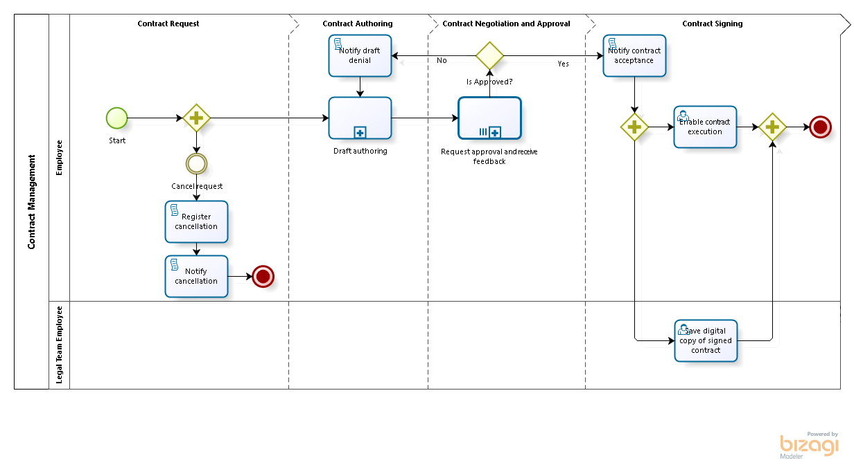

Version: 1.0
Author: DiegoO
This process can be started from:
New Case

Contract Management
Description
The example explained in this document is depicting a Contract management unstructured process, where any sort of contract can be driven from its request to its expiration. Since a process to thoroughly manage any kind of contract would have to consider an enormous number of situations, this process approach is rather general, relying in the tools offered by Bizagi to manipulate every case and task differently.

Scope: The process starts when a contract is required and a Contract owner creates a request which, with assessment of internal employees and defined participants (acting as representatives of the other parties of the contract), results in a released contract. Any modification to the status of the contract is supported, as well as meeting alarms and tracing. Nonetheless, this process does not support direct management of the document itself, namely terms and conditions, policies, constraints, etc.

As mentioned before, this process heavily relies on the use of Bizagi 11 features options, taking advantage of the Experience Design concept to depict an unstructured process.

Unstructured processes are those which you may catalog as highly unpredictable or dynamic, mainly because these processes may involve, at some point, a very large number of possible workflow alternatives.
It represents how the Stakeholders (knowledge workers) are able to make decisions to define the flow of a case, that cannot be predicted beforehand.
The scope of the Contract management case is the assessed release of a contract and the control of its meetings and status changes.

Through Experience Design you will be able to make the most of: Empowering knowledge workers, presenting a personalized user experience, and using contextualized BPM capabilities, among others.

Process Elements

Event

Gateway

Save digital copy of signed contract
Description
Prompts for a digital signed copy of the accepted contract.

Performers
Legal team employee
Form:
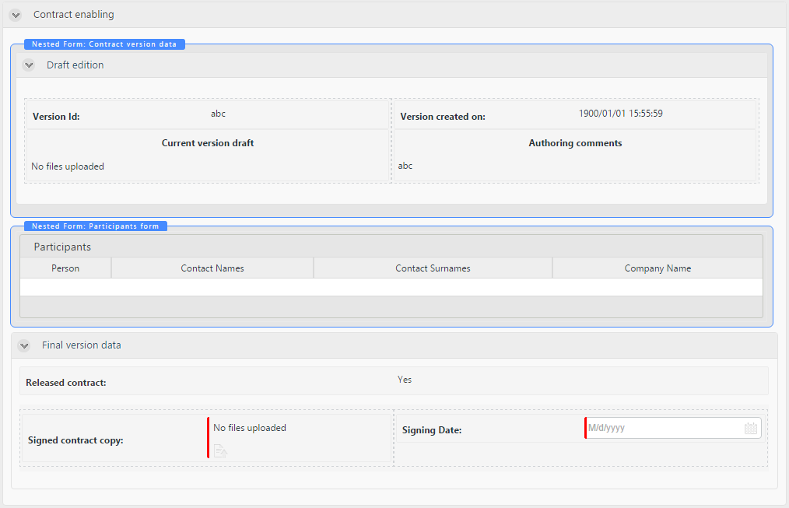

Notify assignment
No

Gateway
Description
This gateway enables the Cancel request event so that the requester can execute it if consider it necessary at any time.

Request approval and receive feedback
Description
This process allow the contract owner to register all participant's feedback and their approval.

Loop type
Multi-Instance
MI Ordering
Parallel
Flow Condition
All
Process
Request approval and receive feedback - Request approval and receive feedback

Is Approved?
Description
This gateway identifies whether all participants approved the contract version.

Gates
Yes
Condition
All participants approved the contract version.
No
Condition
At least one participant rejected the contrac version.

Gateway

Notify draft denial
Description
Notifies all participants about the contract version denial through e-mail.

On exit actions
Rule to create the e-mail that inform the participants regarding the contract version denial.

Notify contract acceptance
Description
Notifies all participants about the contract version acceptance through e-mail.

On exit actions
Rule to create the e-mail that inform the participants regarding the contract version acceptance.

Event

Notify cancellation
Description
Notifies all participants about the contract cancellation through e-mail.

On exit actions
Rule to create the e-mail that must be sent in this task.

Start
Description
Starts a new contract request, allowing the user to select participants, what sort of contract will request and an existing base contract if needed.

Actions
Type | Description
On Exit | Automatically fills information in attributes such as the contract owner, request date, initial version consecutive, and the case number.

Register cancellation
Description
Registers a new cancelled status in the log, and updates the current status to cancelled.

On exit actions
Rule to add a new status log as "Cancelled", and updates the current status of the contract as cancelled.

Cancel request
Description
If the contract is meant to be cancelled, the contract owner must provide explanation regarding its new status.

Enable contract execution
Description
Sets the contract as available, to be refered in other processes.

Performers
Contract Owner
Form:
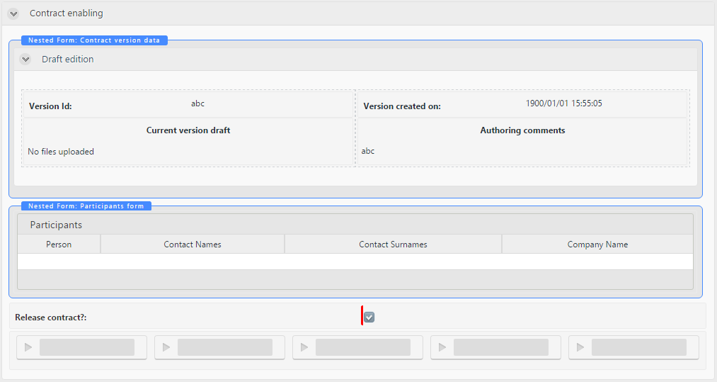

Notify assignment
No
Actions
Type | Description
On Exit | Add a new log record with the status "Released" and update the current status of the contract as "Released".

Draft authoring
Go to details
Description
This process ensures a version approved and consented by the contract owner and the legal representative, in order to be ready for external parties to assess.

Actions
Type | Description
On Enter | Create a new log record with the "Draft" or "Renewal" status, whether the renewal option is selected or not.
On Enter | Assign a new identifier to the current contract request.
On Exit | Create a new log record with the status "In negotiation". And set the contract current status as "In negotiation".

Employee

Legal Team Employee

Contract Request

Contract Authoring

Contract Negotiation and Approval

Contract Signing

Draft authoring
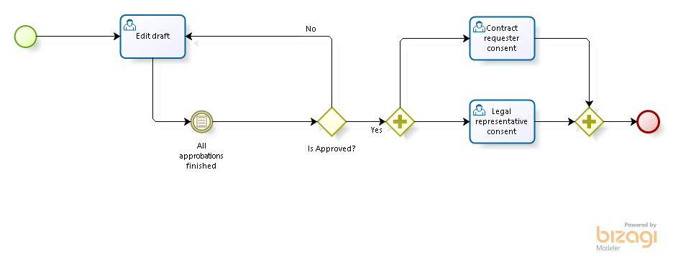

Process Elements

Edit draft
Description
Configure the contract lines, set terms and conditions, define payment structure and add additional contract data for the draft. The contract must be uploaded as a document.

Define the required approvals and the for the contract. Furthermore, the case displays the history of modifications and feedbacks, as well as the option to cancel the creation of the contract.

Performers
Contract Owner
Actions
Type | Description
On Enter | Create a new contract version copying the current attachment file. Add the new version to the versions log.
On Enter | If it is the first version of the contract and it has been set as a renewal, copy the base contract file to the new contract.
On Exit | Check if at least one assessment has been required. Otherwise, do not allow the task to continue.

Is Approved?
Description
This gateway verifies if all assessments resulted in a positive review.

Gates
No
Condition
If at least one assessment is a rejection of the current version of the contract.
Yes
Condition
If all assessments resulted in the current version acceptance.

Contract requester consent
Description
Prompts for consent of the current contract version to be presented to the external parties.

Performers
Consenter
Notify assignment
No
Actions
Type | Description
On Enter | Automatically set the assignation date and the contract owner to assign the task.
On Exit | Register the time in which the consent was given.

Gateway
Description
This gateway is a convergence point after the consent from both performers is registered.

Event

All approbations finished
Description
When all assessments are finished, the process continue.

Legal representative consent
Description
Prompts for consent of the current contract version to be presented to the external parties.

Performers
Consenter
Notify assignment
No
Actions
Type | Description
On Exit | Register the time in which the consent was given.
On Enter | Automatically set the assignation date and the legal representative to assign the task.

Gateway
Description
This gateway enables the legal representative and a the contract owner to give the final consent to the version, in order to present it to the external parties.

Actions
Type | Description
On Exit | Set the current version as a version which needs consent.

Event

Assess Draft

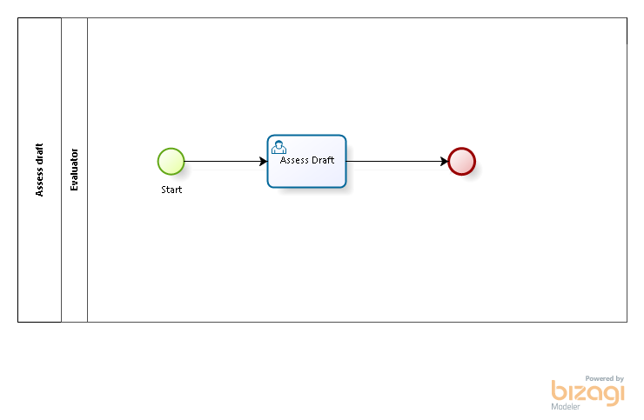

Version: 1.0
Author: DiegoO
This process can be started from:
Actions

Assess draft
Description
This process allows the evaluation of a contract version before any third party review. The evaluator registers its feedback and approval or rejection.

Process Elements

Start
Description
This start the process when a new assess is required after a draft modification, allowing the contract owner to select the evaluator.

Actions
Type | Description
On Exit | Assign the current date to the assessment request date attribute.

Event

Assess Draft
Description
Register all observations, recomendations and corrections to the draft, as well as the approval or rejection of the current draft.

Performers
Evaluator
Form:
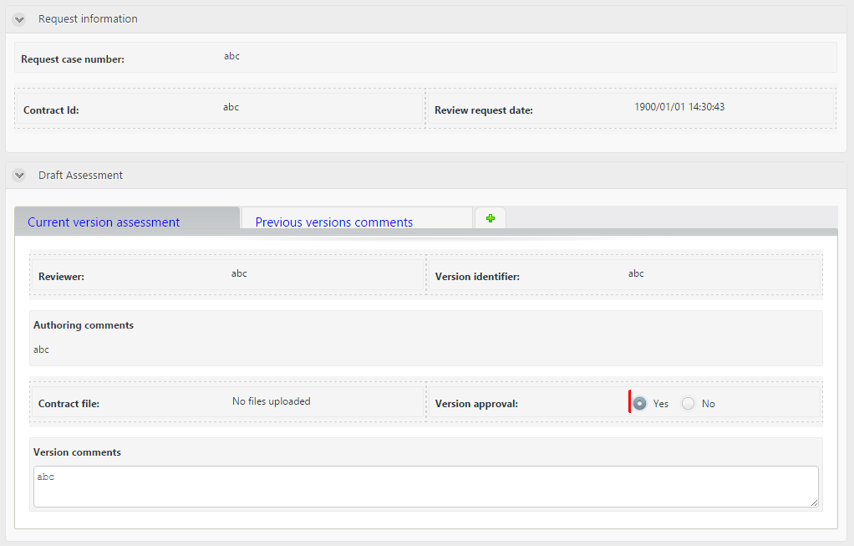

Evaluator

Request approval and receive feedback

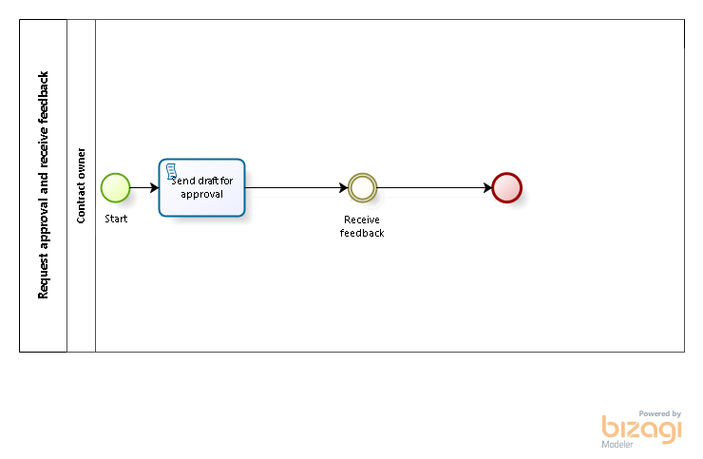

Version: 1.0
Author: DiegoO

Request approval and receive feedback
Description
This process is intended to send the contract and register the version feedback from every participant (External party).

Process Elements

Start
Description
Creates an instance of the process.

Actions
Type | Description
On Exit | Assign the current contract version attribute to the contract to be evaluated attribute.

Receive feedback
Description
Receive and register all feedback given from each participant.

Actions
Type | Description
On Exit | Record the date in which the feedback was registered.

Event

Send draft for approval
Description
Send the current version to participants for approval.

On exit actions
Send an email with the draft.

Contract owner

Contract tracking

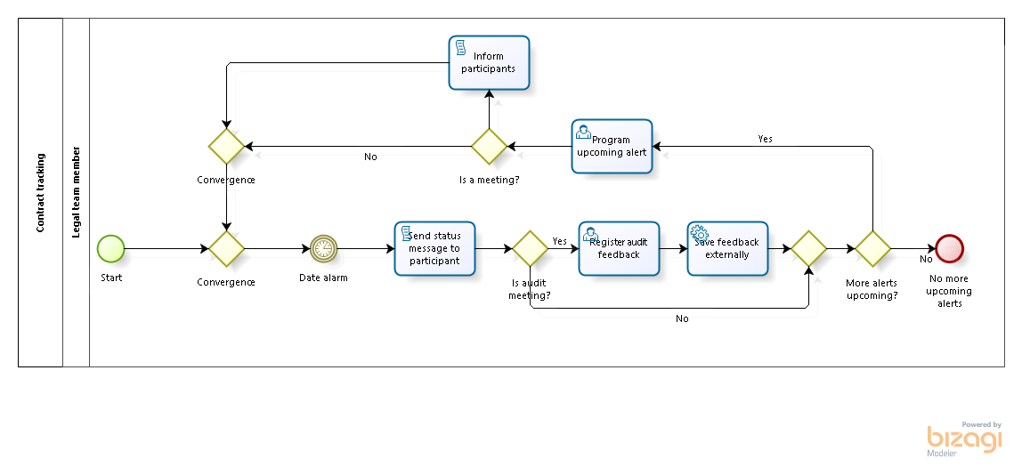

Version: 1.0
Author: DiegoO
This process can be started from:
Actions

Contract tracking
Description
This process is aimed to keep a control of milestones and register feedback of meetings regarding the contract.

Process Elements

Register audit feedback
Performers
Legal team employee
Notify assignment
No
Actions
Type | Description
On Enter | Create a new meeting in the log.
On Exit | Set the current date to the registered meeting date.

Convergence
Description
This gateway is a convergence point.

Gates
Date alarm

Start
Description
When starting the process, select when will the alert be launched, if is a meeting and its description.

Actions
Type | Description
On Exit | Set the alarm creation time as now.

Program upcoming alert
Description
Allows the user to select when will the alert be launched, if is a meeting and its description.

Performers
Legal team employee

More alerts upcoming?
Description
If a new milestone is required proceed to register its details. Otherwise, end the process.

Gates
No
Condition
If any alert is required.
Yes
Condition
If a new alert is required.

Inform participants

Is a meeting?
Description
This gateway evaluates if the new alarm was created due to a meeting.

Gates
No
Condition
Do not alert any participants if the next milestone is not a meeting.
Inform participants
Condition
Inform the participants in case there is an upcoming meeting.

Gateway
Description
This gateway is a convergence point.

Gates
More alerts upcoming?

Convergence
Description
This gateway is a convergence point.

Gates
Convergence

Send status message to participant
Description
Send an e-mail to the participants in order to make them aware of the new milestone.

On exit actions
Send an e-mail defined to raise awareness of the new milestone.

Date alarm
Description
This event waits for the alarm time to let the flow continue.

Timer Date
2016-08-03T00:00:00
Actions
Type | Description
On Enter | Set the event execution time given in previously in the process.

No more upcoming alerts

Is audit meeting?
Description
This gateway decides if the milestione requires to register feedback from a meeting based on what the process owner specified previously.

Gates
No
Condition
If is not a meeting, do not register its feedback.
Yes
Condition
If is a meeting, register its feedback.

Save feedback externally
Description
Uses a connector to store the meeting feedback in Evernote.

Implementation
Unspecified

Legal team member

Update contract status

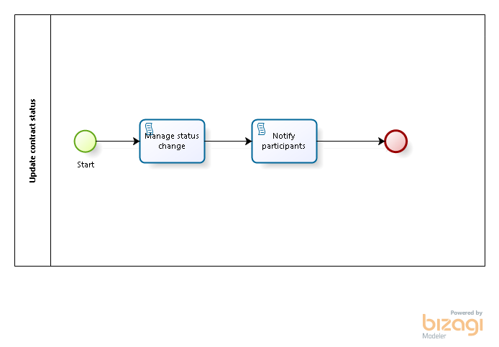

Version: 1.0
Author: DiegoO
This process can be started from:
Actions

Update contract status
Description
This process manages the status changes of multiple processes.

Process Elements

Manage status change
Description
Updates the status for the selected contracts.

On exit actions
For each contract, add a new status record to its log and set the current status as the one selected at the process start.

Notify participants
Description
Notify all related participants regarding the new contract status through e-mail.

On exit actions
Send an e-mail to all related participants raising awareness of the no contract status.

Start
Description
Once the contracts have been selected, select a new status and the description of the change.

Actions
Type | Description
On Exit | Record the user and time of the update request.

Event

Resources

Contract Owner (Entity)
Description
This is the Contract Owner Stakeholder.

Consenter (Entity)
Description
This is the Consenter Stakeholder.

Legal team employee (Entity)
Description
This is the Legal team employeeStakeholder.

Evaluator (Role)
Description
An evaluator is basically any user with the custom property "Allowed to evaluate contracts" turned on.

